

Startup - Starting up the System the First Time 12
Setup Your Viewer: 14
Running the Grid manually 15
Modifying INI Files 17
Quoting 17
Jopensim 18
Apache Webserver 19
Web Port 19
Enable Apache Web Server 19
Content ManageR 20
SSL 20
Troubleshooting: 21
DreamGrid API ReferENCE 23
REMOTE CONTROL (?command=...) 23
PARAMETERS 23
AUTHENTICATION 24
RETURN VALUES 24
DreamGrid (whole application) 24
MySQL 25
Robust (grid server) 25
Apache 25
Icecast 25
Regions 26
Backups (OAR/IAR) 27
Login check 29
REGION LIST (JSON) 29
TELEPORT SIGN LIST (teleports.htm) 30
TEXT-TO-SPEECH API 30
Backup - Autobackup 32
BACKUP TO EXTERNAL Media: 35
How to format an external drive: 35
Backup up to the external drive 35
Backup 1,2,3 37
IAR AND OAR ARE NOT BACKUPS OF YOUR GRID 38
Bird Module 38
Global Settings 40
Security 42
Bird Prims 42
Network Traffic 42
Statistics 42
Opensim COnsole 44
Cache Deletion 45
Flotsam Cache Settings 46
Flotsam asset cache 46
Running DreamGrid On A Server 47
Log Into Your Server 47
Firewall Rules 50
Sharing Files To And From Your Server 54
Backups: 55
Database Settings 56
Robust Database: 56
Local Region Database: 57
Running MySQL as a Service 58
MySQL Crashes: 58
My database still did not start! 58
Starting Over with a Blank Database 59
DEBUG 60
Diva Web Control Panel 60
Wifi Admin 62
User Levels: 63
Confirmation Required to Log In: 63
SMTP Email 64
Theme 64
Viewer Splash Screen URL: 65
Greeting 65
Friendly Name 65
Default Avatars: 66
Customizing your theme 66
Changing the HTML 67
Hypergrid and Domain Name Setup 68
Running on the LAN only 68
Troubleshooting Network: 69
links: 70
Easy Free Database 70
Usage 70
Response 71
Flotsam asset cache 78
General principles 78
FSAssets Settings 78
Data Folder 79
SpoolDirectory Folder 79
Migration 79
Grid Type 80
Grid Server with Robust 81
Region Server 82
OSGrid Server 84
Outworldz.Com Server 84
Outworldz Shoutcast And Icecast Server 84
Troubleshooting: 85
How to Broadcast Music: 85
WINAMP 85
Shoutcast Control Panel 90
Setting up the in-world radio 91
MIXXX 93
Special instructions for MP3 files: 93
Running Mixxx 94
Mixx Setup 95
Troubleshooting: 95
Port Forwards: 95
JOOMLA/JOPENSIM UPDATE 96
How to Update: 96
Installing and Running Joomla and jOpensim 97
Restore data 101
Edits 105
Backups: 106
Update 107
jOpensim Money 107
Landscaping 107
Terrain Section 108
Land Types 109
Load IAR 109
Links: 111
Load OAR 111
Options: - MERGE 114
--displacement 114
--force-terrain 115
--force-parcels 115
--default-user "<first-name> <last-name>" 115
Links: 116
Logging 116
Loopback 117
How to test for loopback 119
Installing the Loopback Adapter 120
LSL Scripting 123
MESH LOADER (Load DAE, GLB, GLTF) 126
OVERVIEW 126
How to open it: 126
STEP-BY-STEP: LOADING A MESH 127
OPTION A - Region + X/Y/Z coordinates 128
OPTION B - Type an avatar's name instead. 128
FOLDER BATCH MODE (OPTIONAL) 128
THE 16-BIT VERTEX LIMIT - WHY IT MATTERS 129
DAE vs GLTF vs GLB - WHAT'S DIFFERENT 129
DAE (COLLADA) 129
TIPS 130
Map Overrides 130
Maps 131
Manual regeneration 132
Migration From Dreamworld To Dreamgrid 133
Region Files 133
Starting Up 134
Modules 134
Moving a DreamGrid to another folder or PC 135
Method 1 135
Method 2 136
Method 3 136
Running DreamGrid On A Server 136
Log Into Your Server 137
Firewall Rules 139
Sharing Files To And From Your Server 142
Options 145
Permission Overrides 145
Physics Engine 147
Links: 147
Permissions 148
Physics Engine 149
Links: 149
Plant Editor 150
Trees and Plants 150
Plant Editor 151
Port Settings and UPnP 151
Port Forwards: 152
Troubleshooting Ports 153
IceCast/Shoutcast 154
Loopback: 154
Firewall Issues: 154
More information about Opensim Ports 155
Port 8001: 155
Port 8002: 155
Port 8003: 155
Port 8004 and upwards: 156
Links: 156
Publicity Overrides 156
Publicity – Publish your Grid 157
Region Panel 158
Region Basics 158
Options 159
Map Overrides 160
Physics Overrides 161
Script Overrides 162
Permission Overrides 162
Publicity Overrides 163
Modules 163
CPU 164
best use of “Real Time,” vs High, or using “low” 165
Rules for INI files 165
Region List 166
Refresh button 167
Details button 167
Icons button 167
Avatars button 167
Users button 167
Add 168
Run All Button 168
Stop All Button 168
Restart Button 168
Import Button 168
File Folder Arrangement 168
Clicking a Region 169
View Console Button 169
Start Button 169
Restart Button 169
Stop Button 169
Teleport Button 170
Send Alert Message Button 170
Load Region OAR Button 170
Save Region OAR button 170
View Log Button 170
View Map Button 170
Edit Button 170
Region Stats 170
Regions 172
Treoubleshooting: 174
Auto Restart and Startup Settings 175
Running the Grid manually 176
Save IAR 177
Switches 178
Script Settings 179
Allow LSL to contact the server: 180
Robust and Server Type 180
Grid Server with Robust 181
Region Server 181
OsGrid Region Server 182
Hypergrid.org Region Server 182
Smart Start 182
Teleports 183
Enable Smart Start 183
Shutdown Mode 184
Suspend Mode 184
Surrounding Sims 184
Details 185
Choose a Parking Region 185
Region Setup 186
Enless Land and Sea 187
SSL Certficates 188
Troubleshooting: 189
Streaming MP3 files in Opensim 190
Streaming MOVIE files in Opensim 194
Terrain 198
Menu: 199
Terrain Section 199
Land Types 199
Text to speech 200
Requirements 200
GUI 200
Voices 201
Use 202
API 202
Parameters: 202
Tides Module 204
Buoy: 204
Tide script: 205
Links: 206
Terms of Service 206
Troubleshooting Manually 209
How to Get on The Hypergrid 209
Step-By-Step 209
Ports are still blocked? 211
Try This SIMPLE BEGINNING 211
Password Reset 211
Troubleshooting the Network. 212
Anti Virus 212
AV Exclusions 212
Flaky Teleports 213
I cannot teleport to two different grids on the same network. 213
The URL I use to Test port forwards: 214
Test Private Loopback: 214
Test Public Loopback 214
UPnP Not Working? 215
Firewall 215
Updater: 215
Help with Opensim Crashes: 215
My database still did not start. 216
Starting Over with A Blank Database 216
Ports 216
Running Manually 217
Run as A Service 218
How to Compile DreamGrid 218
sers 218
Vivox Voice Settings 219
Links: 219
Who Got What Module 219
Setting Up WordPress with DreamGrid 220

Startup - Starting up the System the First Time
You can install DreamGrid by putting ”DreamGridInstaller.exe” in an empty folder and running it.
Or you can install DreamGrid by unzipping the zip file into a new, blank folder.
Then click “Start.exe”. You may get a popup warning. All my binary code is digitally signed and is cryptographically verified to protect you and to assure you that the code you get is what is originally authored. It is virus-free and has no ads. It should say "Verified Publisher: Outworldz, LLC”.
Click [Start] in the top left of the menu:
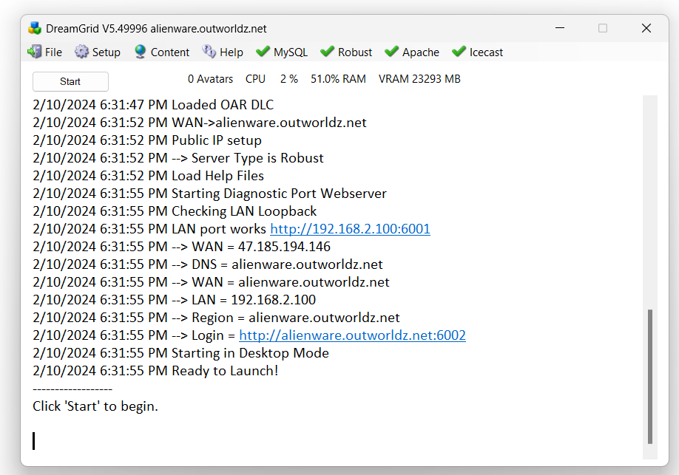
This box will appear for you to claim ownership of the Grid.
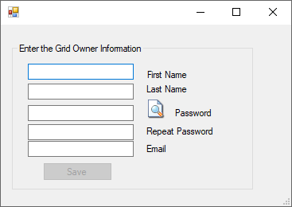
Use a unique, new long password as this is the avatar that owns the grid.
Another DOS box will appear. This will be your first region. The region is named "Welcome". You can change this name later. The system will ask you for an estate name. You can just press enter to name it “My Estate”, or type in a new name.
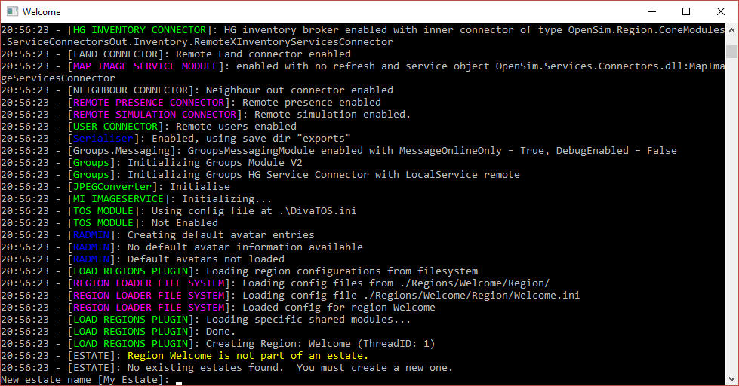
It will then ask you for the owner’s name of this region. Use the same name that you first entered.
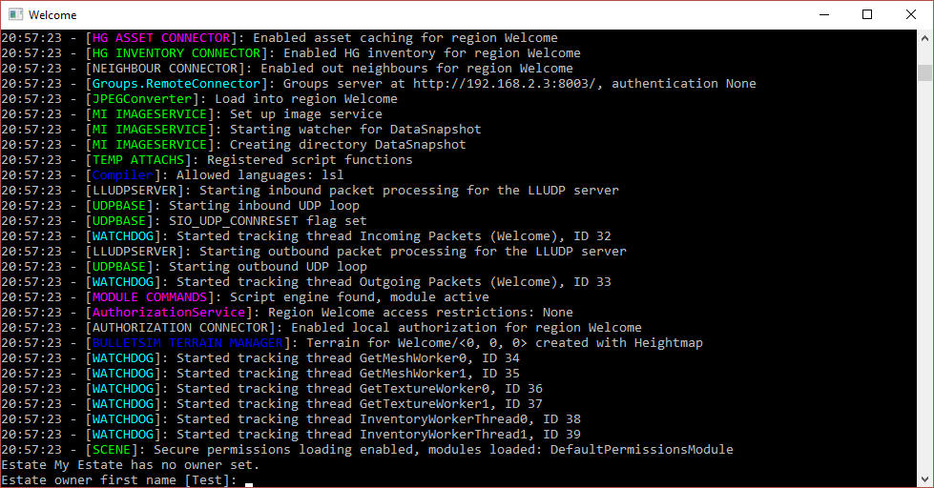
The system will eventually tell you "INITIALIZATION COMPLETE FOR Welcome - LOGINS ENABLED"

Setup Your Viewer:
Click the first item in the Help menu - Show Hypergrid address. It may print a name, or an IP address.
If it is an IP Address, your system will only run on your local area network at this time. The Hypergrid will not be available until you set up the router. See the help section at the bottom of this article on Ports and Loopback.

The system will print the address.
Download the Firestorm viewer for Opensim. You can get it from https://www.firestormviewer.org/
Launch the viewer and go to the Viewer Preferences menu (Ctrl-P).
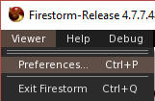
Go to the Opensim Grid manager screen:
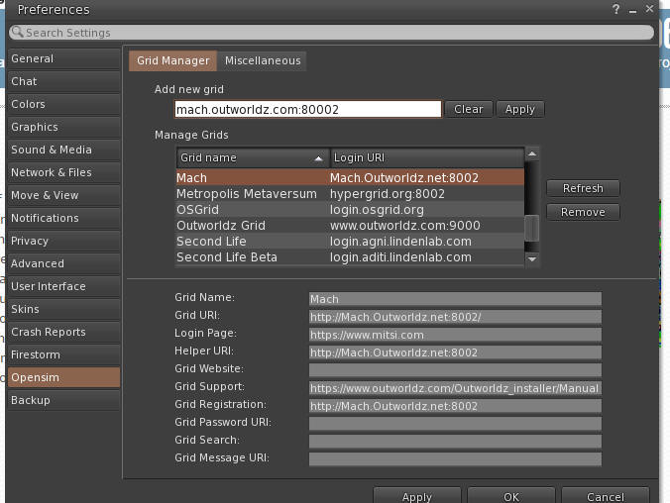
Add the http:// + IP address it showed in Blue, + :8002 to the Firestorm or other viewers "Add new Grid" field and click "Apply".
You should now be able to select your new DreamGrid in the Viewers pulldown for grid login and log in with the same First and Last Name and password you originally entered. You should then appear in an empty sim on a small 1X1 flat island named Welcome.
If this does not work, please use the troubleshooting link at the bottom of this help file.

Running the Grid manually
After the first run of DreamGrid, you can run Opensim, MySQL, and Robust without it.
The batch file Go.bat starts a command prompt with an instance of Opensim in it (an instance is a set of sims). The batch file launches Opensim with the settings it needs for the INI files and the Log file.
Step 1: Navigate to Outworldzfiles\ mysql\bin and run “StartManually.bat”. This will boot Mysql. StopMysql.bat is there which wil gracefully stop MySQL. You can also run (as an Administrator) InstallAsAService.bat so you do not need to start/stop MySQL. It will install itself in Services.msc and start when Windows runs.
StartManually.bat
Do not close the MySQL box. Use this batch file:
StopManually.bat
Step 2. Run “Outworldzfiles\Opensim\RunRobust.bat” which starts Robust
RunRobust.bat
Step 3. Run Outworldzfiles\Opensim\go.bat, which starts any region by Instance (Dos Box) Name.
go Welcome
This is the batch file "StartManually.bat" which does multiple items in sequence:
@remarkable batch file to start DreamGrid manually.
cd mysql\bin
start startmanually.bat
cd opensim
call runrobust.bat
call go Welcome
call go AnotherRegion
add more region names here

Modifying INI Files
As a general rule, you should have no need to edit any INI files, as some of them are controlled by DreamGrid settings and they will override your changes.
To solve this, you can override DreamGrid by modifying OutworldzFiles\Settings.ini by adding a [Section]Key=Value to Settings.ini. [Section]Name=something will put something in Name in Section. This modifier always goes in Settings.ini. For example, you may want move Jopensim to another host, aka a different URL. Adding this to Settings.ini [GridInfoService]welcome = http://google.com will change your welcome page to google.com.
Robust's [GridInfoService] section under Jopensim looks like this.
welcome = ${Const|BaseURL}:${Const|PublicPort}/JOpensim/index.php?option=com_opensim
This sets 'welcome' in Robust's [GridInfoService] to your DreamGrid Apache/Jopensim folder.
But if you are running jOpensim somewhere else, such as http://mygrid.com, you need to override this.
Add this to settings.ini to override [GridInfoService] section's welcome setting to "http://mygrid.com/index.php?option=com_opensim"
[GridInfoService]welcome = http://mygrid.com/index.php?option=com_opensim
This also applies to any other [Section] in Settings.ini, which is defined as section [Data]. The syntax is [Data]key = some value
If I want DG to stop changing the value:
SearchURL = https://YourURL/index.php?option=com_opensim&view=interface
to
SearchURL=http://Mygrid.com:80/Search/query.php
then add this:
[Data]SearchURL = https://YourURL/index.php?option=com_opensim&view=interface
You need to use the [section] you want to modify. [Data] will modify Settings.ini as that is the only place there is a Data section (look at top line of Setting.ini). This declares a new setting. It will override any DreamGrid changes in any INI with a section GridInfoService with a SearchURL and set it to "something""

Quoting
Double quotes on the right-hand side are optional and only needed for right hand side where you want spaces at beginning or end. These are all the same.
X = "yz", X=yz, X= y z
X= " yz" is different as yz has a space at the beginning. I have never seen one, but it could happen.

Jopensim

These are reported to be the current Settings for jOpensim
[Messaging]OfflineMessageModule=OfflineMessageModul
[Messaging]OfflineMessageURL=http://YourURL/index.php?option=com_opensim&view=interface&messaging=
[Messaging]MuteListModule=MuteListModule
[Messaging]MuteListURL=http://YourURL/index.php?option=com_opensim&view=interface&messaging=
[DataSnapshot]index_sims=true
[DataSnapshot]data_exposure=all
[DataSnapshot]SearchURL=https://portal2.moonightestates.me/index.php?option=com_opensim&view=interface
[DataSnapshot]searchPeople=false
[DataSnapshot]GroupsServerURI="https://YourURL/index.php?option=com_opensim&view=interface"
[Profile]ProfileURL="http://YourURL/index.php?option=com_opensim&view=interface"
[Profile]Module="jOpenSimProfile"

Apache Webserver
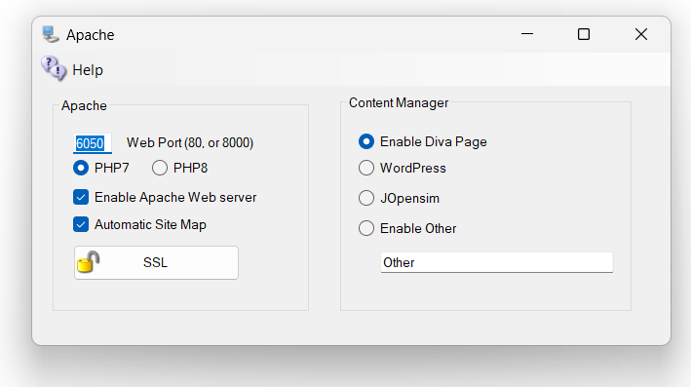
You may optionally set up an Apache Web server with PHP7 or PHP8, WordPress, Joomla/jOpensim, or other Content Management (CMS) systems. The default purpose of Apache/PHP is to serve maps, object search and other useful functions. It is optional. You may disable it and still run Opensimulator. If you do not need the extra maps or a CMS, then you can leave Apache & PHP disabled.

Web Port
Defaults to 80. If your ISP blocks port 80, try 8000. DreamGrid will automatically open this port in your PC’s firewall. You must Port forward whatever port you select in your router, or use UPnP.
If you are going to run a SSL connection, this must be on Port 80. See the section on SSL below.

Enable Apache Web Server
The checkbox for [Enable Apache Web Server] must be set so the web server will work.
Apache will then start when your PC is booted. No DOS boxes will appear. There is less clutter and 24-hour operation of the web server.
Caution: If you move the grid to another folder after installing Apache, the server will still attempt to run from the original folder. You need to click the Menu at the top of The Main interface and Delete the Apache Service, and then Start Apache Service. It will re-install itself and point to the correct folder.
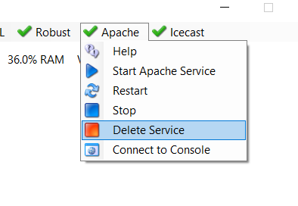

Content ManageR
A content management system (CMS) is computer software used to manage the creation and modification of digital content. CMS’s are typically used for enterprise content management (ECM) and web content management (WCM)
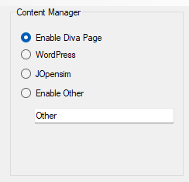
Enable Diva Web Page is setup in Setup-> Setting->Webserver Control Panel section.

Enable WordPress will redirect all traffic to the home page to the WordPress folder in Outworldzfiles\Apache\htdocs\WordPress. You must install WordPress there. Instructions are in that folder.
Enable jOpensim will redirect all traffic to the home page to the JOpensim folder in Outworldzfiles\Apache\htdocs\JOpensim. Instructions are in that folder.
Enable Other will redirect all traffic to the ‘Other’ folder in Outworldzfiles\Apache\htdocs\other. You can make a different folder and 3use that name, provided it is in the Apache\htdocs folder structure.

SSL
The SSL setup screen lets you create a free SSL certificate for Apache. This certificate will automatically renew every 670 days. It expires after 90, so you must keep your grid running sometime during that month to get it to renew.
The process is simple and automatic. You must be running Apache on Port 80. You cannot do this without that set up.
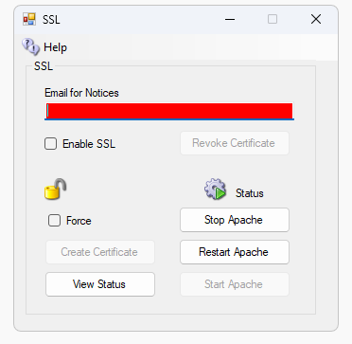

Step 1. Enter your real email.
Step 2. Click “Create Certificate”. The System will take about one minute to create and authorize the certificate. This will create the SSL Certificates. Wait a minute and the icon will show green or it will show it unlocked.
Step 3. Enable SSL
Step 4. Stop and Start Apache. Or click Restart if it is available.
Detail: It makes a batch file in the \SSL folder. You need to type CMD and run CMD as Administrator. Then type cd … to get to the SSL folder, and type this.
InstallSSL.bat {enter}
That is what the Create Certificate button does. DreamGrid makes that batch file and runs it. It captures the output to a log.
If the batch file reports success, DreamGrid will enable the Apache server to use Certificates. It goes into effect when Apache restarts.

Troubleshooting:
There are some rules:
- You must run the Apache webserver.
- Apache must be using port 80. After this step completes you can use port 443 for SSL.
- You must be using a domain name in Setup->Settings->HG DNS Name.
- The domain must be accessible from the Internet so the system name can be validated. A simple test is to see if canyouseeme.org works on port 80. Then try your domain name + :80

There is a log specifically for SSL issues. It is located in Outworldzfiles\Logs.
2022-01-29 00:53:30:OK: A simple Windows ACMEv2 client (WACS)
Software version 2.1.20.1185 (release, pluggable, standalone, 64-bit)
Connecting to https://acme-v02.api.letsencrypt.org/...
Scheduled task looks healthy
Please report issues at https://github.com/win-acme/win-acme
Running in mode: Unattended
Source generated using plugin Manual: smartboot.outworldz.net
Overwriting previously created renewal
Using cache for [Manual] smartboot.outworldz.net. To get a new certificate within 1 days, run with --force.
Store with PemFiles...
Exporting .pem files to C:\Users\XXX\Desktop\Dreamgrid\Dreamworld\OutworldzFiles\Apache\Certs
Installing with None...
Scheduled task looks healthy
Next renewal scheduled at 2022/3/25 5:40:43
Certificate [Manual] smartboot.outworldz.net created
2022-01-29 00:53:31:Info:Certificate installed

DreamGrid API ReferENCE

This is a from-source rewrite of the old !Manuals\API.docx, current as of the Modules\Webserver.vb / Classes\ClassWebServer.vb source in this repository. It replaces stale/inaccurate parts of the old doc (noted below) and adds commands that exist in the code but were never documented.
DreamGrid exposes a small HTTP API on the diagnostics port (Settings-> Network Ports; default 8001) for remote control, region listing,teleport signs, and text-to-speech. All of it is served by the samelistener - see Classes\ClassWebServer.vb - and dispatched byModules\Webserver.vb's ParsePost/CommandProcess functions.
(DreamGrid also exposes this same control surface as an MCP serverfor AI clients like Claude, at /mcp on

REMOTE CONTROL (?command=...)
General shape (GET or POST both work):
http://{LanIP}:{DiagnosticPort}/?
command={UrlEncode(command)}
&password={UrlEncode(MachineHash or avatar password)}
&avatar={UrlEncode(AvatarName)} (needed for avatar-level auth)
&RegionUUID={UrlEncode(regionUuid)} (region commands)
&RegionName={UrlEncode(regionName)} (region commands, alternative to RegionUUID)

Parameter names are read case-insensitively (Command/command/COMMAND all work), so existing links using capitalized names still work.

PARAMETERS
command required One of the commands listed below.
password required Either the grid's MachineHash (see
"Authentication" below) for full admin
access, or a normal avatar's login password
for a lower, avatar-level permission.
avatar optional Avatar name to check permission level for,
when not using the MachineHash.
RegionUUID optional Target region's UUID. URL-escape as needed
(e.g. %2D for a hyphen).
RegionName optional Target region's name instead of its UUID
(e.g. %20 for a space). Resolved to a UUID
internally. Use RegionUUID or RegionName,
not both.
value command- Used by the "Enable" command.
specific
param command- Used by the "SetStatus" command.
specific
AvatarName command- Used by "SaveIAR" (the avatar whose
specific inventory to archive).

AUTHENTICATION
Every command runs through CheckPerms(avatar, password), which grants one of these permission levels:
1000 password exactly matches the grid's MachineHash
(full admin - can do anything)
0-200 password matches the named avatar's login password;
the avatar's user level in the grid becomes the
permission level (100 = Wifi admin, 200 = "Level God")
0 missing/blank password, or no match - denied
Each command below requires a minimum level; if you don't meet it you get back "NAK You do not have permission to ...".
The MachineHash is stored in OutworldzFiles\Settings.ini (key: MachineHash) - it is the MD5 of the grid's Dyn DNS password.
It must be URL-encoded before use.

RETURN VALUES
Commands return a plain string: either useful data, or a status string starting with "ACK" (success) or "NAK" (failure, with a reason).

DreamGrid (whole application)
StartDreamGrid (level >= 200)
Starts all enabled regions on the grid.
http://127.0.0.1:8001/?command=StartDreamGrid&password={HASH}
StopDreamGrid (level > 200)
Stops all regions on the grid.
http://127.0.0.1:8001/?command=StopDreamGrid&password={HASH}
RestartAll (level >= 200)
Stops the grid, then relaunches Start.exe entirely (a full
application restart, not just the regions).
http://127.0.0.1:8001/?command=RestartAll&password={HASH}

MySQL
MySQL is started automatically when DreamGrid itself starts.
StartMysql (level >= 200)
http://127.0.0.1:8001/?command=StartMysql&password={HASH}
StopMysql (level >= 200)
http://127.0.0.1:8001/?command=StopMysql&password={HASH}

Robust (grid server)
Robust is started automatically after MySQL when DreamGrid starts.
StartRobust (level > 0)
http://127.0.0.1:8001/?command=StartRobust&password={HASH}
StopRobust (level > 200)
http://127.0.0.1:8001/?command=StopRobust&password={HASH

Apache
StartApache (level = 1000, MachineHash only)
http://127.0.0.1:8001/?command=StartApache&password={HASH}
StopApache (level = 1000, MachineHash only)
http://127.0.0.1:8001/?command=StopApache&password={HASH}

Icecast
StartIcecast (level > 200)
http://127.0.0.1:8001/?command=StartIcecast&password={HASH}

StopIcecast (level > 200)
http://127.0.0.1:8001/?command=StopIcecast&password={HASH}

Regions

StartRegion (level > 1)
Boots RegionUUID or RegionName if not already running.
http://127.0.0.1:8001/?command=StartRegion&password={HASH}&RegionName=Welcome

StopRegion (level > 1)
Stops a running region.
http://127.0.0.1:8001/?command=StopRegion&password={HASH}&RegionName=Welcome

RestartRegion (level > 1)
Restarts (recycles) a region.
http://127.0.0.1:8001/?command=RestartRegion&password={HASH}&RegionName=Welcome

Freeze (level >= 200)
Suspends a region in place (see Help\MCP.txt's note on the
hourly SmartStart freeze/thaw cycle - this is the same
mechanism, triggered manually).
http://127.0.0.1:8001/?command=Freeze&password={HASH}&RegionName=Welcome

Thaw (level > 0)
Resumes a suspended (frozen) region.
http://127.0.0.1:8001/?command=Thaw&password={HASH}&RegionName=Welcome

Enable (level >= 100)
Enables/disables login and visibility for a region.
http://127.0.0.1:8001/?command=Enable&password={HASH}&RegionName=Welcome&value=true

SetStatus (level > 200)
Forces a region directly into a named state (e.g. Restart).
Note: unlike the other region commands, SetStatus reads
RegionUUID only - it does not fall back to RegionName.
http://127.0.0.1:8001/?command=SetStatus&password={HASH}&RegionUUID={UUID}&param=Restart

RegionStatus (no password required)
Returns the current status of a region as plain text (Booted,
Suspended, Stopped, RecyclingDown, Booting, Error, Restart,
etc.)
http://127.0.0.1:8001/?command=RegionStatus&RegionName=Welcome

Backups (OAR/IAR)
Backup (level >= 200)
Runs a full backup of every region on the grid.
http://127.0.0.1:8001/?command=Backup&password={HASH}

SaveOAR (level > 100)
Saves an OAR (region archive) of one region.
http://127.0.0.1:8001/?command=SaveOAR&password={HASH}&RegionName=Welcome

SaveIAR (level >= 0, but also checks the avatar owns the
named inventory - see note below)
Saves an IAR (inventory archive) for one avatar. Always runs via
the Welcome region, since it is guaranteed to be online. You may
queue several; only one runs at a time.
http://127.0.0.1:8001/?command=SaveIAR&password={HASH}&AvatarName=First%20Last
Note: the current source only saves the file server-side (no
download link is produced yet - see the TODO comment in
CommandProcess's SaveIAR case).

Login check

Login (level >= 0)
Verifies an avatar's name/password pair against the grid and
returns "Success" if valid, else "NAK ...".
http://127.0.0.1:8001/?command=Login&password={AvatarPassword}&avatar=First%20Last

REGION LIST (JSON)

http://{LanIP}:{DiagnosticPort}/?command=regionlist

No password required. Returns a paginated JSON object - the same
data the DreamGrid web UI's region grid table uses - with region
name, status, RAM usage, prim count, estate, SmartStart mode, and a
"hop://" teleport link where applicable.

Optional query parameters:
page 1-based page number, default 1.
rp rows per page, default 100.
query filter text (matched against region name).
qtype set to "RegionName" when using "query".
sortorder "asc" or "desc" (region name), default "desc".

Example:
http://127.0.0.1:8001/?command=regionlist&page=1&rp=50&sortorder=asc

NOTE ON THE OLD DOC: the previous API.docx documented a different "RegionList" command that dumped raw internal region properties (_PrimCount, _FilePath, _RegionPid, etc.) as one giant JSON object keyed by region UUID. That command class constant still exists in the source (CommandClass.RegionList) but is only used internally, for the foreground DreamGrid UI to sync state from a background service instance (see Modules\Services.vb, GetServiceList) - it is not wired into the public CommandProcess dispatcher and is not a supported external command. Use ?command=regionlist (above) instead.

TELEPORT SIGN LIST (teleports.htm)

http://{LanIP}:{DiagnosticPort}/teleports.htm?Start=1&Count=16

Used by the in-world DreamGrid teleport sign object (in the IAR folder) to build dynamic lists of online, teleport-enabled regions. No password required.

PARAMETERS (both optional)
Start 1-based index of the first region to return. Default 1.
Count how many regions to return. Default 256.

Only regions that are running, enabled, and have the "Teleport Sign" checkbox set (Regions -> Options tab) are included. The Welcome region is always first when Start=1.

Because in-world scripts can only read about 16KB from a URL, large grids need to request the list in chunks using Start/Count, e.g. Start=1&Count=32, then Start=33&Count=32, and so on.
Response format: one line per region, pipe-delimited:
*|{RegionName}||{PublicIp}:{HttpPort}:{RegionName}||{RegionName}|
(one line per region, each ending in a CRLF)

TEXT-TO-SPEECH API

See Help\Text2Speech for the full write-up (voices, hardware requirements, etc.) - summarized here for completeness:
http://127.0.0.1:8001/?TTS={text}&APIKey={key}
PARAMETERS
TTS required Text to speak. May need HTML/URL escaping.
A line starting with "M:" speaks in a male
voice; "F:" speaks in a female voice.
APIKey required Must match the Voice password set in
Settings -> Speech.
Sex optional "M" or "F" - forces the whole request's
voice gender.
Voice optional A specific SAPI5 voice name, e.g. Zira,
Mark, or any other voice installed on the
host.
Save optional Any value - saves the speech as MP3 and WAV
files and returns the path to the MP3
instead of just speaking at the host's
console. The .wav is OpenSim/Second Life
compatible: 44.1kHz, mono, 16-bit.

If a sound card is available and Save is omitted, the text is spoken out loud at the server's console.

DreamGrid also exposes a "speak" / "speak_to_file" pair of MCP tools that call this same speech engine directly (bypassing the APIKey check, since MCP has its own permission model) - see Help\MCP.txt.

Backup - Autobackup
The AutoBackup module periodically saves data to a folder.
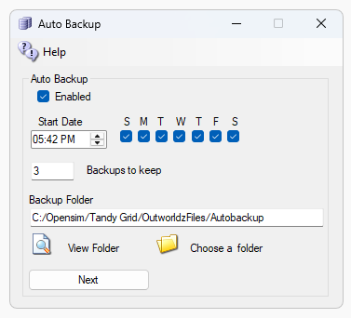
DreamGrid will make various backups of each region when AutoBackup is enabled. We do not use the Opensim AutoBackup mechanism as it is too crude.
Keep for Days will remove any backup folder older than this period. It will always backup first, then delete the excess,
Choose a folder: You can click on “AutoBackup” folder name, or the folder Icon, and set a different location.
CAUTION: These backups may use a great deal of room! It is critical to save them to a different drive so that a full drive does not crash your Database and Opensim system. DreamGrid will check for free disk space and warn you if you are low. It will freeze all Opensim Region activity if disk space gets low. If the disk space is > 100 MB, it will resume operation.
Click Next
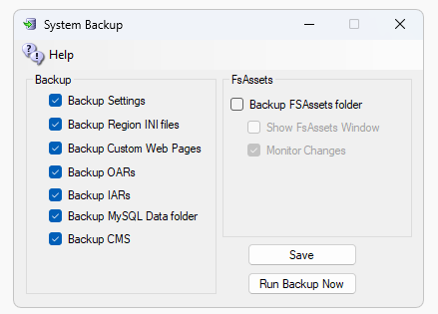
If there are checkboxes set in the [Backup] list, those files will be backup up, too. The files will appear in the Outworldzfiles\AutoBackup folder.
Backup Settings saves the Settings.INI files in a Zip.
Backup Region INI files saves all Region INI files from OutworldzFiles\Opensim\Bin\Regions to a Zip.
Backup FSAssets folder will make a copy of all the (Very Large) FsAsset folder. This should be used only when you have Backup folder set to a different backup disk or PC.
Backup Custom Web Pages are the two Wifi-Custom folders in Opensim and Opensim\bin.
Backup Oars will manually backup all regions that are enabled. There is also a Skip backup switch you can set for regions that never change in each Regions Settings.
Backup IARs will start back up all IARs one at a time. This can take a Very Long Time.
Backup MySQL Data Folder will back up the main database. You need a copy of FsAssets, too!
Backup CMS will backup any Wordpress or Joomla files.
Robocopy: The FSASSETS system uses robocopy, a built in DOS program for FsAssets. The DOS box it runs in follows two rules for visibility that you set for regions, such as Always Show or Never Show. It runs with the following switches:
/E - Everything including empty folders.
/M –Modified files are copied that have the A bit set, then it clears the bit.
/IM - Include Modified files that have changed times.
/J – Use Unbuffered IO for large files.
/LFSM:50M – Will work in low free space mode, enabling copy pause and resume. Robocopy will pause whenever a file copy would cause the destination volume's free space to go below 50 Megabytes.
See the manual on “Manual Backups” for ways to back up manually.
This is what DreamGrid backs up if you check all the boxes:
- OutworldzFiles\Apache\htdocs\jOpensim\ folder
OutworldzFiles\Opensim\WifiPages-Custom\ folder
- OutworldzFiles\Settings.ini file
- OutworldzFiles\XYSettings.ini file
- OutworldzFiles\Opensim\bin\LocalUserStatistics.db database of traffic and viewers.
- OutworldzFiles\Photo.png Custom Hyperica Photo
- OutworldzFiles\NewBlack.png Custom Theme
- OutworldzFiles\NewWhite.png Custom Theme
- OutworldzFiles\NewCustom.png Custom Theme
- OutworldzFiles\Opensim\bin\Regions All the region Ini files
- Mysql Robust as .sql a portable database of Robust
- Mysql Opensim as .sql a portable database of Opensim regions
- Joomla as .sql a portable database of joomla data.
- Opensim\bin\FSassets ALL the assets, which must be backed up last on a live machine.

BACKUP TO EXTERNAL Media:
Get a USB drive, preferably USB 3.0 plug it into a Blue or Teal colored jack for fastest speed. If you do not have the colored jacks, use any Black-colored jack. Format it for NTFS, with a 4096-sector size.
ExFAT is a standard format that works on all machines, including Mac’s, Linux, and Windows. You must select a smaller sector size in ExFAT, or you will waste most of the space! A smaller sector size lets you put more data on the disk.

How to format an external drive:
You can easily change an external hard drive to NTFS or ExFAT file system via Disk Management by following the steps listed below.
1. Connect the external hard drive to your computer and make sure that it is detected by Windows.
2. Press Windows + X at the same time and choose “Disk Management”.
3. Right-click the hard drive partition that you intend to format and choose “Delete Volume” to delete the partition.
4. Right-click the unallocated disk space and choose “New simple volume” and do like the prompts.
5. In the Format Partition window, set the file system as and click “Next” and “Finish” to start the operation.

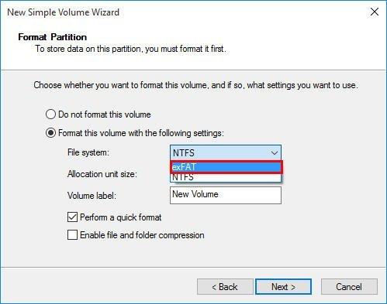

Backup up to the external drive
Set a path to this drive in AutoBackup. Here I have my dev system set for my E: drive, a 14 TB Western Digital Easystore USB 3.0 HDD. Got it on Black Friday for $189 at Best Buy. These are usually the best deals in the USA.

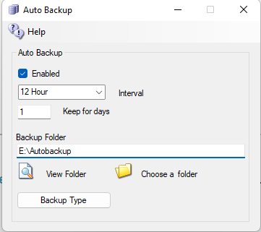
Set it for a week’s worth of backups. The default was 1 day, the default now is 3 days. But that applies only to new grids.
Now click Backup Type
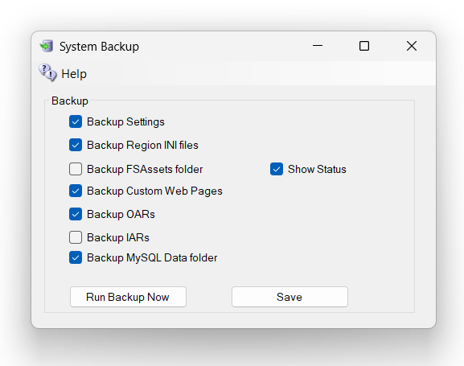
Check all the boxes.
- A FULL backup is to check all boxes except Backup OARS.
- Backup OARS is an effective way to get to the regions in a portable way, but this leaves out your users, your inventory, settings, and other important things.
- To get an immediate backup of your grid, manually, click on the button that says: Run Backup Now.

Click Run Backup Now.
If Fsassets is enabled, this may take days to finish because FSASSETS is going to be HUGE and will grow every time you touch the grid.

Backup 1,2,3
Now run the grid for some time and check on the disk space. If there are lots left over, bump up the days and check again in another week.
If it’s a USB drive, plug it into your concrete and steel Fire Safe that is bolted to the floor and go buy another USB hard drive. Your need TWO backups, and one MUST be offline.
This is only steps 3 and 2 of the 3:2:1 Backup method. You should put at least the most recent copy in the cloud to handle the ‘1’ part. There are many solutions such as Google Drive, Microsoft’s OneDrive, or iDrive. Forget Dropbox. It crashes on large zips and lots of files, such as bin\fsassets. Google is scanning your files and will call the police on you if they find something suspicious. I have not tried OneDrive even though I have a free 1T with my 365 subscriptions. I know that iDrive works well for some and never crashes.

IAR AND OAR ARE NOT BACKUPS OF YOUR GRID
IARS are portable. They have that going for them. You can easily back them all up. Just look in Content under IARs, click the Backup All IARS link and choose a region that will be remarkably busy for perhaps several days or longer. I did 909 people recently. Works great. Used up 156 GB of disk. Spotted one person who had 32 GB of inventory.
IARs are backups of just a portion of inventory. IARs have no usernames, passwords, no UUIDs and until the it was fixed in 2022, no alphas for your avatars. IARs cannot reconstruct Appearances. The UUIDs change when an IAR load, so the appearance links will be broken. You can easily repair them, but it is tedious. They are good for moving to another grid. You can use the Diva Wifi Panel on any DreamGrid to populate your IAR from another grid. IARs have their uses but they are not a full backup.
Same goes for OARS. Very handy. But not a backup of a region. What size is the region? X or Y Engine? That information is in bin\regions, which DreamGrid backs that up for you.
Mysql\data and bin\fsassets are the things you must have to get a full backup to restore a grid. FSAssets will be huge. Millions of files. Mysql must be backed up before you backup FSAssets as it points to the files. If done in the wrong order on a live grid, you will lose assets if you try to restore from the FsAsset + MySQL backup. Do it in the order of MySQL, then Fsassets.

Links:
http://opensimulator.org/wiki/Load_Oar_0.9.0%2B

Bird Module
The bird module makes flocks of birds possible.
You will need a bird. There is a button at the top of the Setup Page that will ask you for your Avatar Name and password. It will load a pair of Seagulls into your inventory.
You should log in and rez "SeaGull1" on the ground in one or more of your regions.
You will need to enable the bird module in each region's control panel.
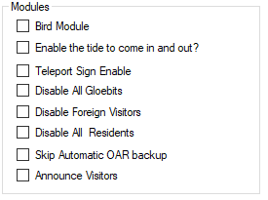
Check this Box to Enable Birds in this region

Global Settings
There are many settings for the Bird Module. You can use the defaults. You must also click Enable and reboot the grid. Birds must also be enabled in each Region. See each Region’s edit screen for the checkbox.
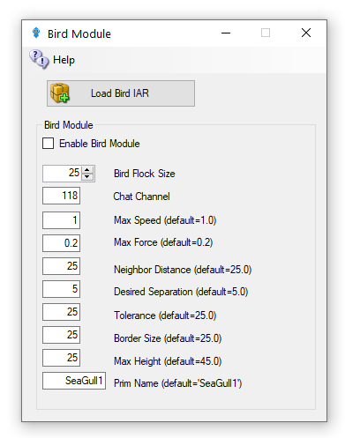
Enable Bird Module: Determines whether the module does anything.
BirdsFlockSize = 50: The number of birds to flock
BirdsMaxFlockSize = 100: The maximum flock size that can be created (keeps things sane)
BirdsMaxSpeed = 3: How far each bird can travel per update. An update is 11 FPS
BirdsMaxForce = 0.25: The maximum acceleration allowed to the current velocity of the bird
BirdsNeighbourDistance = 25: Max distance for other birds to be considered in the same flock as others
BirdsTolerance = 5: How close to the edges of things can we get without being worried
BirdsBorderSize = 5: How close to the edge of a region can we get?
BirdsMaxHeight = 25: How high are we allowed to flock
BirdsUpdateEveryNFrames = 1: Update bird positions every N simulator frames
BirdsPrim = SeaGull1: By default, the module will create a flock of plain wooden spheres, however this can be overridden to the name of an existing prim that needs to already exist in the scene - i.e., be rezzed in the region.
Console Commands
The following commands can be issued on the Console or via in-world chat or scripted chat on the Chat Channel to control the birds at runtime:
- Birds-stats or /118 stats
Shows the current status of the birds
- birds-stop or /118 stop
stop all birds flocking
- birds-start or /118 start
start all birds flocking
- birds-enable or /118 enable
enable the flocking simulation if disabled and rez new birds
- birds-disable or /118 disable
stop all birds and remove them from the scene
- birds-prim <name> or /118 prim <name> changes the name of the bird prim that it loads
- framerate <num>
only update the flock positions every frame, only useful for photography and debugging bird behavior.
- These commands are great for playing with the flock dynamics in real time:
- birds-size or /118 size
change the size of the flock
- birds-speed or /118 speed
change the maximum velocity each bird may achieve
- birds-force or /118 force
change the maximum force each bird may accelerate
- birds-distance or /118 distance
change the maximum distance that other birds are to be considered in the same flock as us
- birds-separation or /118 separation
sets how far away from other birds we would like to stay
- birds-tolerance or /118 tolerance
sets how close to the edges of things can we get without being worried. If distance is less than separation, then the birds will never flock. The other way around and they will always eventually form one or more flocks.

Security
By default, anyone can send commands to the module from within a script or via the in-world chat on the 'BirdsChatChannel' channel. You should use a high negative value for this channel if you want to allow script access, but not in-world chat.

Bird Prims
Any currently rezzed in-scene-object can be used as the bird prim. However, fps is very much affected by the complexity of the entity to use. It is easier to throw a single prim (or sculpty) around the scene than it is to throw the constituent parts of a 200 linked prim dragon.
Tests show that <= 500 single prims can be flocked effectively - depending on system and network. However maybe <= 300 simple linksets can perform as well.

Network Traffic
I tested the amount of network traffic generated by bird updates. 20 birds (each with 4 linked prims) take up about 300kbps in network position updates. 50 of the same birds generates about 750kbps traffic. Each bird uses roughly 15kbps of network traffic. This is all measured using an update framerate of 1, i.e., birds' position is updated every simulator frame.

Statistics
The stats command in-world or via script returns data to BirdsChatChannel. The console command returns stats to the console. All the modules parameters are returned including a list of the active bird prims currently rezzed in the region, and the UUIDs of those prims' root prim. Also included is a list of any avatar UUIDs that may be sitting on those prims.
Here is an example output:
birds-stats (or /118 stats
birds-started = False
birds-enabled = True
birds-prim = SeaGull1
birds-framerate = 1
birds-maxsize = 100
birds-size = 20
birds-speed = 1.5
birds-force = 0.2
birds-distance = 25
birds-separation = 10
birds-tolerance = 5
birds-border = 5
birds-prim0 = OpenSimBirds0: 01abef79-7fb2-4c8d-831e-62ce1ce878f1 :
birds-prim1 = OpenSimBirds1: af85996d-af4d-4dda-bc89-721c51e09d0c :

Opensim COnsole
Start ConsoleClient.exe in the folder ConsoleClient:
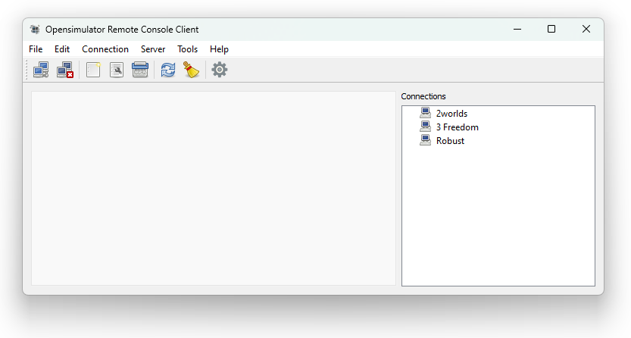
Select New under Connection at the top:
Note: Robust is usually port 8002.
Connection > Enter a name that matches the server connection.
Host > Enter the URL to the server here DNS name.
Port > Enter the region HTTP port here. You can get this from the Region List report
User > Enter the name for the Wifi Admin.
Password > Enter the password for the user. This is the Wifi Admin User password found in the Settings->Web Page
Clicking on OK saves this and displays it on the right-hand side.
You can enter your entire server in the same scheme.
Now click on one of the servers listed on the right-hand side, choose Connection at the top and Connect and you are on the server in the console.

Cache Deletion
Opensimulator has many caches of data to improve performance. You may optionally clear these caches. The system will refresh them during the next startup. This will slow your system down dramatically on the next boot as it must re-fetch all assets the next time it starts.
Opensim must be stopped to clear script and the Avatar Bake caches.
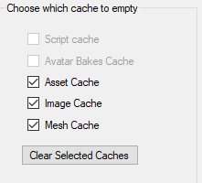
Script cache: Clearing the script cache is only necessary after an update to Opensim binaries. DreamGrid will not delete the “.STATE” files so your virtual pets will not die.
Avatars bakes cache: this folder holds the various baked skin layers.
Asset cache: holds the assets (mesh, prims, textures) and is typically exceptionally large. It automatically flushes itself every 48 hours.
Image cache: holds the images and is typically exceptionally large.
Mesh cache: holds mesh pieces.

Flotsam Cache Settings
OpenSimulator has an asset cache that stores the assets retrieved from an asset service. This reduces the load on a possibly remote asset service and improves OpenSimulator responsiveness.
Viewer cache is for modern viewers. If you use old viewers you may have issues. Turn this off for old viewers.
Cache Enabled: The cache should always be enabled.
Cache Directory man be moved to another disk. It is best practice to save all large folders such as this cache to another disk.
Log level is for debugging.
Timeout in Hours is how you set how much disk it uses. Lower numbers = less disk space. The larger the number, the better performance you will get. Typical numbers are 24 hours for small grids, a few hours for large grids.
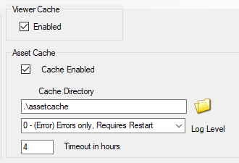

Flotsam asset cache
Note: You must run the Flotsam asset cache if you are running the FSassets file system database.
The Flotsam asset cache stores assets on disk and in memory.
At the moment, the amount of memory or filesystem storage used by the cache can only be limited via manual actions (wiping all or part of cached assets from the filesystem), by console commands (e.g. "fcache clear") or by timeout settings (e.g. FileCacheTimeout = 1 to automatically remove cache files not accessed for 1 hours).
General principles
When OpenSimulator requires an asset (e.g. in response to a viewer request for a notecard), then it first asks the cache for this data. If the data is not found in the cache, then it asks the grid asset service (or possibly a foreign asset service in the case of Hypergrid). If the asset is found, then it is both stored in the cache and returned to the user.
If an asset is uploaded to OpenSimulator (e.g. by the viewer uploading an animation), then the asset is immediately both kept in cache (if there is room and the asset is not temporary) and sent to the asset service (if the asset is not temporary).
Therefore, at any point you can wipe any temporary data stored by the asset cache (e.g. on the filesystem), since the next request for that asset will simply query the asset service as the asset will not be found in cache.

Running DreamGrid On A Server
One of the difficulties in moving to a server such as Contabo.com is moving the files to it.
The big problem is mysql\data\ibdata - which is literally your grid and must be moved.
There are many ways to do this: Google drive, dropbox, ftp, but most of those require $$ or are very slow. A very good way is to use Windows SMB file sharing.
The remote server can appear as a local disk, such as X: or Z: with SMB file shares so you can copy and paste files. This makes it trivially easy to make backups and move OARs and backups off Contabo and store them at your home.

Log Into Your Server
Log in with remote desktop or VNC as an Administrator. You need a strong password for your account! Don't skimp on this step, as your server is exposed to the internet in an intimate way, and it will be probed constantly for weaknesses.
Now choose a folder. The safest way to share is by making a shared folder, such as your AUTOBACKUP folder. If someone guesses your password, then all they get are backups. And you can share the entire drive, too.
Right click a folder or C: and select Properties.
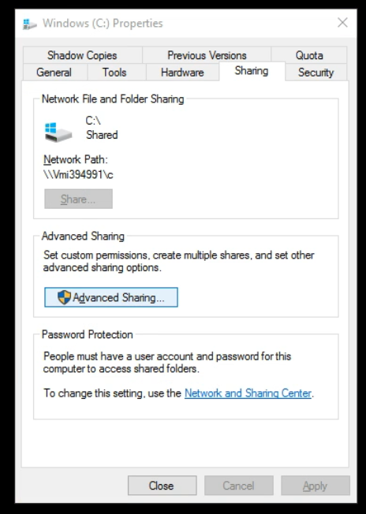
Click Advanced Sharing:
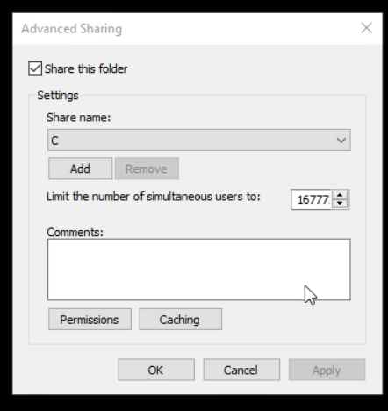
Click Add and give it a name, such as "C", and check "Share this folder"
Click Permissions:
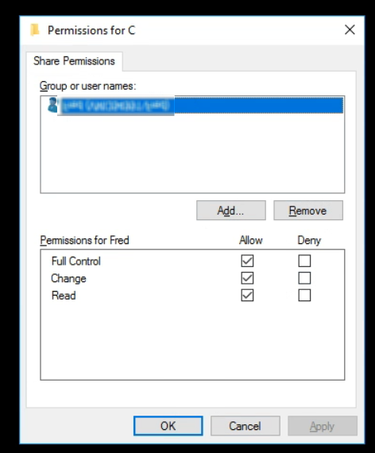
Remove the "Everyone" group and click Add and type in your login name.
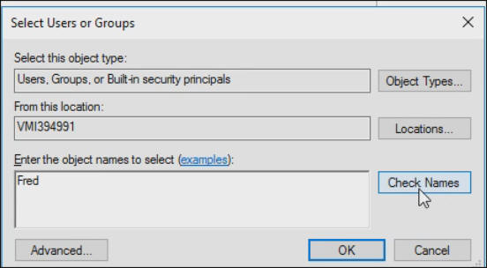
Press OK
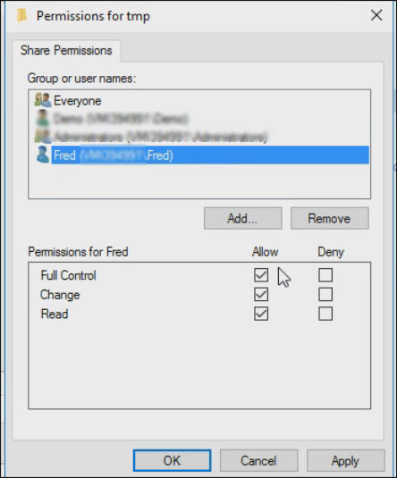
Check "Full control" so all three permissions are lit up.
Click OK

Firewall Rules
You need to enable some ports in Windows Server. Go to Control panel or search for Advanced Firewall.
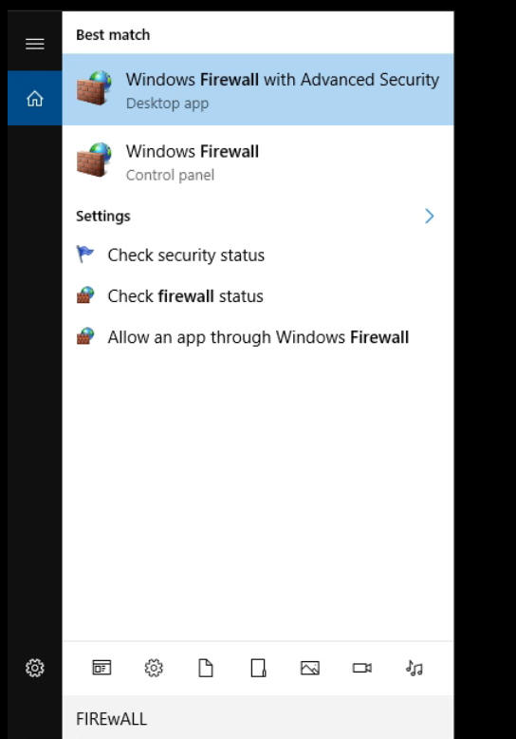
In the firewall screen, click Inbound Rules
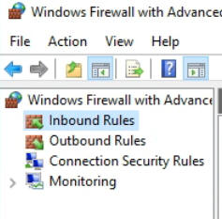

On the right side, click New Rule
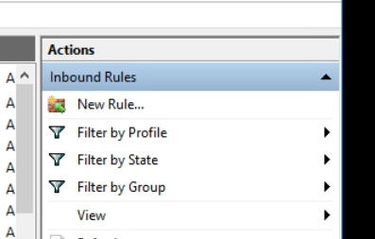
Give it a name such as "File Sharing TCP"
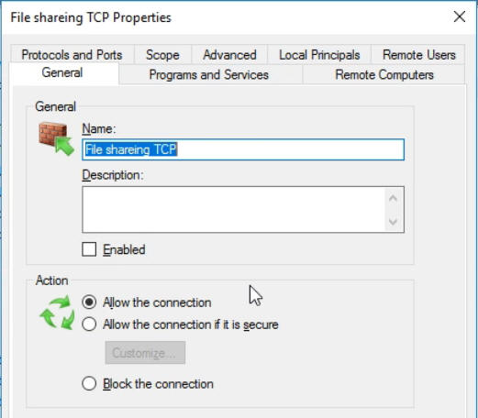
In Protocols and Ports Select TCP and add the following ports: 134-139, 445, 389, 88
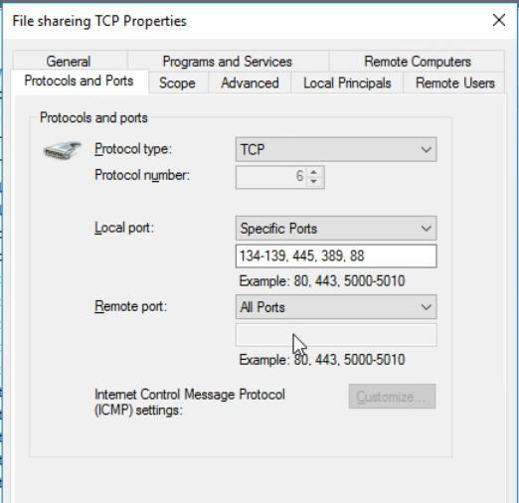
Repeat the above steps for a name such as "File Sharing UDP"
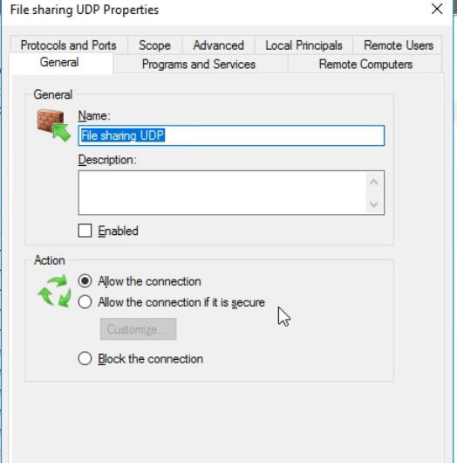
Repeat the step "Protocols and Ports" Select UDP and add the following ports:
134-139, 445, 389, 88
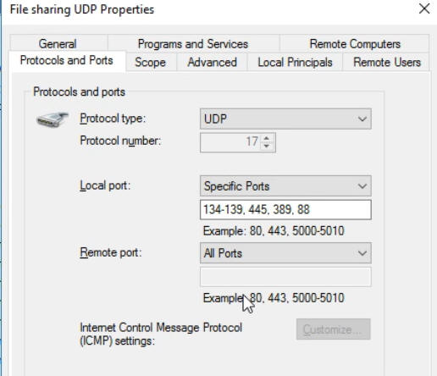
Click Apply

Sharing Files To And From Your Server
To connect, you can use the IP, DNS name, or Outworldz.net name. This is the same name you connect to Contabo in VNC or Remote Desktop,
Go to File Explorer in Windows at your Home PC. You can get there by pressing the Windows Logo key and the 'e' key at the same time.
Type two back slashes \\ in the address bar and then the name of your server:
You should get a password prompt:
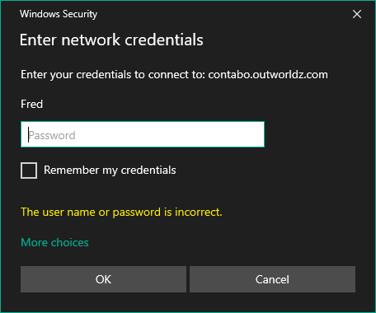
Enter your password and you should see the share name that you set up.
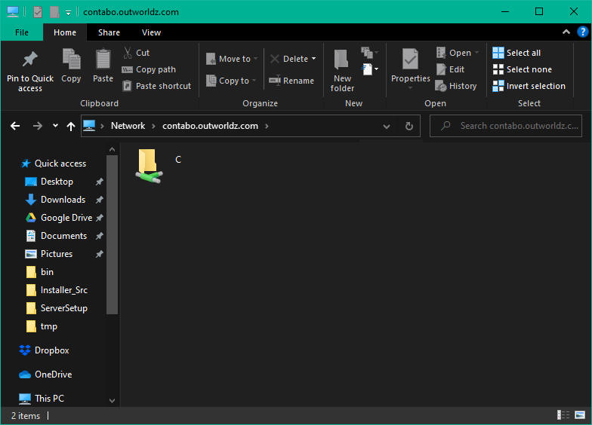
You can use this name and path as if it is local to your PC and drag and drop files to it. Or Copy and Paste.
You can also Map a drive letter to it.
Right click the folder and select "Map Network Drive"
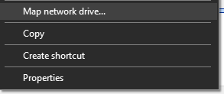
Choose a drive letter and click Apply
Now you can simply go to the drive letter and access your server.

Backups:
Now that your server is set up for file access, you can use programs such as robocopy (free, built into windows), and paid backup programs such as SyncBack to mov e or copy your grid to your home PC on a regular basis.
Example: I created map drive as X: to a folder on the server and added a batch file named Backup.bat.
I then ran this from the server as X:/backup.bat and it copied my Servers X:\tmp folder to my home PC C:\tmp folder.
You can now use robocopy to backup your entire grid, or the Backup folder with one simple command "X:/Backup" by changing the folder names in the batch file.
PS X:\> .\Backup.bat
X:\>robocopy X:\tmp c:\tmp /e
-------------------------------------------------------------------------------
ROBOCOPY :: Robust File Copy for Windows
-------------------------------------------------------------------------------
Started : Monday, October 19, 2020 11:38:27 PM
Source : X:\tmp\
Dest : c:\tmp\
Files : *.*
Options : *.* /S /E /DCOPY:DA /COPY:DAT /R:1000000 /W:30
------------------------------------------------------------------------------
0 X:\tmp\
New Dir 0 X:\tmp\A\
-----------------------------------------------------------------------------
Total Copied Skipped Mismatch FAILED Extras
Dirs : 2 1 1 0 0 1
Files : 0 0 0 0 0 8
Bytes : 0 0 0 0 0 27.63 m
Times : 0:00:00 0:00:00 0:00:00 0:00:00
Ended : Monday, October 19, 2020 11:38:28 PM
PS X:\>

Database Settings
Did MySQL crash? See section Crashes.
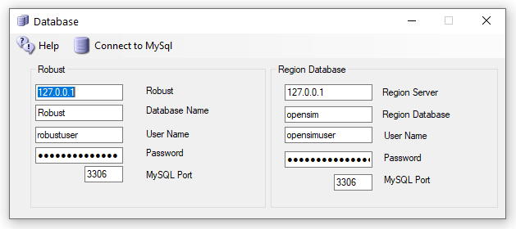
Do not change any of these settings without knowing what you are doing!
Any change here must match complicated hand-made changes in MySQL! See the bottom of this help section for more details.
There are two databases in DreamGrid: Robust is the login and inventory database. Each region also uses a separate Opensim database for storing what is in region.
Database root password is blank. This is safe as it only listens on localhost, which is your server.

Robust Database:
- Robust Server: should always be 127.0.0.1. This is the Server that runs Robust (itself). It can be the IP address of a different server running MySQL.
Default: 127.0.0.1
- Robust name: The name of the Robust database.
Default: robust
- User Name: The login name 'robustuser'@localhost'.
Default: robustuser
- Password: The password for Robust.
- Default: robustpassword
- MySQL Port: The TCP/IP port that both databases use.
Default = 3306. You can set this to 3307, 3308 or 3309 to not interfere with the Other MySQL’s that may be running.
- FSAssets: You can select the FSAssets button to set up a File System As Assets Database. This is recommended only for large grids, with hundreds of Gigabyte sized databases.

Local Region Database:
- DB name: The name of the region database.
default: opensim
- User Name: The login name 'opensimuser'@localhost'.
default: opensimuser
- Password: The password for opensim region database.
default = opensimpassword
- MySQL Port: The TCP/IP port that both databases use.
Default = 3309 to not interfere with the normal MySQL Port of 3306
If you want to alter the username and password to either database, you must use the MySQL.exe program in a DOS box.
cd Outworldzfiles\mysql\bin
mysql -u root
use opensim;
create user 'anewopensimuser'@'localhost' identified by 'opensimpassword';
grant all on opensim.* to 'anewopensimuser'@'localhost';
use robust;
create user 'anewrobustuser'@'localhost' identified by 'robustpassword';
grant all on robust.* to 'anewrobustuser'@'localhost';
quit;

Running MySQL as a Service
DreamGrid will detect any running MySQL using the same port. You can install MySQL as a Windows service. There is a batch file “InstallAsAService.bat” in MySQL\bin to set this up. MySQL will then start and stop safely with Windows. This batch file must be run once, as an Administrator. You type "CMD" in the search box, and then right click the Command Prompt and select "Run as Administrator".

Use that DOS box to run InstallAsAService.bat. Then type in 'Services.msc", and use it to start MySQL, or type in ‘net start MySQL’<enter>.
You can verify MySQL is running by typing 'mysql - u root<enter>'. If you get a MySQL prompt, it is running as a service. Then type quit; with the semicolon and enter.
You should also set the service to restart so MySQL restarts on any crash. Windows knows about services and will send signals to MySQL to shut itself off gracefully. The only danger is that power fails and you corrupt the database. If you are serious about running a grid, then a UPS is necessary.

MySQL Crashes:
Your MySQL database may be crashed. Here is a way to recover and start MYSQL manually.
Navigate to the Outworldzfiles\mysql\bin folder.
Then double-click "StartManually.bat”
Any error message it prints may be helpful. If the DOS window closes, a MySQL LOG file will be saved in OutworldzFiles\mysql\data as a *.err file. That may give you a clue as to what to do.

My database still did not start!
Try running Outworldzfiles\mysql\bin\Repair_ISAM.bat.
Then double-click "StartManually.bat”. The DOS window that appears should ‘stick’ open.
Run Task manager by typing Ctrl-Shift-ESC.
Look for mysqld.exe. Wait for the CPU usage to go to 0 on mysqld.exe. This may take a long time as MySQL is rebuilding the database. It could take an hour or more, depending upon the size and your disk and CPU speed.
Double click CheckandRepair.bat to run diagnostics.
If errors appear, answer any questions with a ‘Y’. This will take a long time as MySQL is repairing the database.
Once the Check and Repair is finished, double-click Mysql\bin\StopMySQL.bat’
The DOS box that first appeared should now close. Your database has been recovered and it is safe to start DreamGrid.
If you still have issues, delete the file MySQL\Data\ib_logfile0 and ib_logfile1. Do not delete ibdata1! Then repeat the above sequence.
If I had really deep issues with a database and it was unrecoverable, I would try the last copied one, then the SQL, then an OAR, and the very last thing I would try is an OAR/IAR restore. So far I have recovered at least a dozen databases for people. One developed a bad bit which took about a week to ftp, to develop a fix for and a simple query to repair.
Also have fixed a crashed "primitems" table that has reoccurred on one grid. You log in to MySQL with the command ‘mysql -u root’ and type in:
use opensim;
repair table primitems;
quit;
Please do not give up if your database will not start! Contact me at fred@outworldz.com and I will see what I can do. I have not yet lost a database.

Starting Over with a Blank Database
You can wipe ALL data out. If you do this, you must re-enter all accounts and recreate your system from OAR and IAR files. This WILL LOSE ALL DATA.
I recommend you make a backup of the MySQL\Data folder first.
I have not yet ‘lost’ a database, and I have seen dozens of them crash in oddball ways. Please contact me at fred@outworldz.com if you have questions or need more help in recovering a database. The largest was 70 Gigabytes which took four days just to get a copy sent to me. It was fixed in a few hours. The problem was to a single bad character in a UUID. So please do not delete it unless you really, really want to start over!
If you MUST wipe out the database and start over, delete the folder MySQL\data. Then extract the contents of the file Blank-Mysql-Data-folder.zip to make a new MySQL\Data folder.
This will make it start over at the very beginning. The database should start up now. You must go to Robust; type create user<enter>’ and re-enter your Avatar name and password. You can then re-enter your estate information in each DOS box for Each region.
You can restore the database if you have a .SQL backup. Or use OARs and IARs.

DEBUG
The Help=> Debug screen has debugging tools. The “True” radio button enables the function, and “False” disables the function. The function occurs when you press Apply is True is set
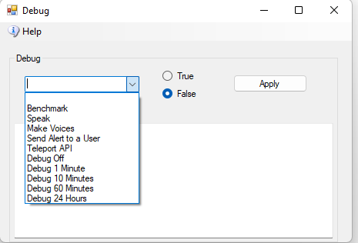
Teleport API – Prompts for an Avatar name, locates the person, and send them to a region. Part of Smart Boot debugging effort.
Debug (off, 1 Minute …..) – The system prints debug stats on each region every hour. You can speed this up or slow it down. Requires a region restart. The new setting is saved and is sticky across reboots. Use it to get rapid glances at Opensim region performance.
Debug LandMaker – Requires that the Smart Boot and Endless land and sea be enabled. Creates multiple avatars that go to and from regions to create a large area of auto generated land. USE WITH CAUTION, for debug only!

Diva Web Control Panel
The Management Web page is at http://127.0.0.1:8002 if the checkbox is enabled and Robust is running.
For other users, it will be http://YourDomainName:8002, where YourDomainName is your Public, Internet-facing IP or DNS name.
The features of Wifi are:
- Account creation, optionally controlled by the Wifi Admin Account
- Configurable default avatars for new accounts
- Account updates by both users and administrator
- Account deletion by administrator
- Password recovery via email
- Simple user inventory management
You can change many of the parameters of Wifi in this panel:
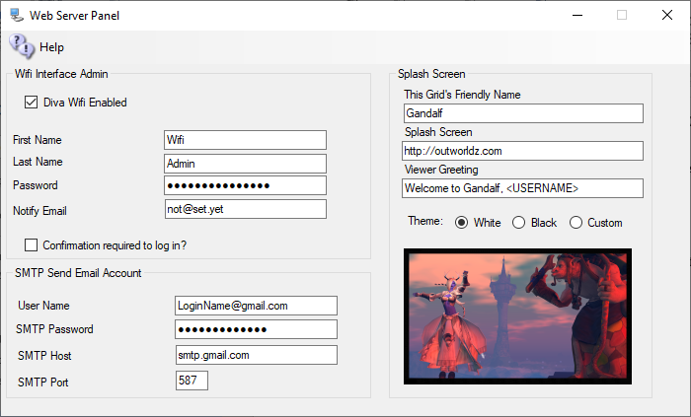
There are three sections that can be modified:
- Wifi Interface Admin: A super-user that administers the system. This can be you. It comes with Wifi Admin as a default login.
- Splash Screen: Things that affect the page that shows in the viewer window.
- SMTP Email: Settings to send email for things such as password changes and confirmation off emails.
The system automatically makes several accounts the first time. One of these is "Wifi Admin'. This user has special rights in the web panel. It can administer all other accounts, change passwords, enable and disable, or delete and approve them.
A random password is created at startup. You may change it. As the Hypergrid exposes this login page to the Internet, please choose a strong password.
You must already have a user with levels set to 100 or higher to change the name from Wifi Admin. You can add another user and set it to that elevated level too.

Wifi Admin
There are three Opensim users made at startup. One is for the grid to use. GRID MANAGER is the main user If you mess with it your grid will die. It does things that require a User account to do, such as send a user an IM.
Wifi Admin is used to control users and run the Web page. It can rename, delete, stop, or allow a user on the grid by the web page. The robust console can do all this, but it is arcane and easier to use the web page.
Wifi Admin is created with a random password. Go to settings->Web Page and click the password field. It will show it to you. You can change this passwort by typing in a new name when Robust is running.
Go to Help-Web Page and it will open your grid Wifi Panel. It is also at http://localhost:8002.
Log in as Wifi Admin using that password. and you will see a Manage Accounts section.
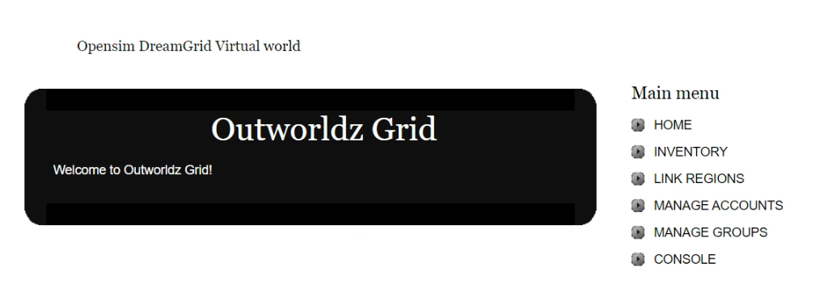

Go to it, press a space bar in search, and it will show you the three users.
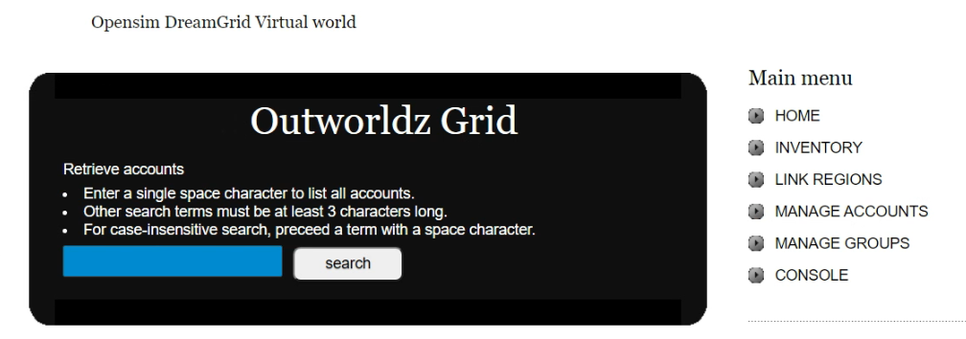

User Levels:
If you any users the level to -1, they cannot log in.
Level 0, they can log in.
Level 100 is a Wifi Admin.
Level 200 allows them to be a god if Allow User Gods switch is enabled in Setup->Settings->Permissions

Confirmation Required to Log In:
Wifi Admin can create new accounts in two manners: uncontrolled and controlled. If you choose to have controlled account creation, every time someone creates an account, the Wifi Admin account will receive an email notifying of such an event (make sure you have the Wifi Admin’s email address properly set).
You should then login to Wifi as administrator and choose USER MANAGEMENT. You are presented with a list of all pending accounts, which you can then approve or ignore.
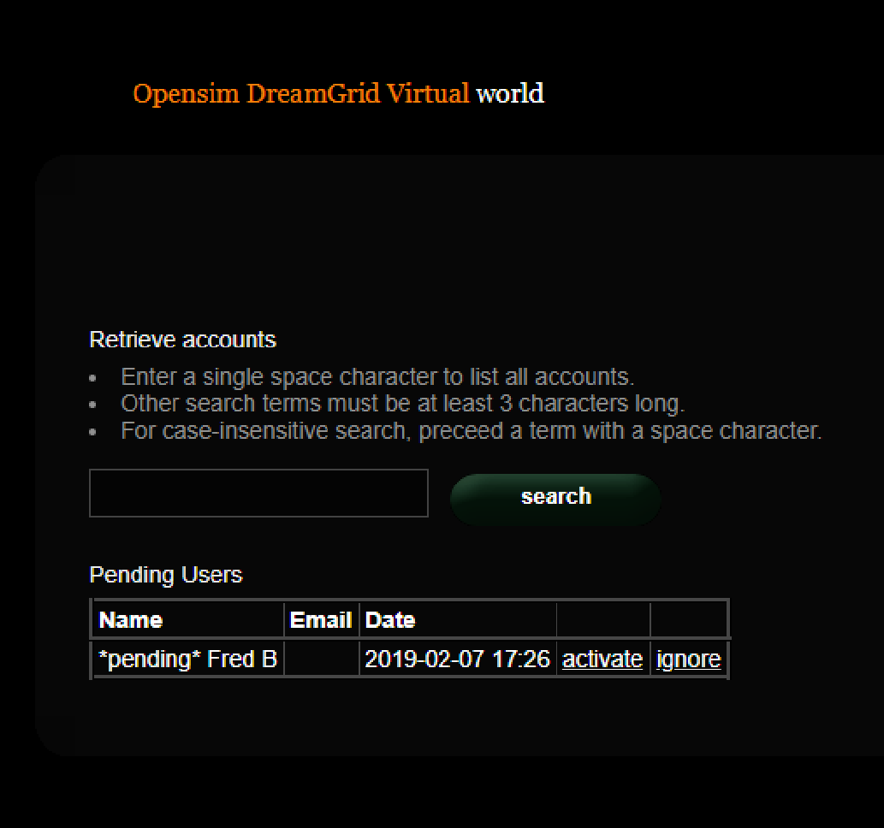
If you choose to have uncontrolled account creation, then anyone can create an account in your world without going through your approval.

SMTP Email
You may optionally set up Simple Mail Transport Protocol to send email for events such as password changes.
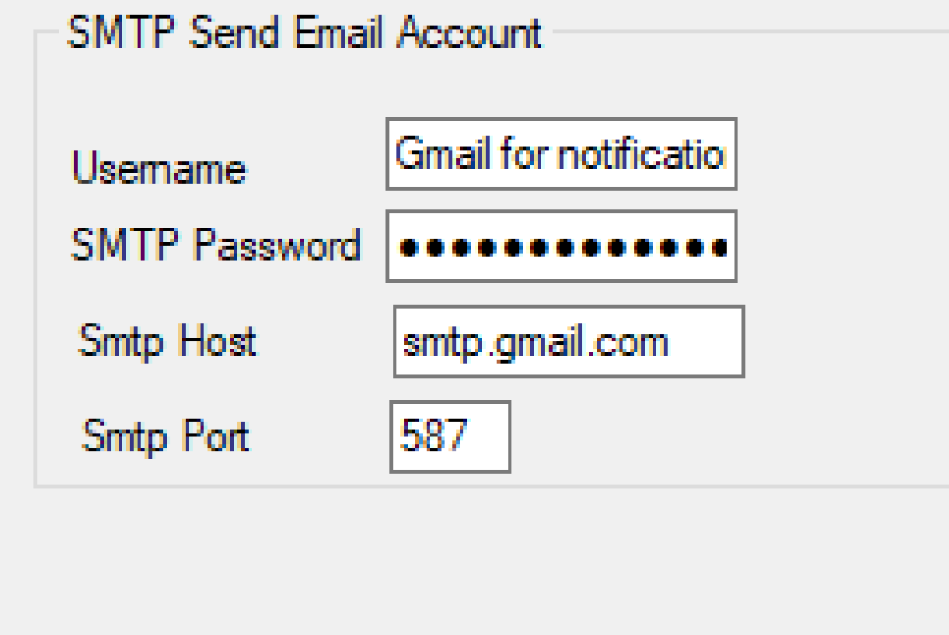
If you use Gmail for SMTP, you will need to enable Less-Secure mail settings at Gmail in your account.
You can find information about this at https://support.google.com/accounts/answer/6010255

Theme
There are three theme colors, Black on White, White on Black, and Custom. The default theme is Black, or the selected theme will be set by DreamGrid into the real WifiPages folder on startup.
Custom starts out as the White theme. You can modify this theme according to instructions down below.
Click the photo to change it for the theme.

Viewer Splash Screen URL:
The Splash screen URL appears on the login screen as a web page. You can use any web page. If you change this URL, you must delete the grid setting in your viewer, and re-add it to get it updated.
If you change this, you must delete and re-add the grid to the viewer.
The Splash Screen URL is shown below.
Set this to http://(URL of your grid):8002 so they can see the Login Page. It can be any web page.

Greeting
This message appears when a person logs in.

Friendly Name
The friendly name appears on the login screen at the top. It is broadcast to viewers as the grid name in the grid Selector Pulldown. If you change this, you must delete and re-add the grid to the viewer.

Default Avatars:

A “Wifi.ini” file lets you select one of three default appearances for a newly created avatar. In a new environment you must set those avatars up first.
Create the avatars with names “Female Avatar”, Male Avatar”, “Neutral Avatar”. and authorize them via the Wifi Admin.
Login as each avatar in turn. They will usually appear as a cloud initially and then after a short while rez to appear as “Ruth” wearing four basic body parts, new pants, and new shirt. These parts come directly from the Opensim Library and MUST NOT be worn in your final appearance for the default avatars. You can COPY these library parts into the avatar’s inventory if you wish, or create new body parts and clothing, but before you finish you should remove any items that show as “worn” in the Opensim Library as those will not rez on avatars based on these models.
Create new body parts and clothing and edit them and/or add any other mesh, clothing, attachments, or HUDs you wish to appear on the avatars.
You can extend (or change the avatars names or labels) for the default appearances and/or change the preselected default by altering Wifi.ini.
;;Syntax: AvatarAccount_<AvatarType> = "<FirstName> <LastName>"
;;(replace spaces in <AvatarType> with underscore)
AvatarAccount_Female="Female Avatar"
AvatarAccount_Male="Male Avatar"
AvatarAccount_Neutral="Neutral Avatar"
;; Preselection for default avatar in new account registration
AvatarPreselection="Neutral"
5. When you create a new avatar via the Wifi web interface based on these predefined avatars the items worn will appear in the newly created avatar’s inventory under Clothes -> Default Avatar <AvatarType>.

Customizing your theme
You can change the theme with this switch to one of several sets of folders, White, Black, or Custom.
White theme consists of two folders:
- Outworldzfiles\Opensim\WifiPages-White
- Outworldzfiles\Opensim\bin\WifiPages-White
Black theme consists of two folders:
- Outworldzfiles\Opensim\WifiPages-Black
- Outworldzfiles\Opensim\bin\WifiPages-Black
If you want to make modifications, please use a custom theme. Otherwise, your changes to the -Black, -White or WifiPages folders will be over-written in an update.
First copy both the two Black, or the two White folders to the WifiPages-Custom folder next to them. Each set of files goes in these places:
- Opensim/WifiPages-Custom
- Opensim/bin/WifiPages-Custom
The updater will never overwrite these custom pages. If you make changes to the custom pages, they will be set into the Wifi page on startup.
Click the photo to change it for the theme.

Changing the HTML
Diva Canto uses some advanced, Opensim-specific code in her Diva pages.
The site starts from Opensim\bin\WifiPages\index.html.
#includes There are several include directives that bring in the rest of the web site. Diva uses a series of <!--#include file=header.html --> statements to bring in files from the other folder set in Opensim\WifiPages. Includes in those files then bring in increasingly of the web pages from Opensim\Bin\Wifipages.
#get There are several statements that are replaced by server data:
Users in World: <!-- #get var=UsersInworld -->
Regions: <!-- #get var=RegionsTotal -->
Total Users: <!-- #get var=UsersTotal -->
Active Users last <!-- #get var=UsersActivePeriod --> days
Active Users: <!-- #get var=UsersActive -->

Hypergrid and Domain Name Setup
Hypergrid requires a DNS name or a Public IP. You can register and use your own domain, or use your routers public IP, or use the Outworldz system’s’ free Dynamic DNS system (DYN DNS).
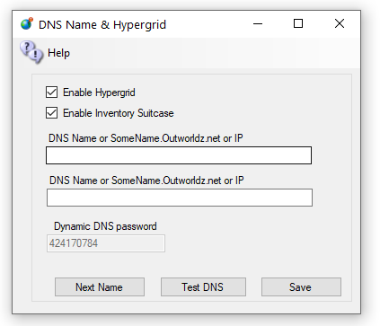
DNS name: For a Free Dynamic DNS name, use the format "somename.outworldz.net" or “Somename.inworldz.net”. You can a;so just make up a name, so choose a name and add ".outworldz.net" or “.inworldz.net”. For domain names, the letters, numbers a-z, digits 0-9 and a dash (-) are the only allowed characters.
You may add an alternate name to be registered in the dynamic DNS system. This is typically used for the WWW function in Apache’s web server.
Do not add anything else other than a name, periods ‘.’ and either ‘inworldz.net’, or ‘.outworldz.net’.
IP addresses may be used.
If blank, the PC's LAN address will be used. Hypergrid will not be available, but other LAN PC's will be able to connect. This is ideal for schools and other types of private work grids.

Running on the LAN only
When there is no network connection, such as when travelling, use localhost, or 127.0.0.1. These allow only the viewer on the server to connect.
DynDNS Password: This is a random number that may be used to keep your DNS Name from being used by others. It is first come, first served. Your password must be copied from one installation to another to use the same DYN DNS name. If you need help with this, or wish to delete your DNS name, please email me at fred@outworldz.net.
Enable Hypergrid: If unchecked, the Hypergrid will not be available. The grid will be only a Private Grid, with access possible only by logging into the grid directly.
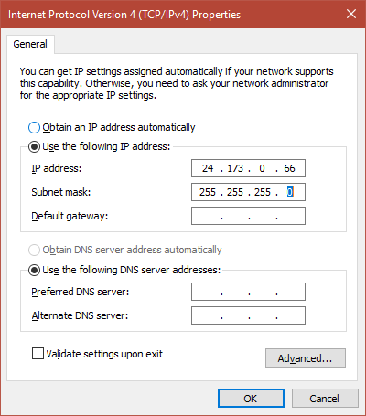
Enable My Suitcase: If checked, Hypergrid travel uses a viewer suitcase. The purpose of the Suitcase is to prevent a foreign "rogue" grid from stealing your inventory while you are visiting. However, any items in your suitcase are exposed to other grids. you can only rez or give items in other grids that are already in your suitcase.
The My Suitcase folder is special: it is the folder tree that receives objects you collect while you are visiting other grids. But now it is even more special: it is the only folder tree that is accessible to you (and therefore to the rest of the Internet) while you are traveling. Period.
If you disable the suitcase by unchecking this box, as OsGrid does, you will be able to rez and give items while on other grids from anywhere in your inventory. Items you take or are given will still end up in your suitcase.
Next Name: to use the free Outworldz Dynamic DNS, click "Next Name" to get a name. The Dreamgrid Dynamic DNS system will automatically register your PC's ever-changing IP address and keep your sim running.
Test DNS: Will register the DNS name and check that it is resolvable. The result should be the Public IP address of your router.

Troubleshooting Network:
1) Go back to running locally. Set the DNS name or IP to 127.0.0.1 and press Save.
Start the grid up.
2) Now that the grid is running, use http://www.canyouseeme.org on port 8002 to verify your router has ports forwarded. if not, work on the router/firewalls so you can see the Opensim Robust service on 8002.
3) Try to get to that same IP address plus :8002 in a web browser from the server. My IP was 24.173.0.66, so I would try http://24.173.0.66:8002
If you get no web page, your router does not support loopback.
4)Add the Windows Device driver for loopback. Use the exact same IP address that http://www.canyouseeme.org reported. This is what mine looks like

1. Click Start, then type cmd in the search box.
2. In the command prompt, type hdwwiz.exe and press Enter.
3. Click Next.
4. Select Install the hardware that I manually select from a list (Advanced), then click Next.
5. Select Network adapters, then click Next.
6. Select Microsoft as the manufacturer, select Microsoft KM-TEST Loopback Adapter as the adapter for Windows10 , then click Next.
7. Select Next to confirm the installation.
9. Select Finish to complete the installation.
To configure the newly created adapter:
1. Click Start > Control Panel > Network Connections.
2,. Select the newly created connection (named Local Area Connection #, where # is its order number).
4. Right-click on the selected connection and choose Properties from the menu.
4. Confirm that Microsoft Loopback Adapter or Microsoft Loopback Adapter # is displayed in the Connect Using: field.
5. If it is not, return to step 2 and retry properties for another adapter.
7. Select Internet Protocol IPV4 and click Properties to open Internet Protocol (TCP/IP) Properties.
8. Select Use the following IP address. Fill in the IP address and Subnet mask fields.
Example: 10.10.10.10, 255.255.255.0 <=====But use the IP address shown by http://www.canyouseeme.org
9. Click OK to close the Internet Protocol (TCP/IP) Properties.
10. Click OK to close the connection properties.
11. Right click the Microsoft Driver and rename it to just "Loopback". DreamGrid will automatically update the driver if your Public IP changes.
12. You should be able to reach your grid at the IP Address:8002 now. If so, you can now go back to the Hypergrid Setting and choose a DNS name.

links:
http://www.canyouseeme.org

Easy Free Database
The Easy Free Database is an LSL-scripted database to save and fetch persistent variables in Second Life and OpenSim scripts.

Usage
http://outworldz.appspot.com/store?service=<service uuid>&keyfield=<variable name>&datafield=<data to be stored>
Example: http://outworldz.appspot.com/store?service=2b307c02-2133-4dba-bcc5-3d8f7db53eee&keyfield=AnimalName&datafield=bunny
service uuid: unique identifier for your application. You can use a different one for each script or share the same identifier across several scripts in order to share data. To generate a random uuid: http://outworldz.appspot.com/rand
keyfield: variable name or other identifier for your data
datafield: data that you want to be stored.

Response
This will return string OK as the body if successful. You can get your data back by loading:
http://outworldz.appspot.com/load?service=<service uuid>&keyfield=<variable name>
Sample LSL script:
// src: https://www.hypergridbusiness.com/2012/12/free-database-for-opensim-scripts/
// Change this to a UUID from http://outworldz.appspot.com/rand
//
string serviceid = "b1e5e346-b831-47fa-9930-11223456778";
default
{
touch_start(integer counter)
{
string URL = "http://outworldz.appspot.com/load?service=" + serviceid + "&keyfield=colors";
key httpkey=llHTTPRequest(URL, [] ,"");
}
http_response(key id, integer status, list meta, string body)
{
list colors = llParseString2List(body,[","],[" "]);
llSetColor(<llList2Float(colors,0), llList2Float(colors,1), llList2Float(colors,2)>,ALL_SIDES);
}
}
FIREWALL
DreamGrid Automatically adds rules to the Windows firewall for Robust, Opensim, Icecast, and Apache. There is no need to adjust these rules.
If you accidently denied the firewall rule request, you will have to locate the NO symbol in the firewall and delete it.
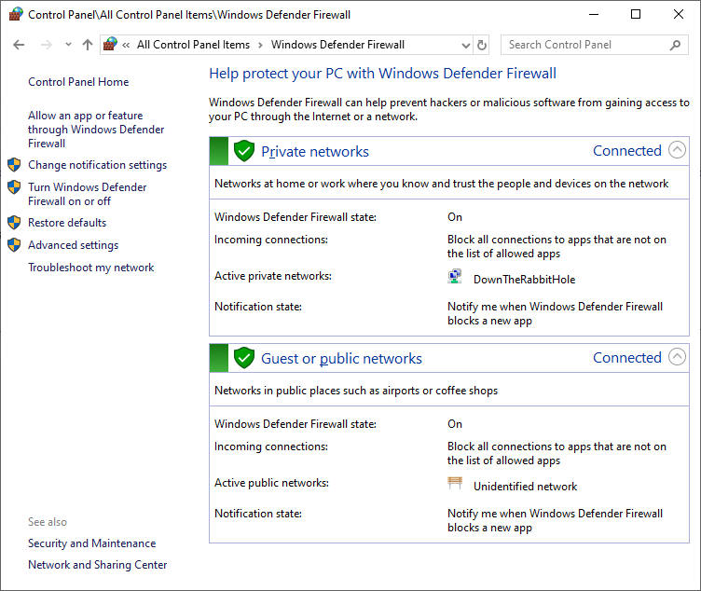
You may want to block certain IP addresses from accessing your system. This manual shows how. The Banlist Manual shows how to do it with DreamGrid.
The Windows firewall is automatically opened for TCP and UDP for any ports that DreamGrid needs. It closes those ports if you reduce the number of regions and increases the open port count if you add regions. This also works on Icecast and Apache.
You can use the Windows firewall to block specific IP addresses and ranges of Ip addresses.
Open the windows firewall and click Advanced Settings on the upper left side.

Advanced settings screen:\

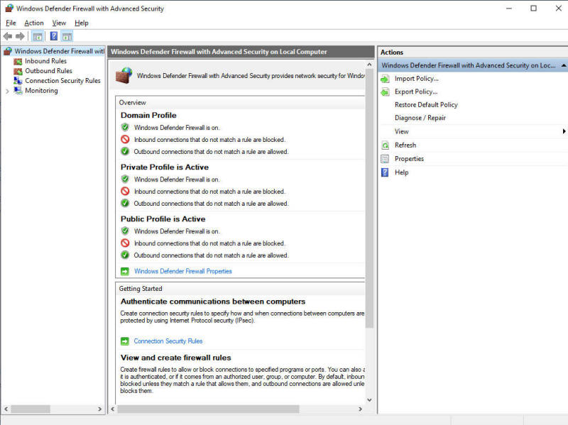
Right click Inbound Rules and select New Rule:
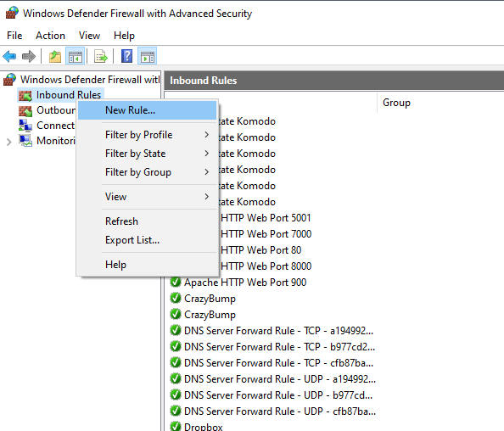

Select Custom Rule
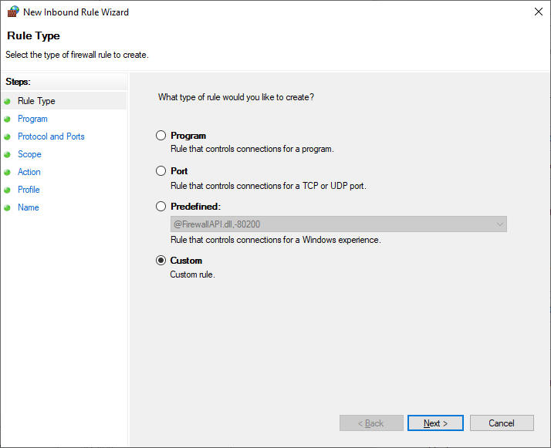
Select All programs:
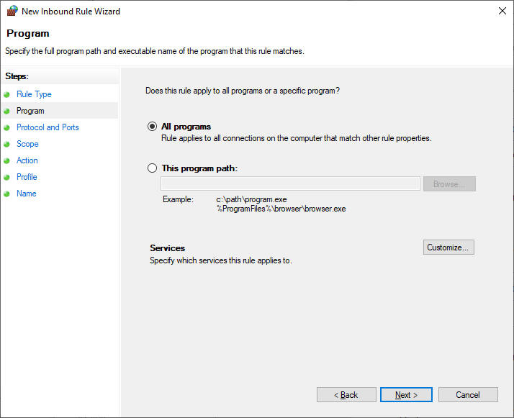

nter the port for your grid login. Yours is likely to be 8002. TCP is used to log in, so we will block it.
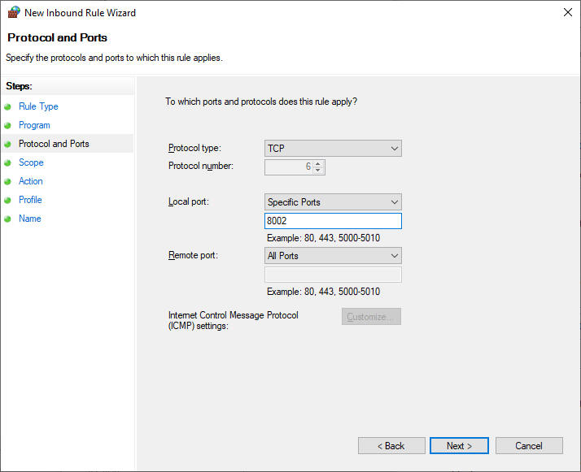

Select Which Remote IP does this rule belong to and click These IP addresses and click Add
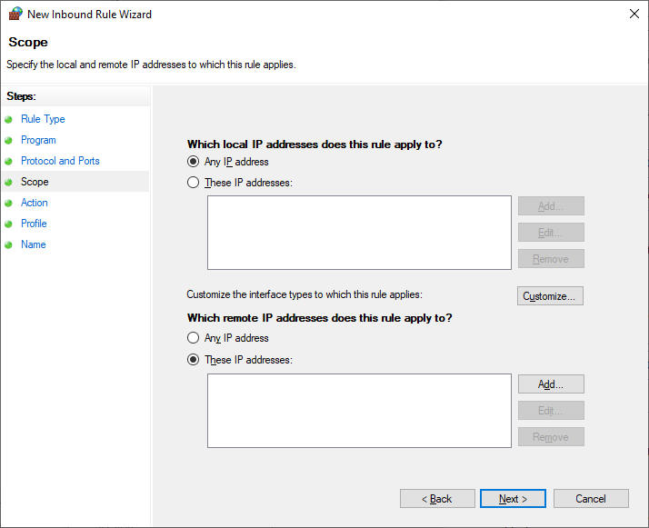
ter the IP or range of IP's.
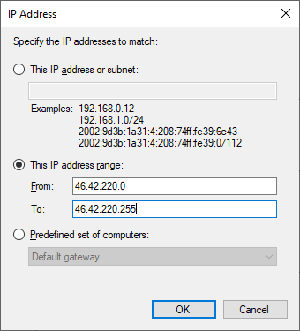
Click OK
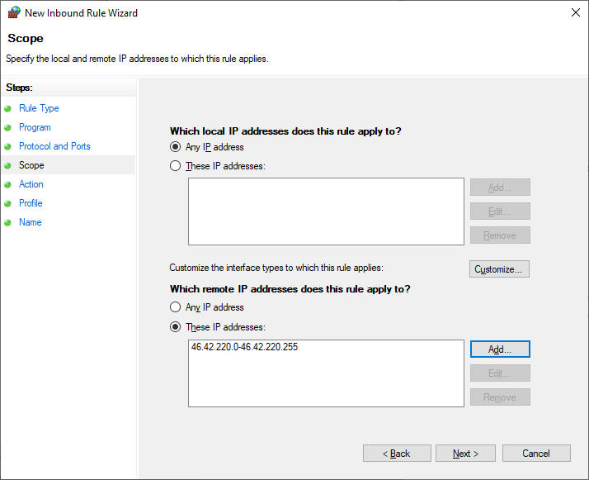
Click Next
Click "Block this connection"
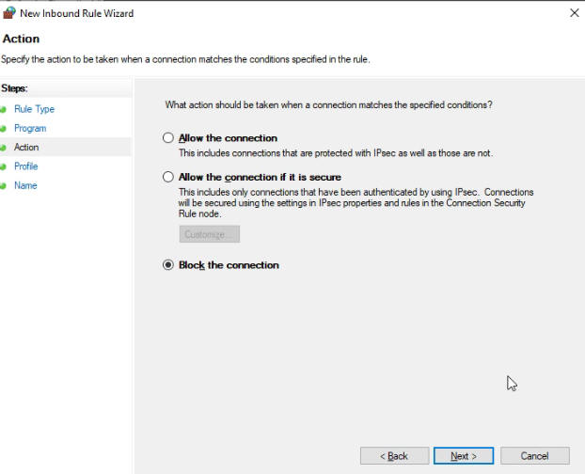
Which firewalls? Do all of them. These are for machines that may travel to public places such as a McDonalds. Your grid should be set for Private. In corporate environments, it would be Domain.
Is safe to just do them all.
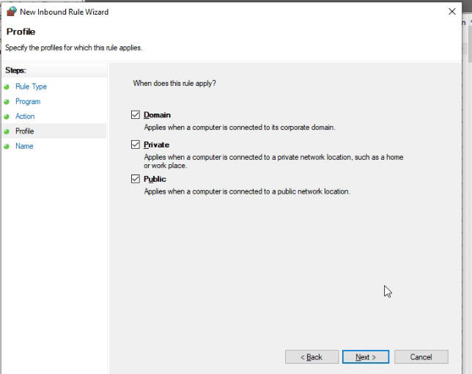
Enter a descriptive name.
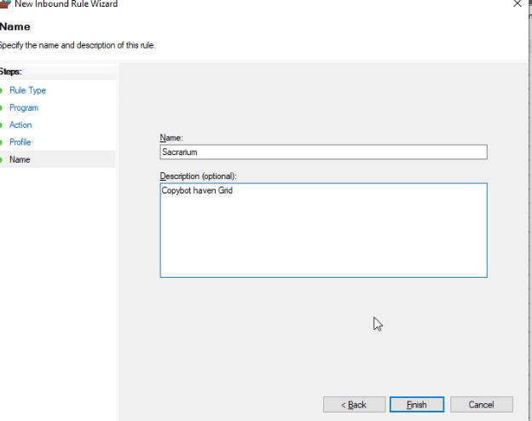
Click Finish.
Flotsam Cache Settings
OpenSimulator has an asset cache that stores the assets retrieved from an asset service. This reduces the load on a asset service and improves OpenSimulator responsiveness.
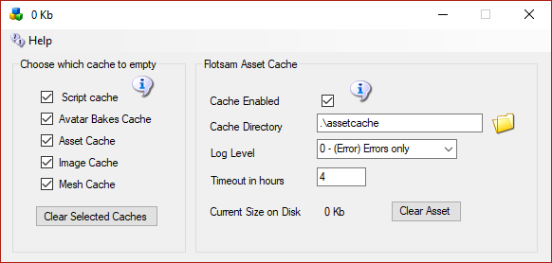

Flotsam asset cache
The Flotsam asset cache, stores assets on disk and in memory.
At the moment, the amount of memory or filesystem storage used by the cache can only be limited via manual actions (wiping all or part of cached assets from the filesystem), by console commands (e.g. "fcache clear") or by timeout settings (e.g. FileCacheTimeout = 1 to automatically remove cache files not accessed for 1 hours).

General principles
When OpenSimulator requires an asset (e.g., in response to a viewer request for a notecard), then it first asks the cache for this data. If the data is not found in the cache, then it asks the grid asset service (or a foreign asset service in the case of Hypergrid). If the asset is there, then it is both stored in the cache and returned to the user.
If an asset is uploaded to OpenSimulator (e.g., by the viewer uploading an animation), then the asset is at once both kept in cache (if there is room and the asset is not temporary) and sent to the asset service (if the asset is not temporary).
Therefore, at any point you can wipe any temporary data stored by the asset cache (e.g., on the filesystem), since the next request for that asset will simply query the asset service as the asset will not be found in cache.

FSAssets Settings
FSAssets is enabled by default. This option will save the assets to the file system as opposed to the default service which stores assets as blobs in the database. This option also provides deduplication abilities. Each asset is hashed when it is received for storage. If the asset already exists, the asset service will link to the existing file rather than store two copies.
IMPORTANT: This is a major change in database structure. If you already have a MySQL database running with a lot of assets, this will help speed it up, but it will take more disk space. If you start out with this setting, it will use the least space. Once you switch to FSAssets, you cannot go back to just MySQL without losing data entered since the switchover!
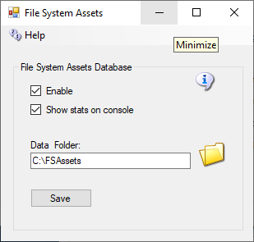

Data Folder
This is the folder in which the asset data will be saved. Default = ./fsassets/data

SpoolDirectory Folder
The spool directory is a folder used for temporary storage while the asset is hashed and compressed before it gets moved to the BaseDirectory. This must be on the same file system as the base directory. Default = ./fsassets/tmp

Migration
FSAssets will use the MySQL database to collect the original data. This will not automatically convert all the old assets to the new service. To convert all assets from the default service there is a Robust console command provided:
import <conn> <table> [<start> <count>]
The import command expects a database connection string and the name of the legacy asset table to be passed as parameters. The following example shows how to start the import process for a MySQL database. Change the connection details to match your database schema, username and password, or use the DreamGrid default shown here, and copy and paste this into your Robust console:
import "Data Source=localhost;Port=3306;Database=robust;User ID=robustuser;Password=robustpassword;Old Guids=true;Command Timeout=300;" assets
Depending on the size of your existing assets table, the import process will take some time to complete. The optional parameters start and count allow you to specify the position and number of rows to convert.
A default, blank database will look like this:
R.O.B.U.S.T.# import "Data Source=localhost;Port=3306;Database=robust;User ID=robustuser;Password=robustpassword;Old Guids=true;Command Timeout=300;" assets
Reading data
0 assets imported so far
100 assets imported so far
200 assets imported so far
Import done, 274 assets imported
R.O.B.U.S.T.#

Grid Type
Grid Type lets you choose from either a Grid Server with Robust, or from 3 Region Server choices to connect to another grid.
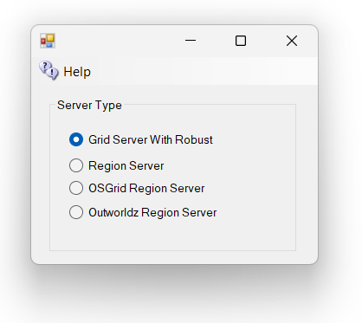

Grid Server with Robust
Grid Server with Robust is a complete DreamGrid, with your own inventory, logins, and name. This is the default. When you start your grid, a Robust Box will open to control all your users’ inventory.
One server must have a running copy of Robust. More PC's can connect to the Robust server to add more regions. These are called Region Servers

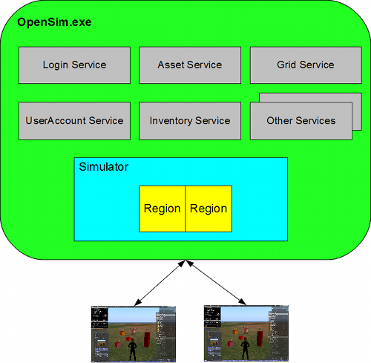
http://opensimulator.org/wiki/Configuration

Region Server
Region Server is an add-on to an existing DreamGrid, or OsGrid. You can connect additional regions on one or more PC's to an existing Grid Server. You must have access to port 8003 on the Robust server to do this.
Region Servers can connect to another DreamGrid, provided it can reach the DreamGrid’s Port 8003. You connect to the DreamGrid server by changing the DNS name on the Region Server to the same name as the grid. For example, my grid is normally named ‘outworldz.com:9000’. So I change the DNS name in my Region server, no matter where it is located, to outworldz.com, and change the HTTP port to 9000 and the robust port to what the grid runs on (which happens to be 9003).
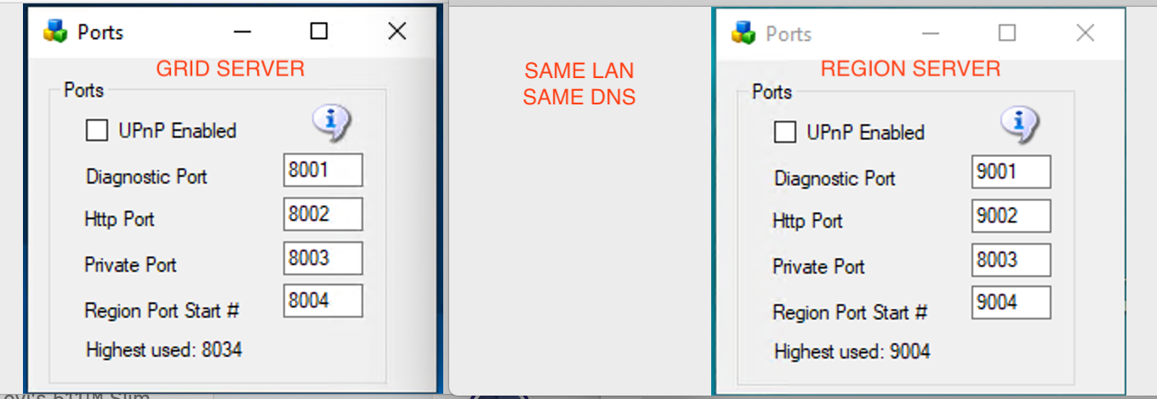
pic courtesy of Michael Bradley
The firewall must also be opened between the two machines. This is not normally an issue on a LAN. But if the region Server(s) are on the Internet, you should not allow access to the port 8003 from everyone unless you want others to connect to your grid with their own regions. Set up a firewall rule to allow only the Region Servers to access your servers port 8003.
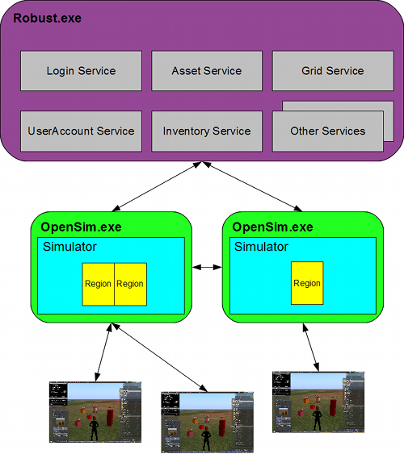
http://opensimulator.org/wiki/Configuration

OSGrid Server
OsGrid Server This choice is running a Region server connect to OsGrid. OsGrid is already configured to accept your connections. There are some simple rules you must follow to connect to OsGrid.
You will need to choose an empty spot on OsGrid's map for each region.
Your viewer login must be set to hg.osgrid.org.

Outworldz.Com Server
Outworldz.com Region Server This choice is also much like running a Region server. These servers connect to outworldz.com. Outworldz Settings are already configured to accept your connections.

Outworldz Shoutcast And Icecast Server
Outworldz DreamGrid contains a free Icecast and Shoutcast server. You can use this to broadcast voice and music to any radio, web page, Opensim, Second Life, or your own grid.
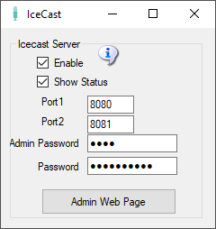
- Enable: Starts an Icecast Server when Start is clicked.
- Show Status: Displays in the window the server’s status
- Port1 & Port 2: Default is 8080 and 8081. Both ports must be Port Forwarded in your router from the Internet so users can hear the music.
- Admin Password: Enter a strong password for control of your Shoutcast server. This Password protects a web page, so choose a good one.
- Password: This password is used to stream music to your server. You give it and the stream mount point out to applications and musicians who can stream music using your server.
- Admin Web Page: Click this button when Icecast is running to get to the control panel web page.

Troubleshooting:
The latest "default" for ports for NEW installs is 8100 and 8101.
Check in Setup->Icecast which port is set. Check that Icecast is enabled. There is an Icecast DOS box that appears when it is running. You can restart it by clicking the Icon or Menu bar at top of DreamGrid.
Check that you can reach the Icecast server at http://127.0.0.1:8080. If not, check Icecast error.log and access.log.
This is normal error.log:
[2019-08-20 11:13:33] INFO main/main. C Icecast 2.4.3 server started
[2019-08-20 11:13:33] INFO yp/yp.c YP update thread started
[2019-08-20 11:13:33] INFO connection/connection.c No SSL capability on any configured ports
Check the port with http://CanyouSeeme.org to see that it is open. If not, make sure both ports are port forward for TCP and UDP.
Add an exclusion for both ports to your firewall. Keep trying this until you get it to answer to http://127.0.0.1:8100. At that point Winamp should connect.

How to Broadcast Music:
To streaming your own radio, you need a program to play music and send it to your stream.
I use Winamp. You can also use Mixxx, or any third-party streamer. Instructions for both follow.

WINAMP
You can use many different music or microphone players to stream music to your system. These instructions are for the popular Winamp player.
First, download and install Winamp.
Then download and install the Shoutcast DSP
Run Winamp. You should see a screen like this:
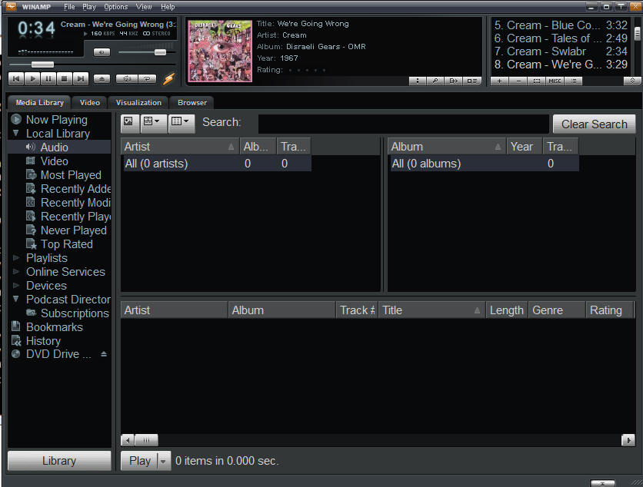
Navigate to the Options -> Preferences screen
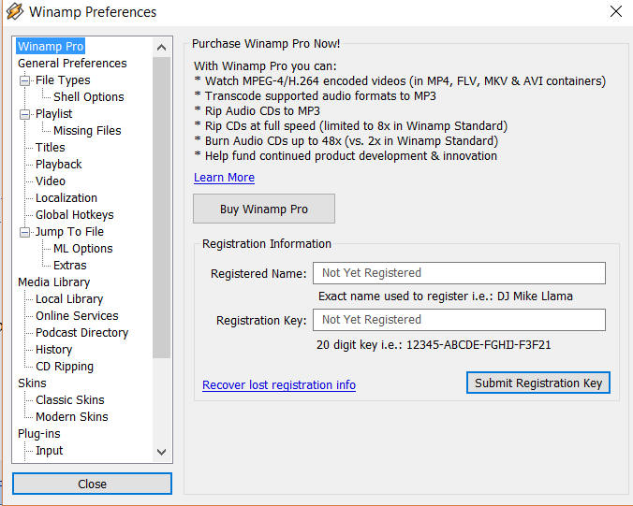
Scroll to the DSP/Effect section on the left side:
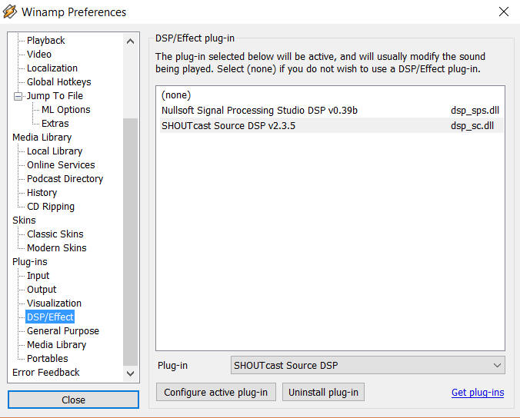
Double click the Shoutcast DSP on the right side to get the DSP setup screen.
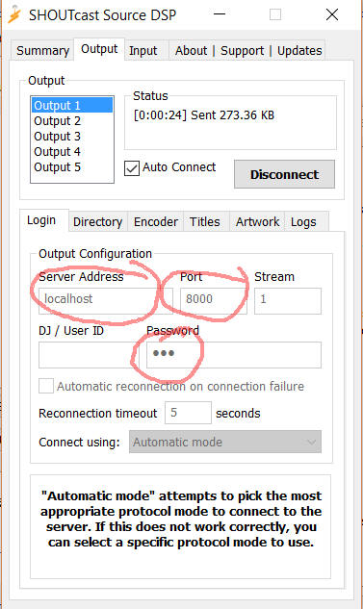

Server Address: Enter 'localhost' for the Server Address. If you wish to run Winamp on a different machine, use the Server LAN address.

Password: Choose the same password as you used in the Dream grid’s password field (not the Admin password).

Port: Also enter the same port you used in the DreamGrid setup screen. The default is 8000. If you want others to hear this stream from outside your network, remember to either forward the port or enable the UPNP setting and restart your server.
You can configure more of the screens, but they are not required.
Click [Auto Connect] and make certain you see it connect to your Shoutcast server.
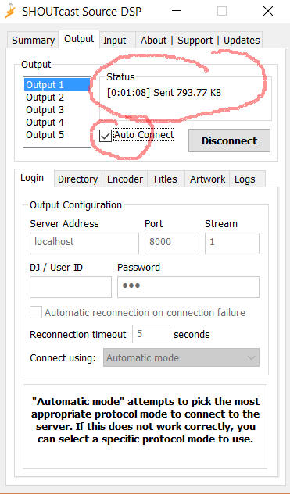

Shoutcast Control Panel

Click the Shoutcast [Control, View and Listen] Button to view your Shoutcast web page.
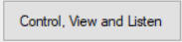
It should open a web page that looks like this when there is no stream playing.
Go find some music in Winamp and press "Play".
The screen should now change to show it is up.

Setting up the in-world radio
You can use any radio script to set your radio onto the land. A straightforward way is to navigate to the About Land tab and enter the URL into the Sound Tab. For more information see http://wiki.phoenixviewer.com/land_audio_tab
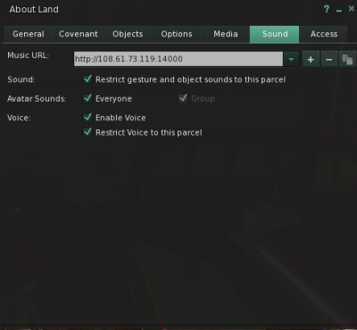
Now enable the media to play in your viewers Sound & Media tab.
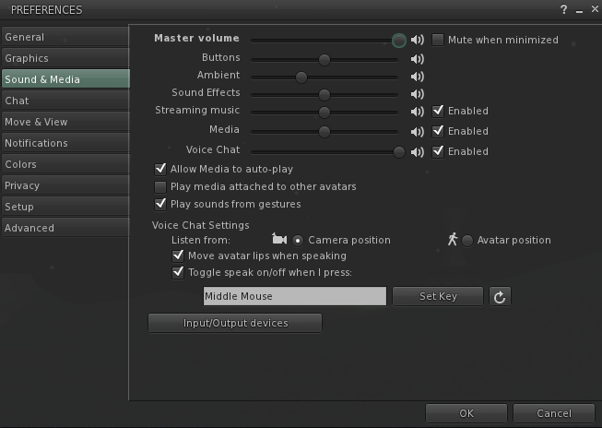
For more details, please see http://wiki.phoenixviewer.com/land_audio_tab

MIXXX
Download and install Mixxx from https://www.mixxx.org/. This is what the screen looks like.
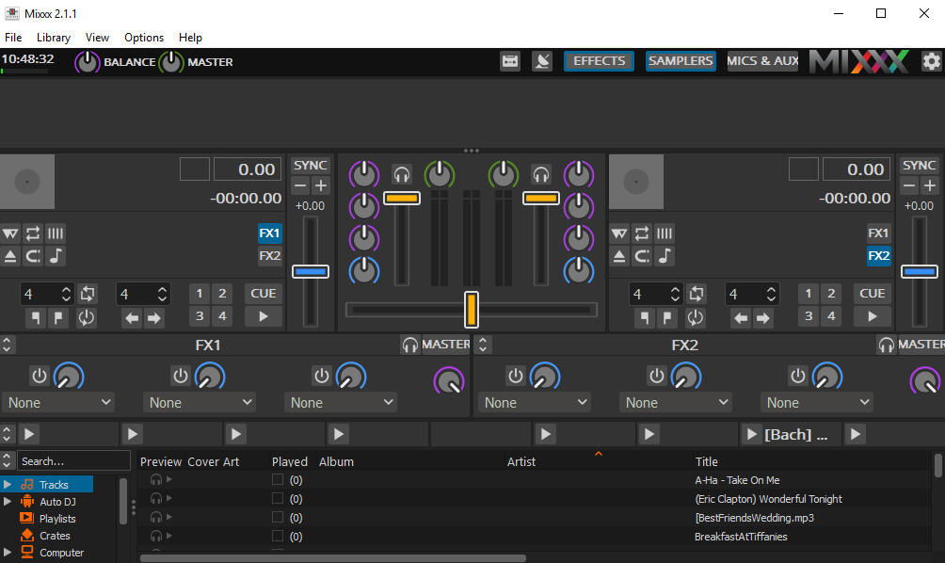

Special instructions for MP3 files:
To enable MP3 streaming on Windows, you must follow these instructions:
First, download the lame library from http://www.rarewares.org. The download page includes 32-bit and 64-bit versions. Make sure the version you download matches the version of Mixxx that you use, not the version of Windows. If you are on 64-bit Windows but are using 32bit Mixxx, you need the 32bit (“x86”) version of the library. Unpack the downloaded ZIP archive.
Copy libmp3lame.dll to the location you have installed Mixxx, probably C:\Program Files\Mixxx\.

Running Mixxx
Go to Mixxx's Preferences Screen, then select the "Live Broadcasting" tab on the left. These are the settings I used:
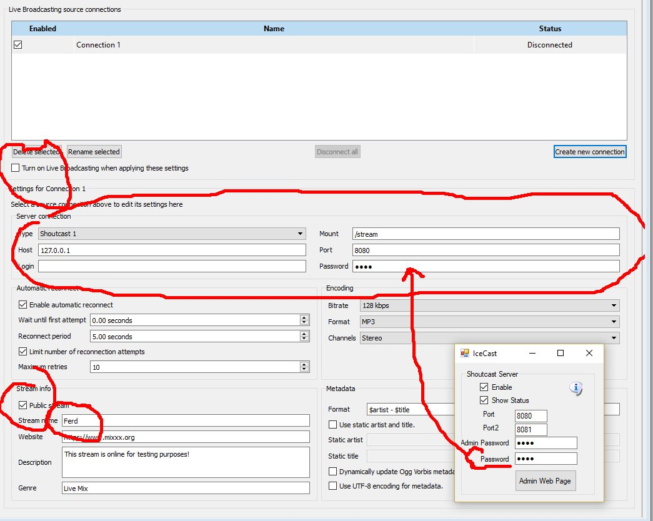
- Check Turn On Live Broadcasting
- Set type to Shoutcast1
- The standard mount point everyone uses is /stream
- Host is 127.0.0.1
- Port is 8080 from the Dreamworld setup.
- Login is blank
- Password is the same password in your Dreamworld setup.
- Check Public if you want your stream to be on the Mixxx website. Give it a name.
- Click Okay and the screen will gray out and should show no errors.

Mixx Setup
On the top of the Mixxx main screen is an Options menu. Click Enable Live Broadcasting. I have it shown in the photo. Load a track and click play. For me, that was hard to find! It is circled in the picture and shows a pause button.

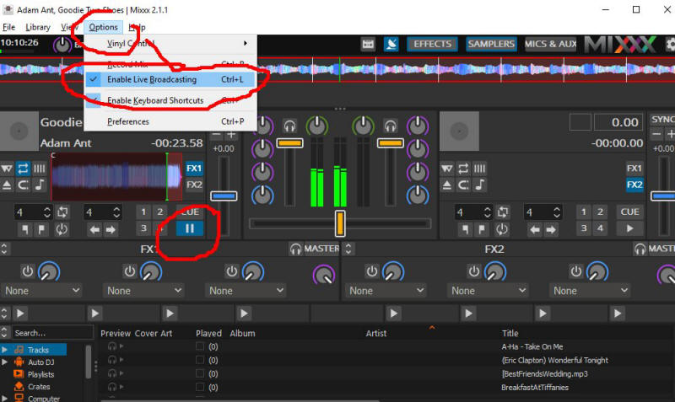
Use a web browser and navigate to http://127.0.0.1:8080/stream and click the play button. You can also click the Admin Web Page button. You should hear the music, delayed by maybe 15 seconds. This is normal buffering. Click Stop in Mixxx and the music will play for a bit longer due to the buffering.
The Public URL or Domain Name for your world is entered into your sim instead of 127.0.0.1, so for my simulator, the music URL becomes http://www.outworldz.com:8080/stream. This URL must include the 'mount point' of /stream you entered earlier.
Navigate to http://127.0.0.1:8080. You should see the standard web page for Icecast. Yours truly, can log in using your administrator password, see the status, and see the mount point.

Troubleshooting:
If it cannot connect, make sure Icecast is running in a separate DOS box.
You do not have to run the grid to stream music. It is only used to set up the files and start Icecast. For example, you can run a radio station or use it for Second Life. There is a batch file in /Icecast called 'icecast.bat' that will run the server.

Port Forwards:
Add port 8080 and 8081 to your routers Port Forward. You should also check they are not blocked by your firewall or anti-virus. This is my setup:
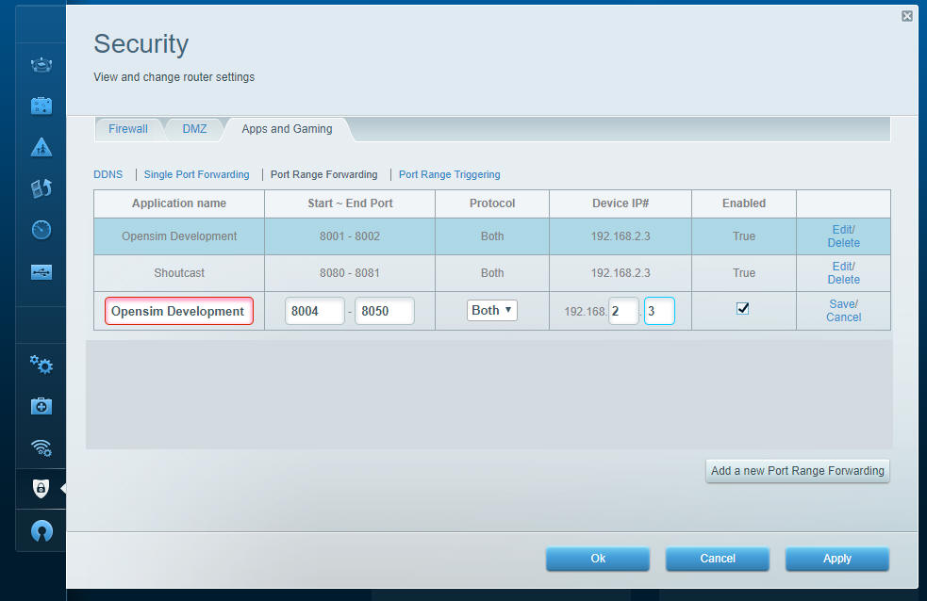
The Shoutcast setting shown above is used when you are running the Icecast/Shoutcast server.

JOOMLA/JOPENSIM UPDATE
IMPORTANT: this version required changes in DreamGrid, Joomla and in jOpensim. This also the reason why this version will not update as usual with the Joomla updater. Clicking on update in Joomla without following these instructions will result in a broken jOpensim installation. If you also have jOpenSim PayPal in use, you will need to update this component as well.

How to Update:
First, update your Joomla installation to version 3.9.23. This can be done by logging into the Administrator panel and clicking the notice. Or click on Components->Joomla Update. Do not update past Version 3.9.23 to V 4!
In DreamGrid, go to Setup->Settings-> and then to Joomla/jOpensim.
Press the [Update] button to update to the latest jOpensim. This will take you to this screen:

Click the big green “Or Browse for file” and navigate to the Outworldzfiles\jOpensimfiles\ folder. Select “pkg_jopensim.0.3.2.0.zip” and click Ok. This will update you to jOpensim V3.0.2.0.

Installing and Running Joomla and jOpensim

Make sure Apache is enabled. See the Help file for Apache on how to enable it. You must install the C++ Runtimes.
Leave the Apache Content Manager set at “Diva” to prevent redirects. When you finish with Joomla, you can enable JOpensim. This redirects all traffic to your web server to Joomla/jOpensim.
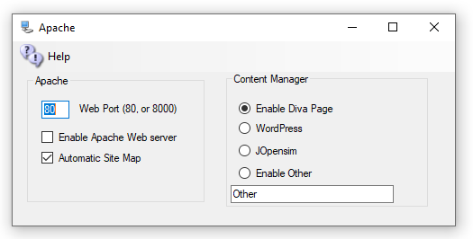
Both the MySQL and Apache icons should be Green.
Click Setup->Joomla/JOpensim and click the Install Button.
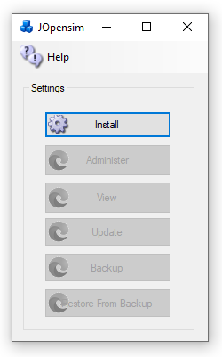
It will install the files
You should see the Joomla Setup Page. Fill in the Site Name, a short Description, and pick a Super User Account name and password. Joomla is exposed to the public Internet, so be sure that you use a long and secure password that you have never used before. Write it down as you will need it often!
Press Next
- Fill in the Host name as 127.0.0.1
- Database name as Joomla
- Username should be robustuser
- Password should be robustpassword.

Press Next
Verify that there are no errors
Press Install
Click

Restore data

In your web browser go to http://127.0.0.1/JOpensim/kickstart.php, or in Setup->Settings->Joomla/jOpensim, click the [Restore] button.
Press <esc> key to close the warning screen.
Select the latest backup jOpensimBackupV{X}.jpa in the pulldown.

CAUTION: There is NO PASSWORD. If your browser adds one, please blank it out or the setup will fail.
Click Start. It will show it is extracting.
Click Run the Installer
Press Next at Upper Right

Fill in the values:
- Database Host is 127.0.0.1
- User name is robustuser
- Password is robustpassword
- Database name is Joomla
Leave the table prefix alone, as the name is assigned randomly for security.
Click Next at the top right
Fill in the upper part and leave the ‘Live Site URL’ blank.
Fill in the bottom part with your Desired Super User Password. You need to remember this! The login id will be Admin with this password, not the prior one you used!
Press Next at Upper right

Close this window to return to Kickstart. Click the Clean Up button to start using your restored site.

Edits
Joomla will require some edits to match your preferences.
Click the Administer button to log in as “Admin” with your Super User password.
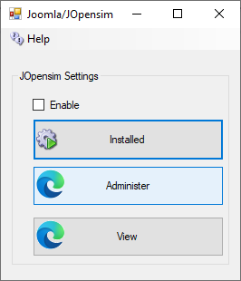

Backups:

You can back up Joomla and JOpensim with Akeeba backup, which I built into your distribution.
Click Components->Akeeba Backup and select “Full Backup”.

To restore a backup, Click [Restore] in the Dreamrgid jOpensim menu to extract kickstart-core-7.0.2.zip and load the URL as shown in section “Restore the Data”, above.

Update

Press the Update button to update to the latest jOpenSim. This will take you to this screen:

Click “Or Browse for file” and navigate to the Outworldzfiles\jOpensim_Files\ and select pkg_jopensim.0.3.2.0.zip. This will update you to Version 0.3.2.0.

jOpensim Money

This is NOT available

References:
Jopensim Wiki http://wiki.jopensim.com/
JOpensim Bugs https://mantis.jopensim.com/

Landscaping
The Landscape modules lets you add terrains and plants to any region.
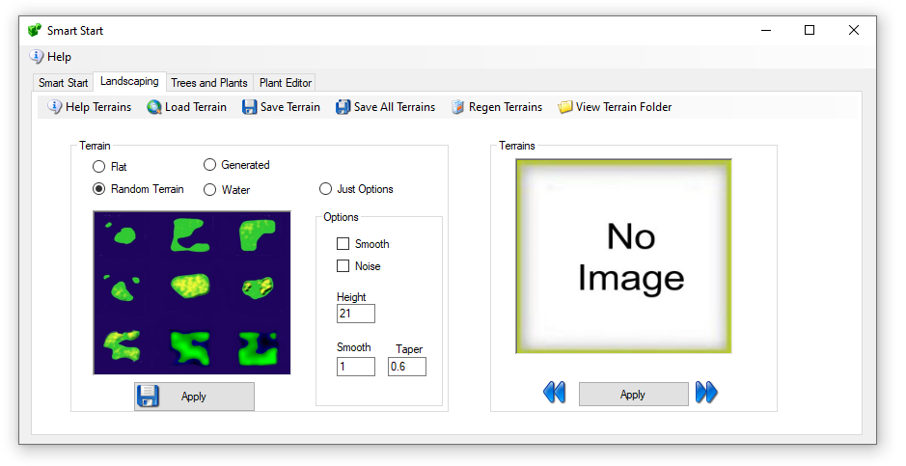
The left side has 4 types of auto or premade terrains. The right side lets you browse and apply to any region any saved Terrain.

- Load Terrain – You can choose any of the many pre-defined terrain files or browse to another location. The system supports PNG, RAW, R32, and TER (Terragen) formats
- Save Terrain – The system will save the selected region file in the above 4 formats along with a JPG image.
- Save All Terrains – The system will save the selected region file in the above 4 formats along with a JPG image in all running regions as well as all Idled Smart Start Regions.
- View Terrain Folder - open file explorer to the Opensim\bin\Terrain\ folder

Terrain Section
The left side has a set of functions for what effect to apply to the land.
Options: These modify the chosen effect
Just Options – ignore the terrain land, just apply the options.
Smooth: smooths the land. The smoothing operation is somewhat different than the others, as it does not deal with elevation values, but rather with strength values (in the range of 0.01 to 0.99). The algorithm is simplistic in averaging the values around a point, and is implemented as follows:
The "strength" parameter specifies how much of the result is from the original value ("strength" * map[x,y]).
The "taper" parameter specifies how much of the remainder is from the first ring surrounding the point (1.0 - "strength") * "taper". There are 8 elements in the first ring.
The remaining contribution is made from the second ring surrounding the point. There are 16 elements in the second ring.
terrain modify smooth 0.5 -taper=0.6
- the original element will contribute 0.5 * map[x0,y0]
- each element 1m from the point will contribute ((1-0.5)*0.6)/8 * map[x1,y1]
- each element 2m from the point will contribute ((1-0.5)*0.4)/16 * map[x2,y2]
Noise - The smooth value represents a delta amount (at centre of range)
Taper - represents a delta amount (at edges of range)

Land Types
Flat – Land is always flat. The Option “Noise” will make the land bumpy. This makes nice underwater if the Option for Height is set below water level of 20 meters.
Random Terrain - uses one of the saved terrains. Options can apply
Water – The same as flat land with Height set to 0
Generated – a series of steps are applied:
- Options are set for Min Level between 22 and 40 meters
- Taper between 0 and 135 meters high
- Upon setting Apply the system will have:
- One in 6 chance fill of land at Height meters with the random taper
- One in 6 chance for low lying land at 12 meters with lots of noise
- One in 6 chance for center to be squared from 20 to 40 meters with the random taper
- One in 6 chance for water level with a variable raised bump with noise
One in 6 chance for water level with a variable raised bump

Load IAR
An IAR is an Inventory Archive - all inventory, or an object, image, mesh, or a folder. You click the Menu to load a Free IAR from the Outworldz, and a list of free IARs appears:
The name, file size, and the credits/license for the IAR appears when you hover your mouse over the photo.
You can search for an IAR.
There is NO PASSWORD used in DreamGrid IARS. Grid Owners are responsible for the contents of the Grid and should be able to backup individual IARS on request.
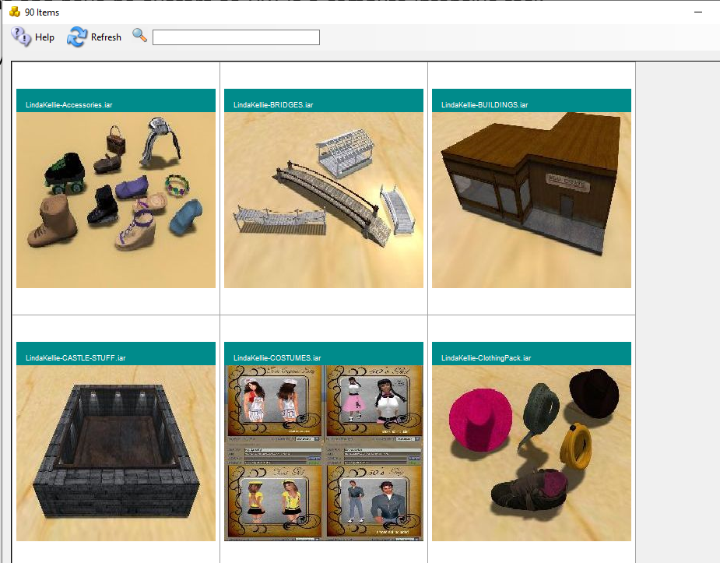

After clicking a desired Item, the system will show an avatar First and Last Name box.
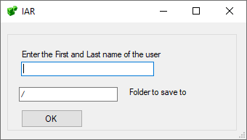
The default is "/", but you can load your IAR to the Inventory with "/Objects", or to a specific folder, such as /Textures.
The inventory will load in one of the Dos boxes.
You may need to re-login in order to see your new inventory item.

Links:
http://opensimulator.org/wiki/Inventory_Archives

Load OAR
An OAR is an Object Archive - a complete region with content, terrain, and scripts. You click the Menu to load a Free OAR from the Outworldz, and a list of free OARs appears:
The name, file size, and the credits/license for the OAR appears when you hover your mouse over the photo.
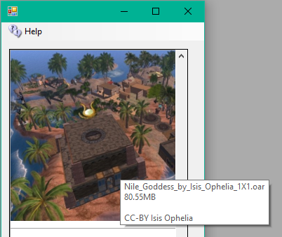
Clicking any photo brings up a region chooser box:
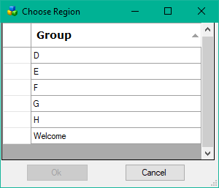
Select the Region you wish to load and click OK. you can also double-click the region.
Click a Blue section to choose which section of this Var Region to put this OAR in.
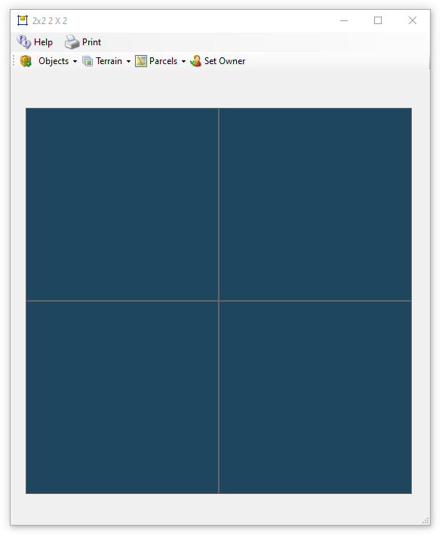
This is a 1X1 region
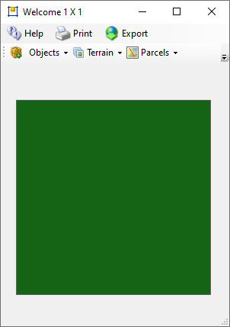

Options: - MERGE
Merge the contents of the reading OAR with the existing contents in the region, or clear the entire region and load it.

--displacement
Specify a displacement that is added to all data as it is added to the destination region. The displacement MUST be specified as "<x,y,z>". So, for instance, to load an OAR from a 256x256 region into the middle of a larger 512x512 region, the parameter would be --displacement "<128,128,0>". Note that you can specify a "Z" displacement which will move the objects up or down. Thus --displacement "<0,0,1000>" will put all the OAR's objects up high for a sky box.
The displacement is applied to the terrain if it is included. The 'z' component is added to the terrain's heights.

--force-terrain
Force terrain loading on --merge. Normally, --merge does not overwrite the existing region's terrain.

--force-parcels
Force parcel loading on --merge. Normally, --merge does not overwrite the existing region's parcel data.

--default-user "<first-name> <last-name>"
Instead of setting object ownership to the estate owner, assign it to the named user. This only applies to objects that have UUIDs that do not match any user account in the receiving grid's installation. There is currently no option that will force a change of owner for all loaded objects no matter whether they match a user in the receiving installation. One workaround to achieve this would be to save the OAR with the --publish "save oar" option to strip owner information and then reload it.

Links:
http://opensimulator.org/wiki/Load_Oar_0.9.0%2B

Logging
There are multiple levels of logging in Opensim:
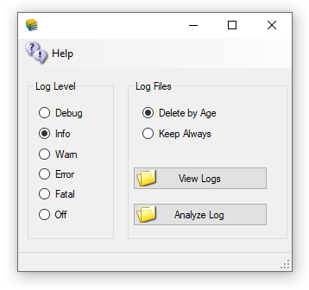
- "DEBUG" - Developer level notices are sent to the log, plus the levels below.
- "INFO" - Useful information, plus the levels below.
- "WARN" - Warnings are logged, plus the levels below.
- "ERROR" - Errors are logged, plus the levels below.
- "FATAL" - Only Fatal errors are logged.
- "OFF" - nothing is sent to the log files.
"Logs" are the Robust.Log located in Opensim\bin, and the Opensim logs located in Opensim\Bin\Regions in each DOS Box folder.
The Log File Age settings apply to most of the logs, including Apache. The Age is set in the AutoBackup settings.

Loopback
If you are reading this, it is probably because you already know loopback is not working and clicked the Help menu to get here. You can skip down below and go right to "How To Test for Loopback ".
Loopback from your router is necessary in Opensimulator if you are going to be running on the Hypergrid. The usual symptom of a broken loopback is being unable to log in to the server after switching to a Public IP or a Dynamic DNS name. If your router does not support loopback, which is common, you can install a simple fix so it can run a viewer. The loopback adapter lets a viewer on the server reach itself, as the loopback via the router is not functioning.
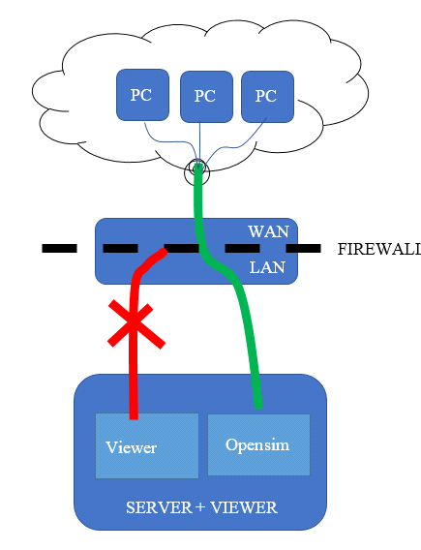
You cannot get to your own PC using the address of outside of the router.
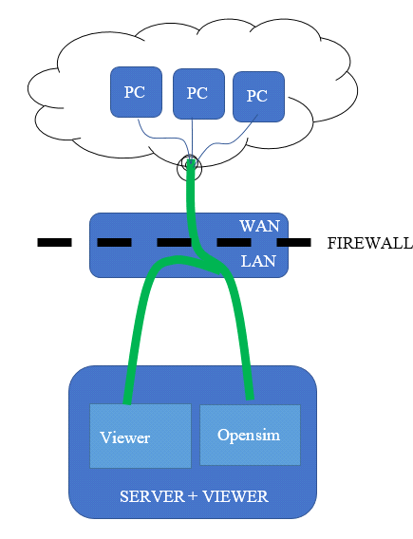

How to test for loopback
You can manually test for loopback by starting Opensimulator, then use a web browser to navigate to http://canyouseeme.org. Enter port 8002 and click Check Port. This must work. if not, fix the port forwarding issues and come back and try this test again. You may need to Open Ports in the firewall or disable it on the PC temporarily.
Do not install a loopback adapter until the above test passes! There is one more test to do to see if you really need to add an adapter.
Your ports are known to be working now, so go get the Public IP of your system from http://canyouseeme.org. Use a web browser to navigate to http://(Public IP):8002. Use your Public IP where it says (Public IP).
You should get a login page. If you get this page, loopback is working. You do not need to install an adapter If you do not get this page, loopback is not working in your router.

Installing the Loopback Adapter
- Click Start, then type cmd in the search box.
- When cmd.exe appears, right-click it and choose Run as administrator.
- In the command prompt, type hdwwiz.exe and press Enter.
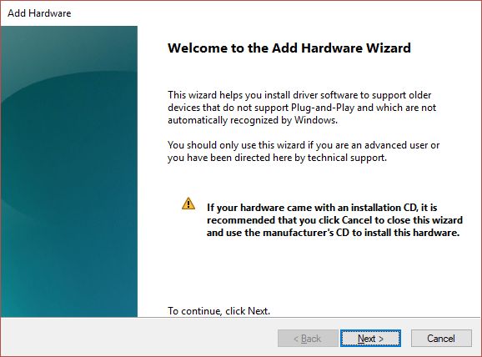
4. Click Next.
5. Select Install the hardware that I manually select from a list (Advanced), then click Next.
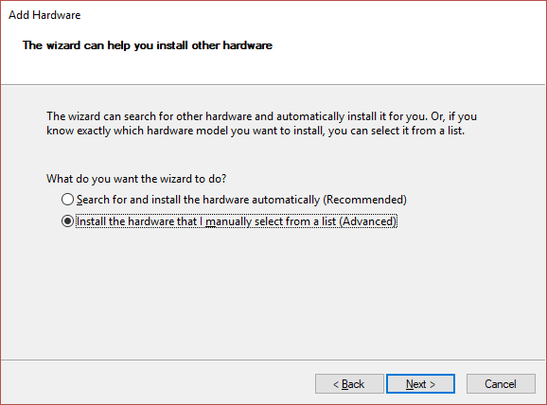

6. Select Network adapters, then click Next.
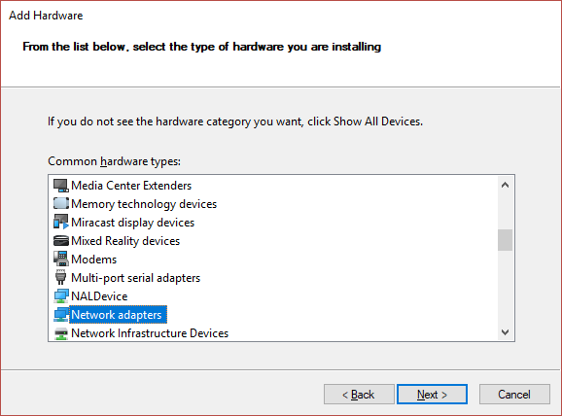

7. Select Microsoft as the manufacturer, select Microsoft KM-TEST Loopback Adapter as the adapter for Windows 10, then click Next.
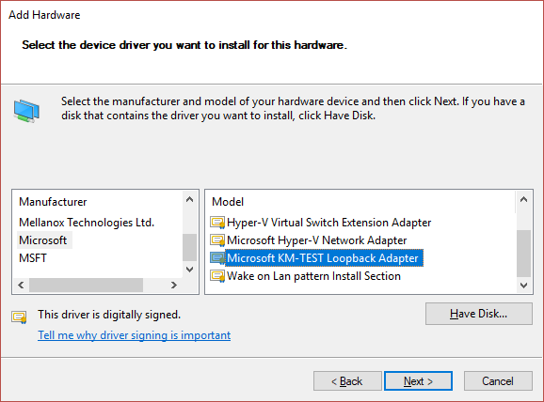
8. Select Next to confirm the installation.
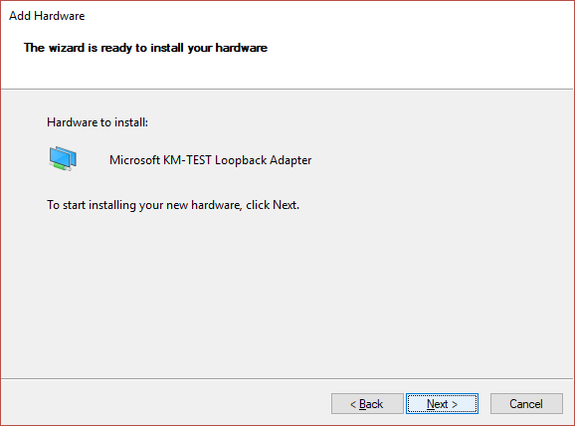

9. Select Finish to complete the installation.
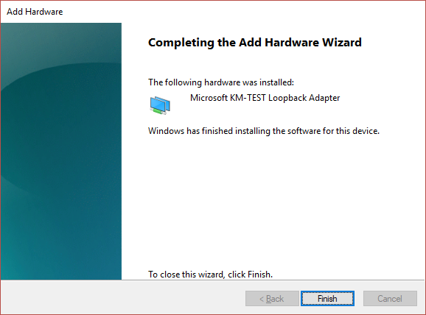
10. Go to your Network Adapters in Control panel and rename the Microsoft Loopback Adapter to just "Loopback".
11. Exit the DreamGrid entirely if it was running, and then start it again. A black DOS box will appear as DreamGrid automatically configures your Loopback adapter.

LSL Scripting
There are several extra features in DreamGrid to help Opensim LSL work better.
EasyDatabase is a way to store name=Value parameters from any script, region, or grid to any other script. See the manual for EasyDatabase.rtf
Online Regions can be fetched from http://YourGrid::8002/Teleports.htm. This is used by the Region signs you will find in Content->Load Local IARs.
Item Giver with Notice Script uses LSL to save the current date, a Name, and a Region to a CSV file. This makes it easy to see what and who got what item by touching a LSL giver script.
You need the password from the file Outworldzfiles\Opensim\bin\ AddinExample.ini.
To test this, fill in some sample data in http://YourGrid::8004/diva/AddinExample.htm This is data associated with the very first region. You must use the port for the region you are in to write, and it must be a POST action.

After clicking submit, you should see a confirmation the data was stored.
The data will be in Outworldzfiles\Opensim\bin\Name.csv

//
// Give with notice via HTTP
//
// Fill in your server and port, if necessary, port 80 is a default. It will connect to this with the parameter: ?name=(Prim Name)
string SERVER = "http://outworldz.com";
// * This function cases the script to sleep for 3.0 seconds.
// * If inventory is missing from the prim's inventory then an error is shouted on DEBUG_CHANNEL.
// * Avatar must be, or have recently been, within the same Region as sending object.
// * Does not create a folder when avatar is a prim UUID.
// o The prim must be in the same region.
//Examples
// When a user clicks this object, this script will give a folder containing everything in the objects inventory
// This can serve as a unpacker script for boxed objects
default {
http_request(key id, string method, string body) {
llOwnerSay("Someone just got " + llGetObjectName());
}

touch_start(integer total_number) {
llHTTPRequest(SERVER + "?Name=" + llGetObjectName(),[], "");
list inventory;
string name;
integer num = llGetInventoryNumber(INVENTORY_ALL);
integer i;
for (i = 0; i < num; ++i) {
name = llGetInventoryName(INVENTORY_ALL, i);
if(llGetInventoryPermMask(name, MASK_NEXT) & PERM_COPY)
inventory += name;
else
llSay(0, "Don't have permissions to give you \""+name+"\".");
}
//we don't want to give them this script
i = llListFindList(inventory, [llGetScriptName()]);
inventory = llDeleteSubList(inventory, i, i);
if (llGetListLength(inventory) < 1) {
llSay(0, "No items to offer.");
} else {
// give folder to agent, use name of object as name of folder we are giving
llGiveInventoryList(llDetectedKey(0), llGetObjectName(), inventory);
llHTTPRequest(SERVER,[],llGetObjectName());
}
}
}

MESH LOADER (Load DAE, GLB, GLTF)
DreamGrid has a Mesh uploader then uploads GLB, GLTF and DAE meshes into Opensimulator without a viewer. This bypasses viewer timeouts and some size limits.

OVERVIEW
The Mesh Loader lets you take a 3D model file from your computer - a DAE (Collada), GLB, or GLTF file - and drop it directly into a region on your grid, at a chosen spot, without going through the normal in-world upload process. DreamGrid converts the model into an OAR (OpenSim Archive) file behind the scenes and loads that OAR straight into the region you pick nondestructively.
You do not need the model to already be rezzed anywhere, and you do not need to be logged in as an avatar to use it - although you CAN target the loader at wherever an avatar is currently standing and looking, which is the fastest way to place something exactly where you want it.
Supported source formats:
- .dae (COLLADA)
- .gltf (glTF, JSON form - textures/binary data as separate side files)
- .glb (glTF, single packed binary file - textures included inside)

How to open it:
In the main DreamGrid window, go to the Content menu and choose
"Load DAE, GLB, GLTF".
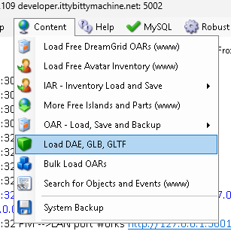

STEP-BY-STEP: LOADING A MESH
1. OPEN THE LOADER
From the main DreamGrid window: Content menu -> "Load DAE, GLB, GLTF". The Mesh Loader window opens.
2. CHOOSE YOUR MESH FILE
Click "Browse..." and pick a .dae, .glb, or .gltf file, OR type/ paste a full file path directly into the "Source model" box.
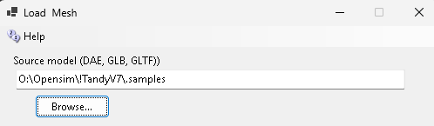

3. VERIFY IT IN THE PREVIEW WINDOW

As soon as you pick a .glb or .gltf file, it automatically appears in the small 3D preview panel on the left side of the window – you can rotate/orbit it with your mouse to check it looks right before committing to a build. (.dae files do not auto-preview in this panel - the format isn't supported by the embedded viewer.)
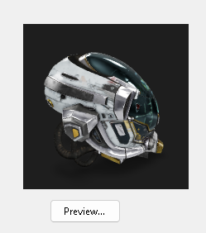
For a closer look, click "Preview..." to open the file in the separate, full GltfViewer tool window (a more complete standalone viewer). This also works for .dae files, unlike the embedded panel.
Always check the preview before building - it's the easiest way to catch a wrong file, a missing texture, or an oddly scaled model before spending time on a full build.

4. CHOOSE WHERE TO PLACE IT
You have two ways to set the destination - pick ONE:

OPTION A - Region + X/Y/Z coordinates
- Click into the "Target Region" box and choose a region from the list (only currently booted/running regions are offered).
- Type the X, Y, and Z coordinates where you want the model to land (defaults to the region's approximate center/128,128,30).
- A small map preview updates to show a red dot marking where in the region the model will be placed, so you can sanity-check the position visually.

OPTION B - Type an avatar's name instead.
- Type the name of an avatar who is CURRENTLY ONLINE and logged into a booted region into the "Avatar Name" box (an autocomplete dropdown will suggest names of avatars who are online right now, across every booted region).
- As soon as you tab or click away from the field, DreamGrid searches every booted region for that avatar and, if found, automatically fills in the Target Region and X/Y/Z fields for you - positioned about 2 meters out in front of the avatar, along the direction they are currently looking (their "gaze"), at roughly their eye/chest height. This lets you place an object right where an avatar is looking without having to know or type exact coordinates yourself.
- If the avatar isn't found online in any booted region, you'll get a message saying so, and the loader falls back to whatever region/X/Y/Z is currently typed in those fields instead.
5. CLICK "BUILD && LOAD"
This does two things in sequence:
a. Builds a native OAR file from your source mesh (saved under OutworldzFiles\OAR), including its materials/textures.
b. Loads that OAR into the target region at the position you set.
There is also a "Process entire folder (one mesh at a time)" checkbox - see the FOLDER BATCH MODE section below if you want to load multiple files in one go instead of a single file.

Progress and any warnings/errors (vertex counts, triangle counts, material extraction, etc.) are streamed live into the Status box at the bottom of the window as it runs. Watch this box – a 65,535-vertex overflow or other build failure will be reported here with the name of the specific mesh part that caused it.
The button is disabled while a build is running; wait for it to finish (or fail) before starting another one.

FOLDER BATCH MODE (OPTIONAL)
If you check "Process entire folder (one mesh at a time)", the Browse button switches to picking a FOLDER instead of a single file. Clicking "Build && Load" then scans that folder (and all subfolders) for every .dae/.gltf/.glb file it can find, and builds + loads them ONE AT A TIME, in alphabetical order, each into its own OAR.
Each successive mesh in the batch is placed 1 meter further along Y than the earlier one, so they don't stack on top of each other. The loader waits for each mesh's OAR to finish loading into the region.
Before starting the next one (up to a 2-minute timeout per mesh), and reports progress for each file in the Status box as it goes.
Note: in folder mode there is no single mesh to measure, so the avatar-gaze height described above is skipped - only the X/Y start position and region are taken from the avatar/region fields. T

THE 16-BIT VERTEX LIMIT - WHY IT MATTERS
Opensimulators’s mesh format stores triangle indices as 16-bit numbers. That means each individual primitive/material section of your model can have AT MOST 65,535 vertices. This is a hard limit built into the mesh format itself, not something DreamGrid can raise.
If a single material section of your model has more than 65,535 vertices, the Mesh Loader will refuse to build the OAR and will report an error naming the offending mesh part rather than silently producing corrupted geometry (an earlier version of the underlying library would let the index numbers "wrap around," which turns dense meshes like a high-poly chessboard into a collapsed, garbled wedge of triangles – the loader deliberately catches this instead of allowing it).
If you hit this limit, go back into your modeling tool and split the offending surface into smaller pieces (more materials), then re-export. You can use a decimate modifier in Blender or convert the triangle matrix into something simpler in Mesh Cleanup.
There is also a SOFT/recommended guideline, not a hard limit: keep each material to no more than about 21,844 triangles. Why that number - 21,844 triangles x 8 materials = 174,752 triangles, which lines up with OpenSim/Second Life's own mesh-upload guidance of spreading a complex surface across up to 8 materials rather than one enormous one. Going over the 21,844-triangle guideline on a single material won't stop the build, but it can produce visible holes or missing geometry once a model's geometry gets highly interspersed across many materials, so the loader will log a warning (not an error) if you exceed it.
In short:
- Hard limit: 65,535 vertices per material/primitive - build fails.
- Soft guideline: ~21,844 triangles per material - warning only.
- Practical target: split detailed models across up to 8 materials so each one stays comfortably under both numbers.

DAE vs GLTF vs GLB - WHAT'S DIFFERENT
All three formats feed the same OAR-building pipeline and follow the same vertex/material rules above, but they are read by different code paths internally, and one feature is GLTF/GLB-only:

DAE (COLLADA)
- Imported using a Collada/Lambert-Phong style material model with diffuse color/texture only.
- No PBR (physically based rendering) material data exists in a DAE file at all - no normal maps, metallic/roughness, occlusion, or emissive channels are possible from this format. You can load a Normal map o Gloss map in-world.
- NOT supported by the embedded live preview panel or by the Preview button's viewer (see below) - .dae files can still be built and loaded, they just can't be visually previewed first.
GLTF (.gltf, JSON + side files) and GLB (.glb, single packed file)
- Imported with full PBR material support: base color, normal map, metallic/roughness, occlusion, and emissive channels are all read from the source file and carried into the built OAR.
- A single node in a GLTF/GLB file can have multiple primitives that use DIFFERENT materials (for example, a tire model with a "Tireside" material and a separate "Tiretread" material on the same node) - the loader extracts and preserves each primitive's own material correctly rather than applying just one material to the whole node.
- Materials that are reused by reference across many parts of a model (e.g., the same lug-nut material used on eight identical lug nuts) are only extracted and uploaded once and then reused, not re-uploaded per occurrence.
- Both .gltf and .glb CAN be shown in the live embedded 3D preview panel inside the Mesh Loader window itself.
Multi-part models (multiple linked prims) are supported from GLTF/GLB sources - the loader builds a real linkset out of all the model's nodes/primitives, not just a single prim.

TIPS
Always preview before building, especially for a model you haven't loaded before - it's much faster than discovering a problem after a full build/load cycle.
- If you get a vertex-limit error, the message names the specific mesh/node that's too dense - fix that part in your modeling tool and re-export, you don't need to rebuild the whole model from scratch.
- Prefer GLB over separate GLTF+textures when possible - it's a single self-contained file, so there's nothing that can go missing between the model and its textures.
- The Target Region list only shows regions that are currently booted (running) - boot the region first if it isn't on the list.

Map Overrides
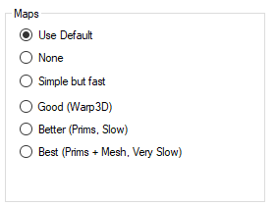
The Map Overrides change this one region’s map making.
- None: No maps will be made. This is a good setting as the regions will boot very quickly. Any existing maps are kept.
- Simple but Fast: MapImageModule is used with just Land showing.
- Good: Uses Warp3D module with just Land showing.
- Better: Uses Warp3D module with Land, Prims, and land Textures showing.
- Best: Uses Warp3D module with Land, Prims, Mesh, Sculpts, and all Textures including prims showing.

Maps
Opensim has many different maps settings. DreamGrid has multiple easy-to-use combinations. Opensimulator has several Map tile makers which vary in quality, and speed. It can take an exceedingly long time to boot when using the Better and Best maps. These maps which use the Warp3D engine must load all prims, mesh, and textures, so it takes a long time to generate new maps. Also, any bad textures may cause harmless errors from corrupted assets to appear on your console.
I recommend you run all maps at Best setting once, then set Maps to None. You can remake maps when enough changes have been made.
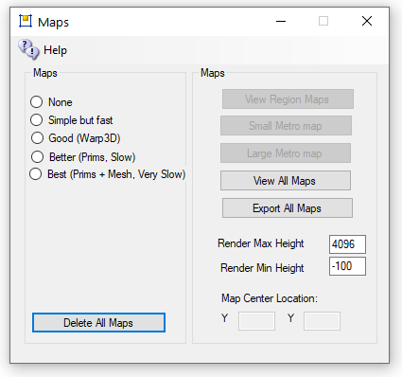
- None: No maps will be made. This is a good setting as the regions will boot very quickly. Any existing maps are not deleted.
- Simple but Fast: MapImageModule is used with just Land showing
- Good: Uses Warp3D module with just Land showing
- Better: Uses Warp3D module with Land, Prims, and land Textures showing
- Best: Uses Warp3D module with Land, Prims, Mesh, Sculpts, and all Textures including prims showing.
- Delete All Maps: If you delete a region the map will remain. Click this to clear out all maps. You will need to regenerate all maps again by choosing a setting and restarting all regions.
- View Map Web page: Enabled if your system is running. Opens a web browser to http://localhost:8002/wifi/map.htm.
- Small Metro Map and Large Metro Maps: Available only if your Apache/PHP is enabled in Settings Web Pages. These maps are generated by PHP and Apache web server.
- View All Maps displays all maps. You can save or print them. Clicking a map causes it to exit.
- Render Max Height can be changed to not show skyboxes.
- Render Min Height can be changed to not show water or ground structure.

Manual regeneration
Normally you would generate map tiles at startup. You can also manually force map tile regeneration with the console command 'generate map<enter>'.
A) Go to Setup Settings->Maps and erase them all with "Delete All Maps"
B) Now choose "Best (prims + Mesh Very Slow)"
C) Close this window which saves the new Global setting.
D) Press Start.
E) Once all the regions have booted to the DOS boxes, set map back to "None". They can still be making maps. They just need to all be starting up and then you can change the Global Settings.
The next time you boot, the regions will load very quickly as the maps will not be remade. Maps only need to be cleared when you delete a region or move them around.
F) Each region has an override setting. If set, the override will choose a different setting for maps.
Example: I leave the global maps off all the time. But I may be working heavily on a region and changing it around and want that to appear after every reboot. I go to the Regions List and click the Region and set the override to the desired setting, and reboot the region

Migration From Dreamworld To Dreamgrid
Migrating from a Standalone Dreamworld to a Gridded Dreamgrid requires you to take special steps.
Start your original Dreamworld. Dump the database by clicking the Content-> Backup Database menu. This makes a backup in the AutoBackup folder in the Standalone Dreamworld.
Created a new DreamGrid, but before you start, set the robust name to opensim and the robust userid to opensimuser and the robust password to opensimpassword. These are the same as in the lower section for the Regions database. Also fill in the various Setting menus for the name and ports to match the original Standalone Dreamworld.
Then click [Start]. This boots Mysql on the new grid. It will start Robust and a new Welcome region (even if it has the same name, it has a random UUID so will be different). Then shut the grid down gracefully by clicking [Stop]. This left the DreamGrid menu enabled and MySQL running.
Navigate to the DreamGrid’s Content->Restore Database menu and browse to the original Dreamworld's AutoBackup folder. Click the .sql file you just made. This will load the OpenSim.sql file into the new grid.

Region Files
You will need to move your region.ini file. You cannot just copy them over in a file explorer unless you make a special pattern of folders.
Open the Region Panel with Ctr-R or go to Setting->Region. Delete the existing Welcome region.
Now click Import and browse to the Opensim\bin\region folder in the OLD dreamworld and import them one at a time.
There will be anywhere from one-t-any Region.INI files in your old system. There is no need to load from OAR files.

Use the Import button and locate the original Dreamworld location on your disk. Look in Outworldsfiles\Opensim\bin\Regions. If you are running 0.9.0, look in Outworldsfiles\Opensim-0.9\bin\Regions
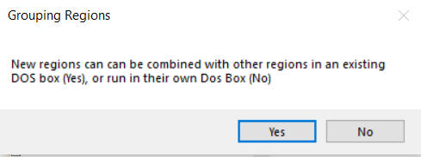
Yes: If you answer Yes, a Chooser dialog will appear. You must choose which region you want to combine your new region with. This places both regions into a single DOS box.
No: If you answer No, you will get a different DOS box when this region starts.
You should limit the number of DOS boxes by combining your regions into logical groups. A typical system will run 4 to 8 such groups. You can run more, but you will pay a penalty in RAM use for each box.

Starting Up
Now click [Start] to boot the new grid. You can log in with the Standalone grids user names at this point. Your inventory should be there. The regions will appear.

Modules
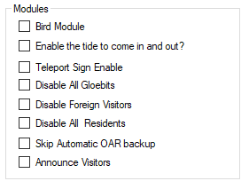
Bird module makes flocks of birds possible. See the help manual on Birds. This must be enabled for birds to appear in a region.
Enable Tides makes the water level rise and fall in this region. See the help manual on Tides. This must be enabled for tide to appear in a region.
Teleport Sign Enable lets you use a standardized Outworldz Teleport Sign to direct visitors in your world. This sign is located in the Content-Inventory IAR Load and Save ->Local IAR menu. There are multiple variations of the sign.
Outworldz Teleport System.iar is a standardized sign for all uses.
Outworldz Teleport System V3.9.iar is for testing of the Smart Start system and is subject to change.
Disable all Gloebits should stop the Gloebits system on this region.
Disable Foreign Visitors will prevent hypergrid visitors from entering your region.
Disable Residents will prevent all resident from entering your region. Only Estate managers or owners can get in.
Skip Automatic OAR backup will prevent the automatic OAR system from backing up this region.
Announce visitors will chat any arrivals or departures.

Moving a DreamGrid to another folder or PC
There are no dependencies outside of the DreamGrid folder to copy to a new location.

Method 1
Stop the original grid and go to Setup->Setting->Caches. Select and clear all the caches. These do not need to be copied and are huge. Opensim will recreate them as needed. The states of scripts will be maintained as the .STATE files are not deleted.
Now copy the entire folder from one machine to the other or from one folder to another.

Method 2
Another method is to unzip a new copy of DreamGrid on the destination machine. Then copy the file Outworldzfiles\Settings.ini, Outworldzfiles\mysql\data, Outworldzfiles\opensim\bin\fsassets and Outworldzfiles\opensim\bin\regions to the second machine or folder.
If you are running the Apache web server (for jOpensim Or Maps), install the service packs in Setting->Apache, which is also in the folder MSFT_Runtimes.
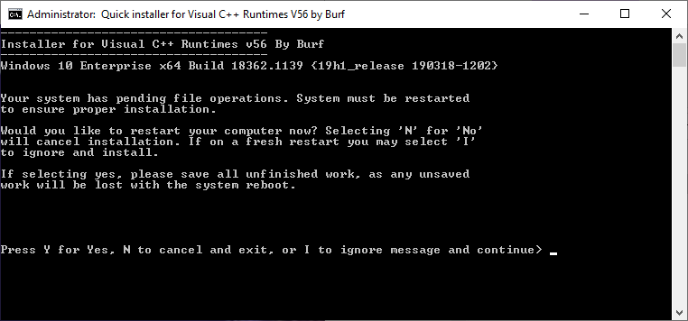
It may ask to reboot. There is no need to reboot. If it asks, type 'i' to ignore, then 'y' to install.
Router: You will need to port forward to the new IP if you are on the hypergrid.
Anti Virus: If setting up a new computer, you will want to check that any 3rd party anti-virus is not blocking ports. Also add an exclusion to the Opensim\bin folder to the Real-time component of any virus scanner as this area gets heavy use of Script DLLS, and it will cause issues with scripts starting up or being created. Opensim does not create viruses, and all my code is digitally encrypted and signed by Microsoft Authenticode and will not run if even a single bit changes.

Method 3
All these ways to copy the files depends upon copying up to a million or more files. In particular, Msql’s ibdata file and the Outworldzfiles\opensim\bin\fsassets folder are extremely large.

Running DreamGrid On A Server
One of the difficulties in moving to a server such as Contabo.com is moving the files to it.
The big problem is mysql\data\ibdata - which is literally your grid and must be moved. There are many ways to do this: Google drive, dropbox, ftp, but most of those require $$ or are slow. One way is to use Windows SMB file sharing.
The remote server can appear as a local disk, such as X: or Z: with SMB file shares so you can copy and paste files. This makes it trivially easy to make backups and move OARs and backups off Contabo and store them at your home.

Log Into Your Server
Log in with remote desktop or VNC as an Administrator. You need a strong password for your account! Don't skimp on this step, as your server is exposed to the internet in an intimate way, and it will be probed constantly for weaknesses.
Now choose a folder. The safest way to share is by making a shared folder, such as your AUTOBACKUP folder. If someone guesses your password, then all they get are backups. And you can share the entire drive, too.
Right click a folder or C: and select Properties.
Click Advanced Sharing:
Click Add and give it a name, such as "C", and check "Share this folder"
Click Permissions:
Remove the "Everyone" group and click Add and type in your login name.
Press OK
Check "Full control" so all three permissions are lit up.
Click OK

Firewall Rules
You need to enable some ports in Windows Server. Go to Control panel or search for Advanced Firewall.
In the firewall screen, click Inbound Rules
On the right side, click New Rule
Give it a name such as "File Sharing TCP"
In Protocols and Ports Select TCP and add the following ports:
134-139, 445, 389, 88
Repeat the above steps for a name such as "File Sharing UDP"
Repeat the step "Protocols and Ports" Select UDP and add the following ports:
134-139, 445, 389, 88
Click Apply

Sharing Files To And From Your Server
To connect, you can use the IP, DNS name, or Outworldz.net name. This is the same name you connect to Contabo in VNC or Remote Desktop,
Go to File Explorer in Windows at your Home PC. You can get there by pressing the Windows Logo key and the 'e' key at the same time.
Type two back slashes \\ in the address bar and then the name of your server:
You should get a password prompt:
Enter your password and you should see the share name that you set up.
You can use this name and path as if it is local to your PC and drag and drop files to it. Or Copy and Paste.
You can also Map a drive letter to it.
Right click the folder and select "Map Network Drive"
Choose a drive letter and click Apply
Now you can simply go to the drive letter and access your server.Backups:
Now that your server is set up for file access, you can use programs such as robocopy (free, built into windows), and paid backup programs such as SyncBack to move or copy your grid to your home PC on a regular basis.
Example: I created map drive as X: to a folder on the server and added a batch file named Backup.bat.
I then ran this from the server as X:/backup.bat and it copied my Servers X:\tmp folder to my home PC C:\tmp folder.
You can now use robocopy to backup your entire grid, or the Backup folder with one simple command "X:/Backup" by changing the folder names in the batch file.
PS X:\> .\Backup.bat
X:\>robocopy X:\tmp c:\tmp /e
-------------------------------------------------------------------------------
ROBOCOPY :: Robust File Copy for Windows
-------------------------------------------------------------------------------
Started : Monday, October 19, 2020 11:38:27 PM
Source : X:\tmp\
Dest : c:\tmp\
Files : *.*
Options : *.* /S /E /DCOPY:DA /COPY:DAT /R:1000000 /W:30
------------------------------------------------------------------------------
0 X:\tmp\
New Dir 0 X:\tmp\A\
------------------------------------------------------------------------------
Total Copied Skipped Mismatch FAILED Extras
Dirs : 2 1 1 0 0 1
Files : 0 0 0 0 0 8
Bytes : 0 0 0 0 0 27.63 m
Times : 0:00:00 0:00:00 0:00:00 0:00:00
Ended : Monday, October 19, 2020 11:38:28 PM
PS X:\>

Options
This has optional items that are part of standard Opensim you may choose to change.
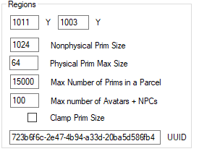
The Options page has the (x, y) Global location of the region on the grid. You can set regions next to each other by changing the X and Y coordinates and restarting the region. The X and Y is the lower left point on the global map.
If you get messages saying that regions overlap, change the coordinates to some substantial number and retry the region boot.
UUID: You can only change the UUID of the grid is stopped. Never change the UUID unless you want to start with a blank region again. Altering the UUID will force the system to create a new, blank region the next time the grid starts, and you will be forced to move your region to another spot if it is not deregistered. This is a read-only field when the grid is running. You can only change this by stopping the grid.
MaxAgents: The maximum number of agents that can be in the in the region at any given time. The default is 100.
MaxPrims: The maximum number of prims that the region will be listed as supporting. However, this limit is not currently enforced by OpenSimulator. Due to LL protocol constraints, the maximum limit that can be shown is 45000.
PhysicalPrimMax: The maximum dimensions of a physical prim. This is a single number which applies to X, Y and Z co-ordinates. This will affect resizing of existing prims. Default is 10.
NonphysicalPrimMax: The maximum dimensions for a non-physical prim. This is a single number which applies to X, Y and Z co-ordinates. This will affect resizing of existing prims. Default is 256.
ClampPrimSize: If true then if a viewer attempts to create a prim which has any dimension larger than the NonphysicalPrimMax, then that dimension is reduced to NonphysicalPrimMax. Default is false.

Permission Overrides
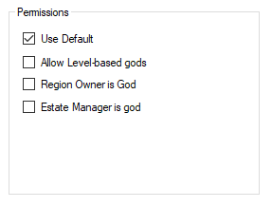
Allow Gods: God mode is available to selected people if enabled. These levels can be set for individual users in the Web control panel.
• Level = 0 is a normal user
• Level = 50 (or a level you set) is used to indicate a privileged user (e.g. who can set up new Hypergrid linked regions)
• Level = 100 is a Wifi admin account user
• Level >= 200 can become a God
Estate Owner is God: If enabled, the region owner may go into God mode.
Estate Manager is God: If enabled, any region estate manager may go into God mode.

Physics Engine

The Physics selection box lets you set basic physics, where the only collidable object is a box shape. It supports the original Open Dynamic Engine physics. The ubODE engine, by Ubit Umarov, is an advanced version of ODE that is closer to Second Life compatibility with vehicles. Bullet is an award-winning physics engine.
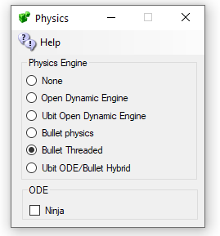
- ODE is a very old physics engine with many limitations. It does support Ninja Physics.
- UBODE is closer to Second Life in vehicle performance.
- Both BulletSim and UBODE support varregions.
- BulletSim provides the best performance and most functionality.
- Bullet in a separate thread prevents physics crashes from crashing the region. It is the default physics engine.
- ODE Ninja physics are documented in another manual.

Links:
http://www.ode.org/
https://en.wikipedia.org/wiki/Bullet_(software)

Permissions
Grid god mode allows certain users to take and control permissions over objects. Setting Grid God Mode on allows you to control individual users by editing their access level in the Wifi Users Panel. Any user with a level > 100 will be a grid god. You can set any estate owner or estate manager to be a grid god, too. Users can become Gods by using the Request Admin Level button in the Advanced Viewer menu.
God mode is a useful function. However, making copies of items that are no copy or no transfer and giving them to others could be illegal. Please remember that copyright laws for your country need to be respected.
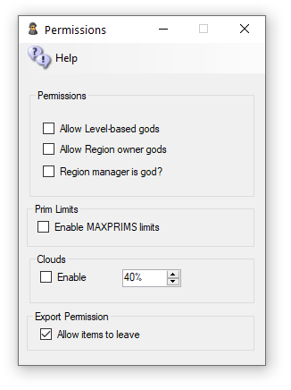
Allow Gods: God mode is available to selected people if enabled. These levels can be set for individual users in the Web control panel.
Level = 0 is a normal user
Level = 50 (or a level you set) is used to indicate a privileged user (e.g. who can set up new Hypergrid linked regions)
Level = 100 is a Wifi admin account user
Level >= 200 can become a God
Estate Owner is God: If enabled, the region owner may go into God mode.
Estate Manager is God: If enabled, any region estate manager may go into God mode.
Prim Limits: Opensimulator normally does not enforce limits on the number of prims for a region or a parcel. The viewer can show a maximum of 45,000 prims.
You can lower or raise any region limit in the Regions Control panel.
Default: Unchecked
Clouds: The original particle clouds from the early days of Second Life are still available for older viewers such as Singularity.
Default: Checked
Export: Export Checkbox can disallow export of prims by a viewer. Default -> Allow

Physics Engine
The Physics selection box lets you set basic physics, where the only collidable object is a box shape. It supports the original Open Dynamic Engine physics. The ubODE engine, by Ubit Umarov, is an advanced version of ODE that is closer to Second Life compatibility with vehicles. Bullet is an award-winning physics engine.
- ODE is a very old physics engine with many limitations. It does support Ninja Physics.
- UBODE is closer to Second Life in vehicle performance.
- Both BulletSim and UBODE support varregions.
- BulletSim provides the best performance and most functionality.
- Bullet in a separate thread prevents physics crashes from crashing the region. It is the default physics engine.
- ODE Ninja physics are documented in another manual.

Links:
http://www.ode.org/
https://en.wikipedia.org/wiki/Bullet_(software)

Plant Editor

The Plant Settuing lets you easily save, restore and add Trees and Plants to regions. It is used with Smart Start “Automatic Sim Surround” to create regions with water or various landforms as you drive, fly or boat across Opensim.

Trees and Plants
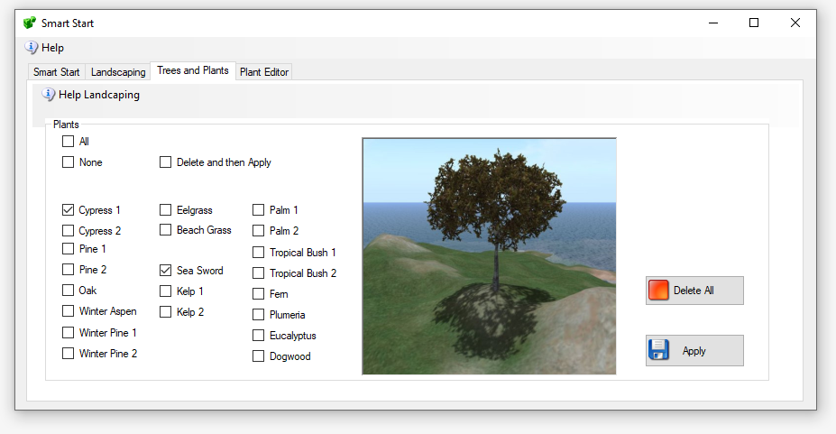

Apply: Plants the tree or plant that is selected. It will be placed on any chosen region when you click Apply.
Delete All. Deletes any AI-planted tree on this region.

Plant Editor
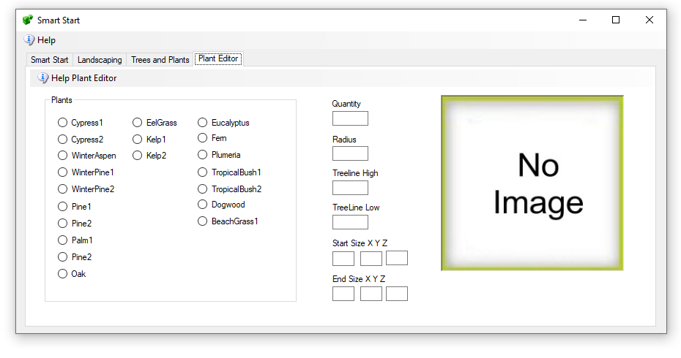
The Plant editor can modify any of the plants.
First, Choose a plant. They are categorized by a range of heights they will be placed within.
The larger trees are planted higher than grasses. The Eelgrass and Kelp will only be planted underwater.
Quantity - A random number of plants, from 0 to N plants, will be created.
Radius - The plants start in the middle and are sprayed onto the land in a circle. A radius of ~ 300 seems to fill most of a Standard 256 X 256.
Tree Line High – is the highest place a tree is planted.
Tree Line Low – is the lowest place a tree will be planted. Water is at 20 usually, so a 20 would be right to the edge of a beach.
Start Size X, Y, Z – The size of the tree at the start of the growth cycle.
Stop Size X, Y, Z – The size of the tree at the end of the growth cycle.

Port Settings and UPnP
Multiple TCP and UDP Ports are used in Opensim. The defaults are shown below.
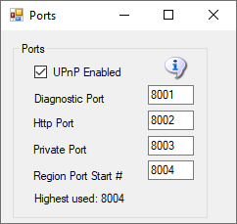
The defaults are 8001 (Diagnostic), 8002 (Public) , 8003 (Private) and 8004 (Starting Region). If you have manually added more regions, their region ports also need to be open. Each region that is used takes up one port. They start at 8004 and count up by one.

Port Forwards:
See the section on Troubleshooting Ports on how to manually set the ports.
UPnP Enabled: The Outworldz program uses Universal Plug and Play (UPnP) to automatically allow data to come from the Internet to your computer. This is called "Port Forwarding". UPnP capability may be disabled in your router, or it may not support it.
You may need to stop the SSDP Service to prevent this service from intercepting these messages.
If UPnP is enabled and your router supports it, DreamGrid will automatically open the correct ports. This can be slow and time-consuming, so you may prefer to disable UPnP and set your ports manually
Do you have Plug and Play (UPnP) issues? The DreamGrid help menu has a useful tool to look at uPnP in your router:
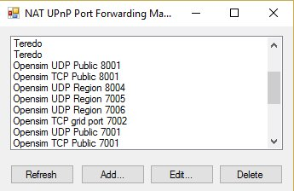
UPnp (Universal Plug and Play) Tool for Windows
You can add, delete, and modify the settings without a password, assuming you have UPnP enabled. This tool is available in Dreamworld and DreamGrid in the Help menu.

Troubleshooting Ports
A list of routers and instructions is at http://www.portforward.com which can help you identify your router type.
Step 1) Get your PC LAN IP address by going to a DOS prompt and typing 'ipconfig'.
In the above photo, my IP was 192.168.1.3. Yours is likely to be in the range 192.160.*.*, but it could also be a 10.0.*.* number. For my Linksys, it looks like this:

IceCast/Shoutcast
Ports 8080 and 8081 must be added when you are running the Icecast/Shoutcast server.
Which ports? You need to Port-Forward 8001, 8002, and 8004-8010 (or higher, I usually open up to 8050) to have room for expansion. You can also add 8080 and 8081 for Shoutcast/Icecast. Do not do 8003 for security reasons. These can usually be done in ranges, like 8001-8002 and 8004-8010. The latter ones are for regions - you need one port per region, so this would let you have 7 regions. Add more if you want - nothing wrong with opening up to 8020 or 8030 or so. In the above photo, I have opened ports 8004 through 8005.
They need to be open for both TCP and UDP. Your router will have a button or a pulldown to select UDP, TCP, or both. If you do not have a Both or All option, you have to add them twice, once for UDP and once for TCP.
How do I know this worked? You can tell if it worked by starting Opensimulator, and then use a web browser to go to http://www.canyouseeme.org, and enter 8002 while Opensimulator is running. Then click the Test Button at CanYouSeeMe. If that works, the ports are fine. If this does not work, try disabling your PC firewall. If this works, you must add exclusions to the firewall and then turn the firewall back on.
See Firewall Issues for help with the PC firewall.
Keep working with the router, firewall, antivirus exclusions and IP address until this test passes.

Loopback:
The second part that must work is loopback - either your router supports it, or not. You can immediately tell if your loopback works after running the above CanYouSeeMe.org tests. You use your web browser to navigate to http://(YOUR PUBLIC IP):8002. Mine was http://24.173.0.66:8002. Of course, your IP address will be different than shown here, so use whatever CanYouSeeme.org shows you. If the system is working, you get a web page.
If not, you must add a loopback adapter. Go to https://www.outworldz.com/Outworldz_installer/Loopback.htm and follow the instructions.
Then go to Hypergrid/DNS Name page and enter your desired Hypergrid name

Firewall Issues:
Windows will prompt you to allow Opensim to open ports when it first runs. If you say no, you will not be able to log in. I also set all the ports to be open in firewalls when you first click start.
If you are using an Anti-virus with a firewall, such as Zone Alarm, AVG Internet Suite, or anything else, running Start.exe may trigger the 3rd party firewall popup warnings. Opensim.exe needs to be allowed internet access, and Start.exe must be allowed to make changes to the firewall. If not, it will not work, and you will have to take manual action to fix it.
This code is safe and is digitally signed by me, Fred Beckhusen of Outworldz.com, and is open source and available for inspection at https://www.github.com/Outworldz.
You may have to manually add firewall rules to allow incoming traffic on the ports.
1. On the client operating system, go to Start>Run and type firewall.cpl. The Windows Firewall window opens.
2. Click on the “Advanced Settings” link on the left pane. The Windows Firewall with Advanced security window opens.
3. Click on the “Inbound Rules” option.
4. On the left pane, click on “New rule”.
5. Under “Rule Type” select the option “Port” and click next.
6. Select “TCP” and “specific local ports” options.
7. Key in the port number, the port is 8001-8010 (or higher for more regions)
8. Click Next.
9. Select the option “Allow the connection”.
10. Click Next, do not change any option here and click Next again.
11. Specify a name for this rule.
12. Click Finish.
14. Repeat the above but using UDP from step 6

More information about Opensim Ports
Here is more detail about ports and the way the interact with the outside world such as www.canyouseeme.org and to my diagnostics tests.
Put simply, only port 8001 and 8002 can report back to those tools as to being open and can do so only when Opensim is running.

Port 8001:
8001 is a TCP/HTTP port that is open for help->Network diagnostics. It is unique to Dreamworld and not to Opensim. It is used for a "port forward" test, just like Canyouseeme.org does, and for a loopback test. It collects data on sim's going up and down to change the icons and collects Partner information if two people click the partner prim.

Port 8002:
Opensim has a web server that web browsers understand, using the same protocol (TCP/HTTP) that tools like www.canyouseeme.org support. Put simply, Opensim is the only thing that listens to port 8002 and answers to http:// GET and POST requests on 8002. Port 8002 is like port 80, the default port for web pages. You can actually set Dreamworld's 8002 port to 80, and it will still work. You can then drop the need to type :8002 at the end of your hyperlink. http://hg.Osgrid.org does this. There would be no need to type the :80, as literally http:// means "add a :80 to the end of it".
8002 works with web based ‘GET’ probe tools. If you do switch it to 80, then you forfeit using an additional web server on your home machine as only one program can listen to a port.
If Opensim is not running and your ports are open, it is as if you tried to connect to www.google.com's web server, but their web server is down. Nothing will happen, though your packets can get through the Google firewall because it is still open to traffic and is steering it to a dead server. You will get no answer. Similarly, if Opensim is not running, there is no web server to answer the request.

Port 8003:
This port is used by Opensim to listen to region traffic. Regions chat to the server database for login, presence, and other services use it to talk to the region so people can teleport from one region to another. In Dream World, regions must be on the same machine. In DreamGrid, just like OsGrid or any other remotely attachable grid, the regions can run on any machine anywhere in the world.
If you opened port 8003 to anyone on the web, you expose the internal database protocol to the web. Anyone with the right knowledge could attach a region to your sim. If you run a DreamGrid and host regions outside your LAN, it is recommended you use firewall rules to only allow access from known IP addresses running approved regions.

Port 8004 and upwards:
The region ports (8004-upward) run both TCP and UDP. UDP is used for the viewer. UDP cuts the load on the server dramatically as there is no need to automatically always ACK every packet. As one example, no one cares if an audio stream gets briefly interrupted as you cannot hear it anyway, and it is too late to use it if it comes later in a retry. It just gets discarded.
For multiple regions in a single DOS box, all regions listen for TCP traffic on the last port used in that DOS box. As one example, if one region is in a DOS box by itself, and it is the first region, then it listens on both TCP and UDP on 8004.
If you had two regions in one DOS box, and they start at 8004, then the regions listen to UDP on 8004 and 8005, and both regions listen to 8005 for TCP traffic. You can check that the region is reachable on the Hypergrid only by using port 8005. 8004 will not respond, as it only listens to 8004 on UDP.
As a result, you can test regions with tools like Canyouseeme.org or a web browser

Links:
Port Testing: http://www.canyouseeme.org

Publicity Overrides
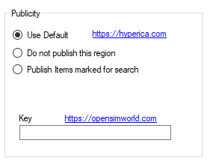
Publicity override can be used to publish or unpublish one region at a time to Hyperica.com.
Use Default uses the Settings->Publicity.
Do Not Publish will not send data to Hyperica.
Publish Items marked for search will send your grid location, description and any items you have martked for Show In Search in world.
OpensimWorld Key: You can enter your OpensimWorld key here for this region. Then you do not need the scripted box. Also, and Smart Boot Regions will be reported as online. This cannot be done by a script.

Publicity – Publish your Grid
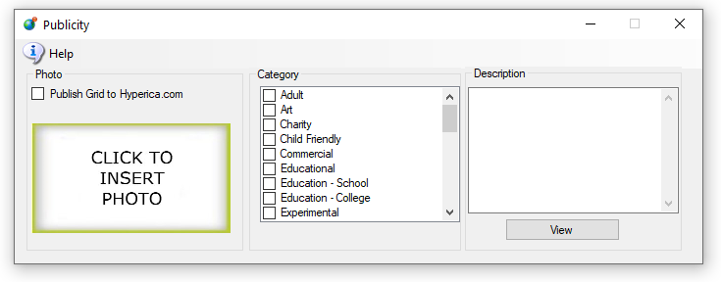
Publish Grid sends shows your grid in the list at Hyperica.com:
Categories are used to put you grid into the Destination Guide.
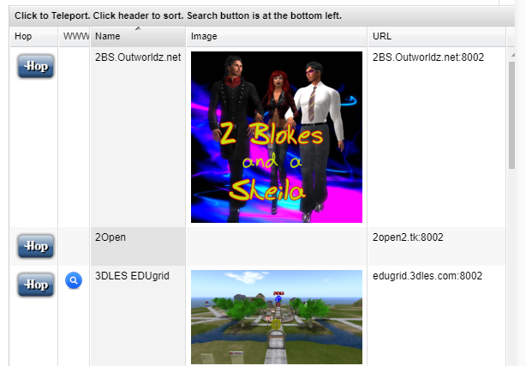

hotos: Click the box to load a PNG image and it will appear in your listing.

Region Panel
This panel has setting that are is specific to this one region. As an example, if you want maps to made Best quality for just one region, you can set it here. It will override the global maps setting for this region.

Region Basics
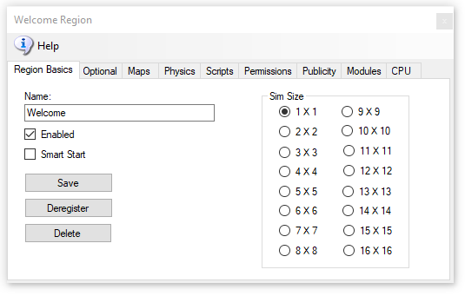
Give your region a name and click [Save].
Make sure it is Enabled. Smart Start is discussed in the Manual “Smart Start”.
Sims can be any size from 1X1 (256 X 256 Meters) to 16X16, with 64 regions. Larger regions take more RAM and cut the frame rate down considerably.
If you click [Delete], the region INI file will still be there, but the file name will change to .bak from .ini and will be ignored. This should automatically Deregister the region.
[Deregister] will remove the region from the Robust reservation list but not remove the region. A region that shuts off is deregistered automatically. But a crashed region cannot deregister itself.
The result is that you cannot place another region with a different UUID in the same registered place. Deregistering the region lets you move another region to the original position.
Smart Start Regions remain registered when powered down so that they appear on the map and appear as available. If your region still will not start due to it overlapping, type this into the Robust console:
deregister region id <UUID Goes Here>
Regions are stored by DreamGrid in OutworldzFiles\opensim\bin\Regions in folders by each DOS box name. The DOS box folder has a Region folder in it that holds the Region.ini file. See Rules for INI files at the bottom of this Help file for more details.

Options
This has optional items that are part of standard Opensim you may choose to change.
The Options page has the (x, y) Global location of the region on the grid. You can set regions next to each other by changing the X and Y coordinates and restarting the region. The X and Y is the lower left point on the global map.
If you get messages saying that regions overlap, change the coordinates to some substantial number and retry the region boot.
UUID: You can only change the UUID of the grid is stopped. Never change the UUID unless you want to start with a blank region again. Altering the UUID will force the system to create a new, blank region the next time the grid starts, and you will be forced to move your region to another spot if it is not deregistered. This is a read-only field when the grid is running. You can only change this by stopping the grid.
MaxAgents: The maximum number of agents that can be in the in the region at any given time. The default is 100.
MaxPrims: The maximum number of prims that the region will be listed as supporting. However, this limit is not currently enforced by OpenSimulator. Due to LL protocol constraints, the maximum limit that can be shown is 45000.
PhysicalPrimMax: The maximum dimensions of a physical prim. This is a single number which applies to X, Y and Z co-ordinates. This will affect resizing of existing prims. Default is 10.
NonphysicalPrimMax: The maximum dimensions for a non-physical prim. This is a single number which applies to X, Y and Z co-ordinates. This will affect resizing of existing prims. Default is 256.
ClampPrimSize: If true then if a viewer attempts to create a prim which has any dimension larger than the NonphysicalPrimMax, then that dimension is reduced to NonphysicalPrimMax. Default is false.

Map Overrides
The Map Overrides change this one region’s map making.
- None: No maps will be made. This is a good setting as the regions will boot very quickly. Any existing maps are kept.
- Simple but Fast: MapImageModule is used with just Land showing
- Good: Uses Warp3D module with just Land showing
- Better: Uses Warp3D module with Land, Prims, and land Textures showing
- Best: Uses Warp3D module with Land, Prims, Mesh, Sculpts, and all Textures including prims showing.

Physics Overrides
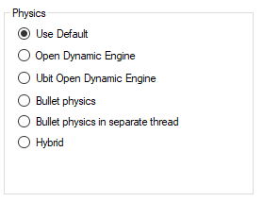
- ODE is a very old physics engine with many limitations. It does support Ninja Physics.
- UBODE is closer to Second Life in vehicle performance.
- Both BulletSim and UBODE support varregions.
- BulletSim provides the best performance and most functionality.
- Bullet in a separate thread prevents physics crashes from crashing the region. It is the default physics engine.
- ODE Ninja physics are documented in another manual

Script Overrides
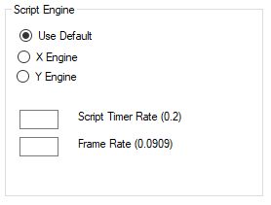
- XEngine is and older and very stable Opensimulator script engine.
- YEngine is a new engine that has better support for the llSleep() command. YEngine offers some features that improve performance and prevent timeouts. The problem with using llSleep function in Opensim scripts is that it may cause a script to freeze, requiring a reset. This is due to the way XEngine deals with running multiple scripts at once.
- The parse in Yengine is also like Second Life as it uses the same order when evaluating a series of expressions. XEngine parsed the order in the opposite direction from Second Life.
- Script Timer Rate is normally no faster than 1/5th of a second. It should rarely, if ever be faster than this. There are many less laggy ways to code a LSL system!
- Frame rate is how fast physics and other ‘steps’ are run. It is normally set to 1/11ths of a second, which is 1/5th of Second Life’s rate. Some systems can benefit by running this slower or faster.

Permission Overrides
Allow Gods: God mode is available to selected people if enabled. These levels can be set for individual users in the Web control panel.
• Level = 0 is a normal user
• Level = 50 (or a level you set) is used to indicate a privileged user (e.g. who can set up new Hypergrid linked regions)
• Level = 100 is a Wifi admin account user
• Level >= 200 can become a God
Estate Owner is God: If enabled, the region owner may go into God mode.
Estate Manager is God: If enabled, any region estate manager may go into God mode.

Publicity Overrides
- Publicity override can be used to publish or unpublish one region at a time to Hyperica.com.
- Use Default uses the Settings->Publicity.
- Do Not Publish will not send data to Hyperica.
- Publish Items marked for search will send your grid location, description and any items you have martked for Show In Search in world.
- OpensimWorld Key: You can enter your OpensimWorld key here for this region. Then you do not need to scriptred box.

Modules
- Bird module makes flocks of birds possible. See the help manual on Birds. This must be enabled for birds to appear in a region.
- Enable Tides makes the water level rise and fall in this region. See the help manual on Tides. This must be enabled for tide to appear in a region.
- Teleport Sign Enable lets you use a standardized Outworldz Teleport Sign to direct visitors in your world. This sign is located in the Content-Inventory IAR Load and Save ->Local IAR menu. There are multiple variations of the sign.
- Outworldz Teleport System V2.5.iar is a standardized sign for all uses.
- Outworldz Teleport System V3.9.iar is for testing of the Smart Start system and is subject to change.
- Disable all Gloebits should stop the Gloebits system on this region.
- Disable Foreign Visitors will prevent hypergrid visitors from entering your region.
- Disable Residents will prevent all resident from entering your region. Only Estate managers or owners can get in.
- Skip Automatic OAR backup will prevent the automatic OAR system from backing up this region.
- Announce visitors will chat any arrivals or departures.

CPU
The CPU tab lets you choose one or more cores for the region to run on. You can also set priority for the region.
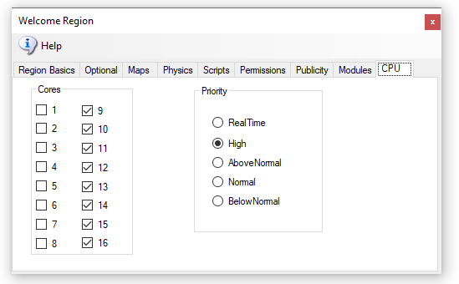
You can choose to set the process priority to Normal, High, Above Normal, Below Normal, or RealTime. Based on the time elapsed or other boosts, the base priority level can change when a process needs to be put ahead of others for access to the processor.
The processor affinity is the set of processors it has a relationship to. In other words, those cores it can be scheduled to run on.
A process thread can migrate from processor to processor, with each migration reloading the processor cache. Specifying a processor for a thread can improve performance under heavy system loads by reducing the number of times the processor cache is reloaded. The system schedules threads on their preferred processors whenever possible.

best use of “Real Time,” vs High, or using “low”
A scenery/low script region has no need for any optimization. It is already low lag, and load load. You need to think about these system-wide, and what the regions are doing under load.
You could just dedicate all such regions to Core 1 and set priority normal. If one person was in one of those regions, it would seem 'normal to them even if all other cores were hard at work. Opensim loves cores, so this may not be ideal, but it does protect that region from the other CPU cores.
Limit: Scripts or physics may need to be limited. A limit may be needed on large Satyr Farms. They make a great number of changes to prims which can swamp a server with MySQL writes. I can show you a half dozen regions on two different grids that write to SSD's as fast as possible - 7 to 15 MB a second! I upgraded one to more cores and it just wrote even faster. So these sims really need to be much lower in priority for CPU. It's horrible - a Contabo machine costing $50 a month is barely capable of running one region because of Satyr Farm!
Unlimited: The opposite example would be a racing simulation, where you want more responsiveness. Set that region to a higher priority. Look at ﻿@Cuteulala Artis﻿ wonderful organ simulation in your free OARs list near the bottom. This wonderful creation requires a faster script timer in region settings to play properly. It could potentially benefit from a higher priority above 'Normal' on a heavily loaded server.
Dedicated Cores is something else. To increase performance even more, you can dedicate one or more cores or more to a DOS box. Default is all cores are served to all DOS boxes. A dedicated core is more efficient as the system does not share the cores with other tasks and the hardware scheduler can make smarter decisions about this one DOS box.
Dedicated Cores are a marketable product. SL sells a dedicated core with one 256 X 256 region in it for $229 a month. We are not SL, obviously , but if someone wanted to sell a dedicated core for more than the usual fee, they can now.
Src: https://secondlife.com/land/private-pricing. It has a higher value than sharing a machine with all others.
Assume you are running a high CPU load on an 8-CPU Intel machine with hyperthreads so 16 cores are available. (AMD is not hyperthreadable). Assume also that the GUI in DreamGrid is lagging, or Windows is not being very responsive. You can set all your regions to use, lets say 14, of those 16 cores so two cores would be left for Windows and DreamGrid GUI, Robust, and Mysql, and other tasks without being bothered by Satyr Farm. ( I currently do not have code to dedicate a core to Robust and Mysql, but I will add that soon)

Rules for INI files

DreamGrid has several simple rules for *.INI files that differ slightly from stock Opensim.
- No Duplicates: Do not leave a Region.ini in one folder and the same Region.ini in another. All files such as Region.bak are ignored.
- The only thing you need to put in the SOME DOS BOX NAME\Region\ is one or more Region.INI files.
- All other files, such as Opensim.ini are automatically re-created when you start the region.
- The INI file name must match the [Region Name] inside it. This example region [Welcome] must be saved as “Welcome.ini”.
- Only one [Region Name] is allowed in an INI file.
- Use multiples of 256 such as 256X256, 512X512, and so on.
- Each region size can be anything from 256 X 256 to 1024 X 1024, or higher. Huge region sizes such as 4096 X 4096 can be used for flying or car racing. If you go over 8192 X 8192, you can expect it to be slow and laggy as the land size gets exceptionally large as it grows exponentially.
- You can replace 4 single regions with a single 2X2 region and there will be no lag when crossing the (nonexistent) border. Vehicles can move smoothly anywhere. Also, NPCs can move about freely. Look in any region settings panel and you will see a "size" box. Check the 2X2 box, save it, and restart the region. It will grow North and East and will be 4 times larger, overall. You will also need to move it in X and/or Y or delete the other regions as regions cannot overlap. You can shrink them, too, but objects that fall off the right and top edge will be lost.
Example of how regions are organized in the file system:
- Opensim\bin\Regions\SOME DOS BOX NAME\Region\Fred.ini
- Opensim\bin\Regions\SOME DOS BOX NAME\Region\Rak.ini
These two regions Fred and Rak will be in a single Dos box named "SOME DOS BOX NAME".
If you rename the folder "SOME DOS BOX NAME" to "Internet", they will be in a DOS box named "Internet". If you create a new folder named "HEY", like this:
Opensim\bin\Regions\HEY\
And then MOVE Region\Rak.ini into it:
Opensim\bin\Regions\HEY\Region\Rak.ini
You will end up with a DOS box named "Hey" with the Region named "Rak" in it.
The other Dos box will have just Fred in it:
Opensimulator\bin\Regions\SOME DOS BOX NAME\Region\Fred.ini

Region List
Open the Region Panel with Ctrl-R or go to Setting-Region.
There may be many Region.INI files in your system. These show up in this panel. The default is an island called "Welcome".

Refresh button
Click Refresh to rescan the system status and update this panel.

Details button
This screen shows the regions plus all the details on each region.
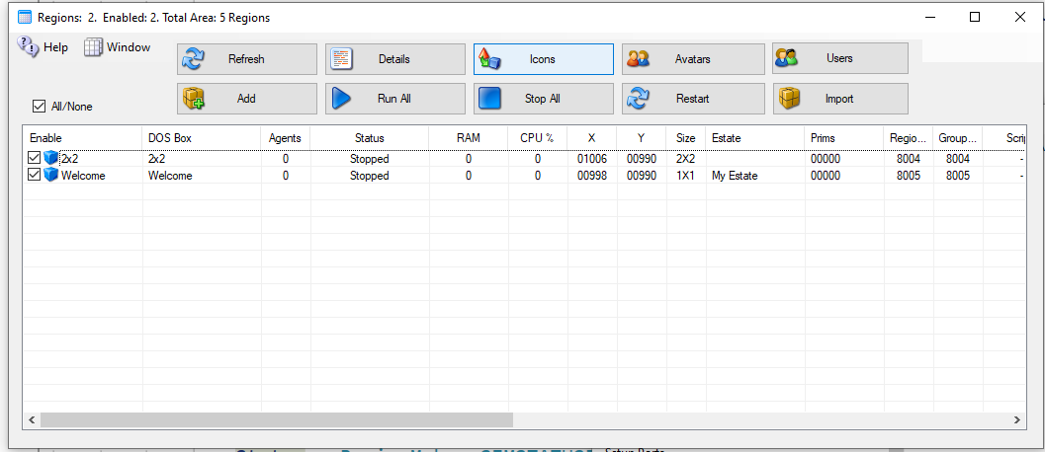
The Detail view can be sorted by Name, Group, Agents or Status by clicking the column name.

Icons button
This screen shows the Icon on each region. Clicking a Region opens the Region Editor.

Avatars button
This screen shows the Hypergrid and Local Visitors to your regions. If you have a viewer on the server, you can click the person and it will generate a Teleport link to that person.

Users button
This screen has a list of all registered users on your system.
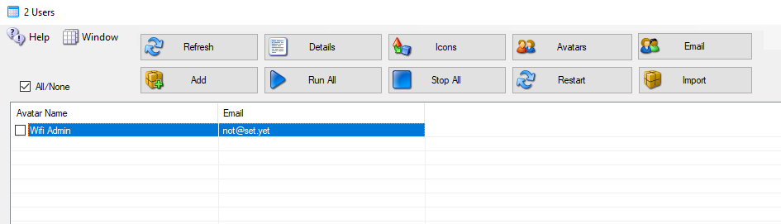
You can Checkmark each user to send an email to them. The Email button appears to top right

Add
Click the Add button to make a new region. You only need to give it a name and save it.

Run All Button
Runs all Checked regions.

Stop All Button
Stops all regions.

Restart Button
Restarts all checked regions.

Import Button
This button lets you find region.ini files from other system, such as the standalone Dream World or backups, and import the file into DreamGrid in a new or existing DOS box.

File Folder Arrangement
DreamGrid uses a slightly different folder setting than stock Opensim. You cannot just copy them over in a file explorer unless you make a special pattern of folders, with an extra set of folders inside it.
The format is:
Opensim\bin\Regions\DOS Box Name\Region\RegionName.ini
DreamGrid has several simple rules for *.INI files that differ slightly from stock Opensim.
- The INI file name must match the [Region Name] inside it. This example region [Region Name] must be saved as “Region Name.ini”.
- Only one [Region Name] is allowed in an INI file.
- All contents of a Region file are made by Dreamgrid and will be overwritten. See the Region Control Panel to change the settings.

Clicking a Region
A new panel appears if you click a region:
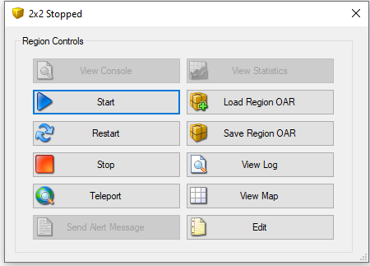

View Console Button
Shows the DOS Box console window.

Start Button
Starts this one region.

Restart Button
Restarts this one region.

Stop Button
Stop this one region.

Teleport Button
Generates a Teleport to the region in the viewer.

Send Alert Message Button
Send a region wide message to all users in the region

Load Region OAR Button
Loads an OAR into the region

Save Region OAR button
Saves an Oar from the region

View Log Button
Views the Opensim.log file

View Map Button
Shows the region Map.

Edit Button
Edits the region.

Region Stats
The region stats are a web-based data collector. First, choose a region:
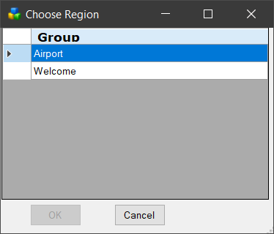
The first screen shows general statistics:
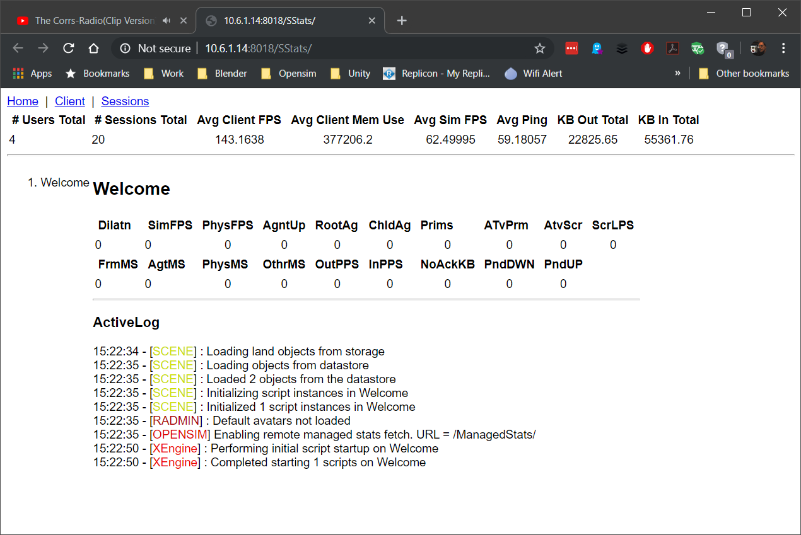
The client screen shows the types of viewers that have visited
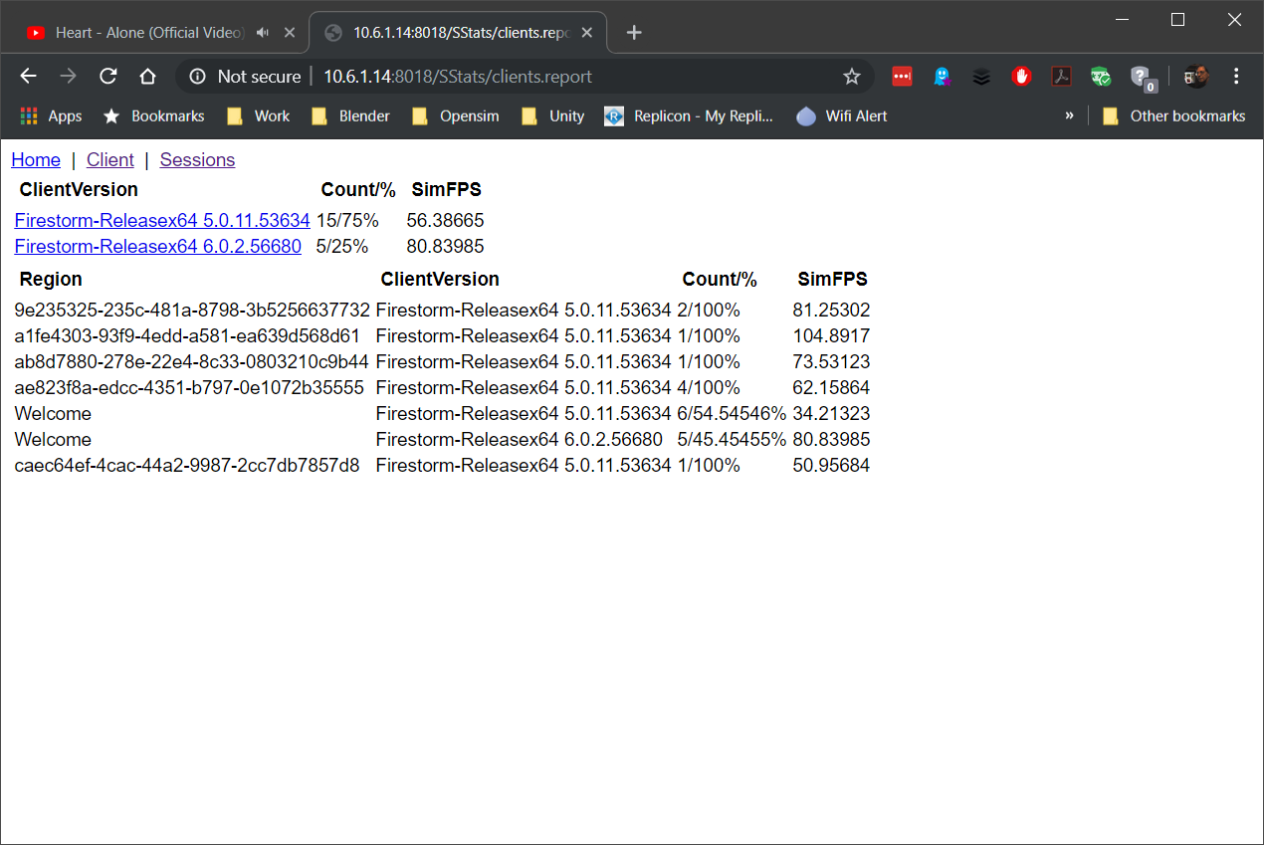
The Sessions screen shows the visitor list
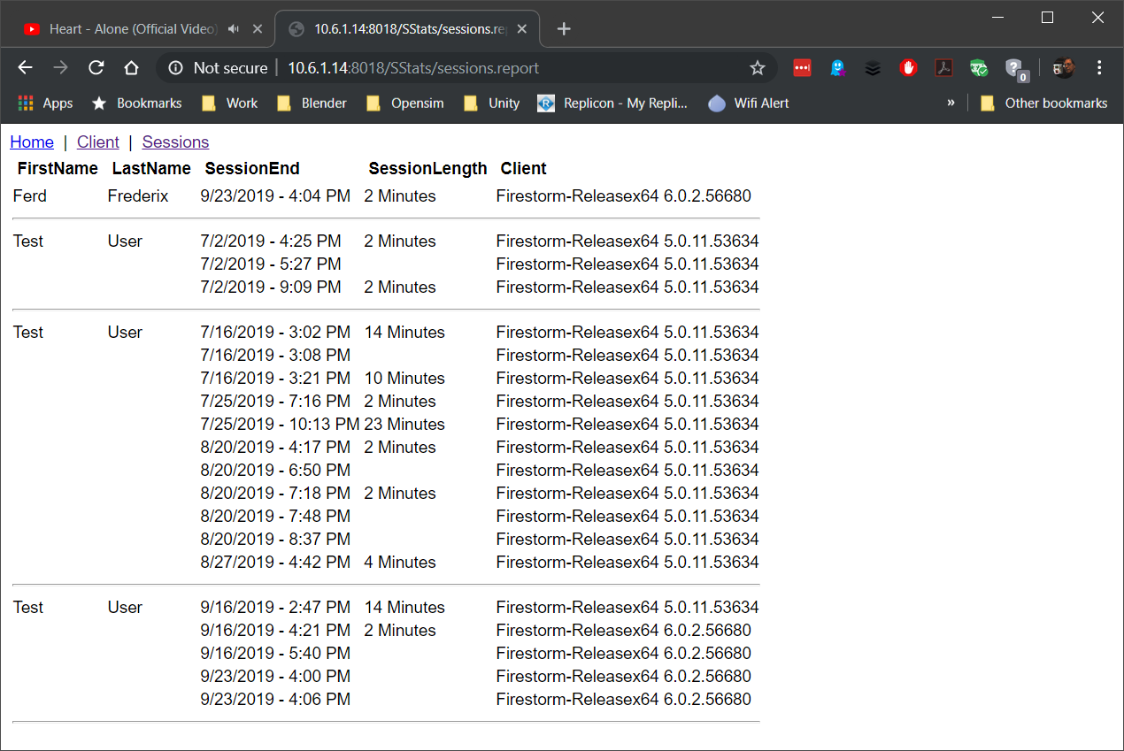

Regions
Region Settings holds various defaults for all regions.

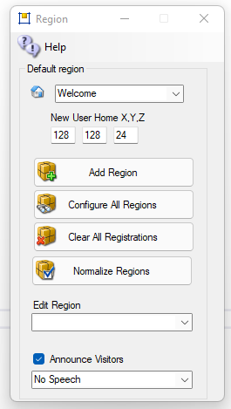
Default region for visitors: This is your “Welcome” region. Hypergrid visitors and people who log in for the first time get sent to this region. The region must be online.
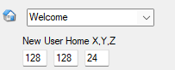
New User Home X, Y, Z: Users that create accounts on the web page will land at this spot on your Welcome region. Their home is set here. Default: 128,128,24
Add a Region: will bring up a dialog form for adding a new region.
Configure All Regions: will open all regions for editing.
Clear All Registrations: You may get an error when you add a region where another region once existed or overlapped. This operation will remove all registrations of all regions from the database. All regions, including Smart Boot regions re-register when the grid is booted.
Why is this useful? crashed region will leave behind this registration, and you cannot place another region in the same spot. Pressing this will deregister all regions so all regions can be moved. This button deletes all regions from the “present and accounted for’, region table in Robust.
This requires that the grid not be running. See below for more details in Troubleshooting.
Normalize Regions: The Javascript web map requires that the lower left corner starts at 1000,1000. This will move all regions so that the chosen region is at 1000,1000. All regions maintain their relative positions.
Edit Region: will bring up a dialog form to edit the selected region.
Announce Visitors: This is a global enable. Visitors that arrive in a region are chatted using Opensimulator’s Concierge module. The region must also have an override for “Announce Visitors” in the Modules section of the Region settings.
Speech Selection box: This setting uses a Microsoft or a 3rd party Speech Synthesizer to announce when visitors arrive or leave. You can choose Zira or David voices, or add a 3rd party voice by purchasing and installing a SAPI compatible voice.
This speech feature will not work on Contabo/ Windows Servers without there actually being a sound card. A vi\rtual sound card from one of these source may fix that.
https://github.com/duncanthrax/scream Scream - Virtual network sound card for Microsoft Windows
http://virtualsoundcarddriver.com/ Virtual Sound Card Driver
https://www.e2esoft.com/vsc/ e2eSoft VSC is a Sound Card Emulator
https://www.vb-audio.com/Cable/ VB-CABLE is a virtual audio device working as virtual audio cable. It creates Virtual Sound Card
https://vac.muzychenko.net/en/ Virtual Audio Cable (VAC) is an audio bridge between applications that transmits sounds, but it creates Virtual Sound Card

Treoubleshooting:
Region Error: if you add a region where another already exists, you may get this error.
2021-03-27 09:53:51,132 ERROR [GRID CONNECTOR]: Registration failed: Region overlaps another region when contacting http://192.168.2.139:8003/grid
2021-03-27 09:53:51,137 ERROR [STARTUP]: Registration of region with grid failed, aborting startup due to Region overlaps another region at OpenSim.Region.Framework.Scenes.Scene.RegisterRegionWithGrid() in C:\Opensim\Outworldz_Dreamgrid\OutworldzFiles\Opensim\OpenSim\Region\Framework\Scenes\Scene.cs:line 2384
at OpenSim.OpenSimBase.CreateRegion(RegionInfo regionInfo, Boolean portadd_flag, Boolean do_post_init, IScene& mscene) in C:\Opensim\Outworldz_Dreamgrid\OutworldzFiles\Opensim\OpenSim\Region\Application\OpenSimBase.cs:line 499
Robust says:
09:59:23 - [GRID SERVICE]: Register region conflict in scope 00000000-0000-0000-0000-000000000000. Region overlaps another region
One solution is to deregister it by hand. Go to robust and type this:
show regions < enter>
you get a list of all regions.

R.O.B.U.S.T.# show regions
Name ID Position Size Flags
Region 1016, 1007 0e871ad3-41ec-4eb5-8aad-96d9b5561803 1016,1007 256x256 RegionOnline
Region 1017, 1010 0f75a6ba-bbc0-4489-846d-a3aaa286c3ae 1017,1010 256x256 RegionOnline
Region 1017, 1008 1b47af46-9364-4cde-909c-a3173d98291f 1017,1008 256x256 RegionOnline
Region 1015, 1007 2302b841-11d3-4c2c-9ebb-0fce4c26beea 1015,1007 256x256 RegionOnline
Region 1013, 1009 4e69b298-c084-466f-b450-f34fbffa2238 1013,1009 256x256 RegionOnline
Region 1015, 1009 74f9d745-fa42-450b-96e5-0770eae37928 1015,1009 256x256 RegionOnline
Region 1016, 1009 a357ccd6-43d6-45ff-8563-35f09345908e 1016,1009 256x256 RegionOnline
Region 1017, 1007 c8775e97-ae1d-4164-8db8-ec205e46a148 1017,1007 256x256 RegionOnline
Welcome c91ceea4-77f5-40f6-afad-36f822097a4d 1016,1008 256x256 DefaultRegion, RegionOnline, DefaultHGRegion
Region 1015, 1008 dce9b253-789f-497a-b040-7df958262c69 1015,1008 256x256 RegionOnline
Region 1017, 1009 e819b0f7-86d7-4391-9064-67f6cb8708cd 1017,1009 256x256 RegionOnline
Region 1016, 1017 eab4f2bb-c92f-42fe-be92-30b29ba5a61b 1016,1017 256x256 RegionOnline
Find the region at the same coordinates as the one you are trying to boot. The one that is conflicting on my test server is this one at 10156,1009
Region 1016, 1009 a357ccd6-43d6-45ff-8563-35f09345908e 1016,1009 256x256 RegionOnline
This UUID is different than the one there previously. So it will not let the new region steal it.
Copy the UUID from, above: a357ccd6-43d6-45ff-8563-35f09345908e
Type in this:
deregister region id <PASTE UUID HERE>
R.O.B.U.S.T.# deregister region id a357ccd6-43d6-45ff-8563-35f09345908e
Deregistered Region 1016, 1009 a357ccd6-43d6-45ff-8563-35f09345908e
R.O.B.U.S.T.#

Auto Restart and Startup Settings

Opensim uses up increased RAM as people arrive and leave. Periodic restarting of regions is necessary to clear memory. You can set up a restart timer here.
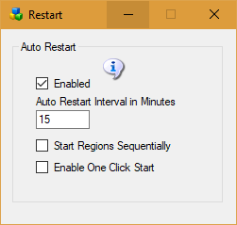
Dreamgrid will not restart a region if avatars are present. It will restart the region only after all avatars leave.

Enable: If enabled, the auto restart interval will be set to 1440 minutes, which is one day. If disabled, the regions will try to run forever.
Auto restart Interval: The number of minutes a region runs before it restarts.
0 = Off
720 is 1/2 day. 1440 is one day. 2880 is 2 days.
If Autobackup is enabled, this interval will be extended beyond the Autobackup Interval by 30 minutes to allow Autobackup to complete.
Start Regions Sequentially: Unchecked= start a new region every few seconds. This can overwhelm the database, memory and/or CPU on some systems. Checking this box will start each region sequentially it will wait for it to boot completely before starting the next. It will extend the waiting period up to 3 minutes. per region.
Enable One Click Start: If set, running Start.exe will automatically start Opensim without needing to click the second [Start] button.

Running the Grid manually

After the first run of DreamGrid, you can run Opensim, MySQL, and Robust without it.
The batch file Go.bat starts a command prompt with an instance of Opensim in it (an instance is a set of sims). The batch file launches Opensim with the settings it needs for the INI files and the Log file.
Step 1: Navigate to Outworldzfiles\ mysql\bin and run “StartManually.bat”. This will boot Mysql. StopMysql.bat is there which wil gracefully stop MySQL. You can also run (as an Administrator) InstallAsAService.bat so you do not need to start/stop MySQL. It will install itself in Services.msc and start when Windows runs.
StartManually.bat
Do not close the MySQL box. Use this batch file:
StopManually.bat
Step 2. Run “Outworldzfiles\Opensim\RunRobust.bat” which starts Robust
RunRobust.bat
Step 3. Run Outworldzfiles\Opensim\go.bat, which starts any region by Instance (Dos Box) Name.
go Welcome
This is the batch file "StartManually.bat" which does multiple items in sequence:
@remarkable batch file to start DreamGrid manually.
cd mysql\bin
start startmanually.bat
cd opensim
call runrobust.bat
call go Welcome
call go AnotherRegion
add more region names here

Save IAR
OpenSimulator Inventory Archives (IARs) are a means by which inventory folders and items can be saved offline to a single file (an IAR). This file can then be loaded into a different OpenSimulator installation.
Like Opensim Archives, IARs save all the necessary asset data to fully restore the items including textures, sounds, scripts, and objects contained in the inventory of other objects.
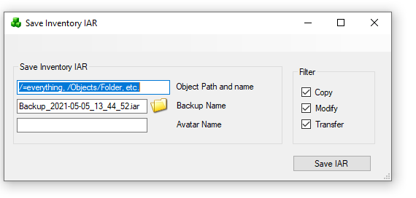
The command to save an IAR on the region console is
save iar [-h|--home=<url>] [-v|--verbose] [--noassets] [--perm=<permissions>] <user-name> <path> [<filename>]
where <user-name> is the name of the user to save inventory.
<path> is the path to an inventory item or folder. If the path is for a folder, that folder and all its contents (both descendant folders and items) are saved. If the path is for an item, then only that item is saved.
Components of the path are separated by a forward slash ("/"). If you need to specify a path with spaces, you can surround the whole thing with double quotation marks (e.g. "Folder A/Folder B")
You can specify that the contents of a folder should be saved rather than the folder itself using the * wildcard. For instance, "a/b/*" will save the contents of folder b but not folder b itself.
If a name or folder contains a forward slash ("/") then it can be escaped with the backslash (i.e. "\/") to stop it being seen as a path separator. Back slashes themselves need to be escaped with another backslash (i.e. "\\").
One further issue here is that it is not possible to distinguish between identically named folders or items on the path - the workaround is to rename your items/folders if you need to specify them in the path :)
filename> is an optional filename for the IAR. If none is supplied, then the filename user-inventory.iar is used in the current directory. I recommend that IARs have the .iar extension.

Switches
If the --noassets option is specified, then the archive will be saved without assets. This can be handy if you are backing up the asset database separately and do not want the expense of including all the assets in each archive.
--home=<url> is the URL of this world's profile service. It is not required that the profile service is operational; the information will be saved, and it will be displayed wherever the archive will be loaded. NOTE: the older --profile option (the previous name of this switch) produced IARs that are not compatible with OpenSimulator 0.7.0.2 and earlier; do not use this option if you want to produce a compatible IAR.
--verbose prints out verbose saving messages
When the C/MX switches are set, the --perm option is specified, and items with insufficient permissions will not be saved to the IAR. This can be useful for grids that allow their customers to export their inventory to IARs, because it ensures that exporting to IAR cannot be used to bypass content permissions.
<permissions> specifies which permissions are required. It is a string that contains one or more of these characters:
"C" = Copy
"T" = Transfer
"M" = Modify
Examples
Here is an example. Suppose you have an inventory structure like this
My Inventory
|
+-- FolderA
|
+-- FolderB
| |
| +-- ItemX
|
+-- ItemY
If you type:
save iar John Doe FolderA PASSWORD my-items.iar
then FolderA and everything in FolderA (FolderB, ItemX and ItemY) will be saved into an IAR called my-items.iar. On the other hand, if you type
save iar John Doe FolderA/FolderB/ItemX PASSWORD my-items.iar
then only ItemX will be saved.
If there is a space in the path to the item, for example if John Doe's folder was named "Folder A" instead of "FolderA", then quotes around the path are necessary on the command line:
save iar John Doe "Folder A/FolderB/ItemX" PASSWORD my-items.iar
Saving an entire user's inventory
With save iar you can save your entire inventory as well as the contents of particular folders or individual items.
For instance, typing
save iar John Doe / password

Script Settings
Default Engine for scripts is XEngine.
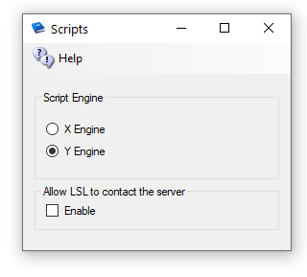
YEngine is a new engine that has better support for the llSleep() command. YEngine offers some features that improve performance and prevent timeouts.
The problem with using llSleep function in Opensim scripts is that it may cause a script to freeze, requiring a reset. This is due to the way XEngine deals with running multiple scripts at once.
The parse in Yengine is also like Second Life as it uses the same order when evaluating a series of expressions. XEngine parsed the order in the opposite direction from Second Life.

Allow LSL to contact the server:
By default, OpenSimulator does not allow scripts to make HTTP calls to addresses on the simulator's LAN. This stop LSL from scanning your ports inside your firewall. If you need to allow scripts to make some LAN calls, enable this checkbox. We recommend that you do not enable this unless you are very sure about what you are doing. When disabled, it will allow access to no ports on the server. You can see more in Opensim.proto - search for OutboundDisallowForUserScripts.
Default: Unchecked

Robust and Server Type
This menu item “Server Type” lets you choose from either a Grid Server with Robust, or from different Region Server choices to connect to another grid.
You MUST first run as a regular grid, then switch to a region server. DreamGrid needs certain tables in robust, even though regions do not use them.
After it boots, stop the grid, drop the Welcome region it created, and make a new region at a free spot coordinate on the OsGrid map. Then you can change to a region server.
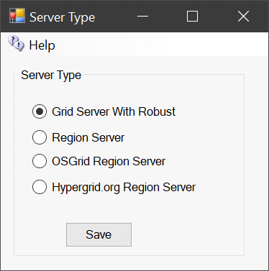

Grid Server with Robust
A grid server is modeled after the World Wide Web, with independent domains. Content is spread across small, independent and on large domains, independently, yet interlinks. Robust is the service that lets Hypergrid users enter each world. A Grid Server can also support regions locally. A grid server can host as many Region servers as its memory and CPU capacity allows.

Region Server
A Region server uses a separate DreamGrid Robust Grid Server for all assets and login services. Only regions and their content are stored locally. The grid server may be on the same LAN, or on another WAN. A Region Server always uses the same Domain Name and port as the Hosting server.
In cases where the Grid server is on a different WAN IP address, you must also enter the Region Servers IP address or domain name in the Region Ports setting:

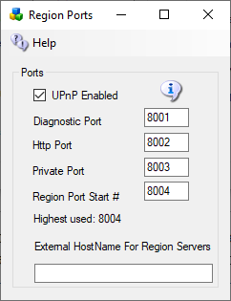
UPNP may be checked, if so, there is no need to port forward. It will be unchecked if it does not work. If you have more than a few regions, it is faster to port forward all ports and leave UPNP off.
The Diagnostic port default is 8001. This is
The HTTP port is set to 8002, or whatever your Host server is set to. 8002 is the default.
Private Port MUST be the same as the Robust Private Port. Default is 8003. This port is blocked at the Robust server. You must go to the host server and port forward that Port 8003 and make sure that the Windows firewall only allow the region server in by its IP Address.
Region Port Start # Default is 8004.
Highest Used shows how many ports MUST be open and forwarded. DreamGrid can do this with UPNP in the router and it does it automatically in the Windows Firewall.
External Hostname: If on the same LAN as the Host Robust machine, this can be left alone, as port forwards do the work. If on a Different WAN, the IP address of DNS name of the Region Server MUST be entered here.

OsGrid Region Server
The OsGrid region server is a preconfigured region server already set up to connect to OsGrid.
The port values are hard coded in a separate set of INI files used for OsGrid.

Hypergrid.org Region Server
The Hypergrid.org region server is a preconfigured region server already set up to connect to Hypergrid.org.

Smart Start

Smart Start regions shut down when no one is in them. A Smart Start region appears as a dual blue arrow ’recycle’ icon in the Regions panel. This means they boot once., then power off and wait for a teleport before they start again. The icon is a Pause symbol.
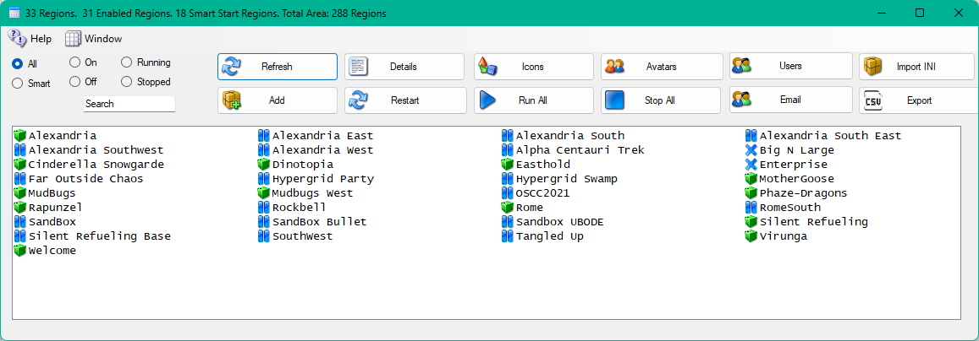
It can also appear as a ‘frozen’ ice cube. This type is frozen in RAM. All the treads it was executing are put to sleep, but it remains in RAM. Windows will see this as inactive RAM and will swap the region to disk when RAM is needed for another process. When a teleport occurs, the region is thawed out, and runs again.

Teleports
Smart start detects teleports. When someone teleports into the system, or logs in, the system decides if their destination is already bootet. If so, the teleport happens normally. But If the region is not ready, the system sends the avatar to a waiting area while the region is booted. When the original destination region is ready for logins, the avatar is teleported to the original destination.

Enable Smart Start
Smart Start is disabled by default. You must first enable it in Setup->Settings->Smart Start:
There are two modes: Suspend or Shut Down.

Shutdown Mode
When set to Shutdown Mode, the system will boot all regions and then power it off ‘quit’ after the “shutdown In Seconds” passes. This registers the region as “Persistent” in Robust, so you can teleport to it. If the region is shutdown, or offline, DreamGrid will move you to a temporary parking area, or it may cancel the teleport. DreamGrid will announce how long it takes to wait for the region while it is booted. When the region is ready, you will be sent there.
The system can be set to power down the region when no one is in it. This length of time is from 15 seconds upward. If no one is in the region, it will power down after the timer expires.
There is a Region Ready Delay that is adjustable. DreamGrid cannot know when a region will accept teleports due to the way regions are coded. A delay of from 5 to 30 seconds may be required. Regions with more data and/or scripts will take more time. If you get teleport fails yet the region is running, increase this time.

Suspend Mode
When set to suspend, the system will boot all regions and then power it off after the “shutdown In Seconds” passes. It works the same way as Shutdown in the way teleports work. However, after the region has run long enough for the timer to expire. It is not powered off. It is frozen. It remains in RAM. The icon is an ice cube.
You will not be able to type or interact with a frozen region. You can thaw the region by clicking on the region name in the region panel. Then click “Console”. The region will be unfrozen.

Surrounding Sims
Smart Boots can boot surrounding sims when a visitor arrives. The default is to not do this (Fill Size = 0)
If you set the fill size to 1, and an avatar lands in a sim, then any Smart Start regions that touch the region will be booted. If the avatar moves to one of those, then additional regions surrounding that region will boot.
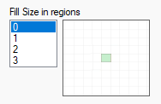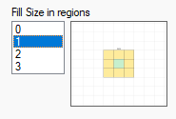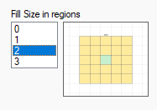

Details
These regions will always boot once to register themselves. The Smart Settings only go into effect when the entire grid restart, or Robust restarts and the Region restarts. If you change a region to Smart Start while robust is running, Robust will restart.
Any teleport request is intercepted in Opensim and sent to DreamGrid. The desired Region UUID is sent, such as "000-A…" and DreamGrid returns "UUID -000A…" if the region is ready, or UUID = 000-B…, or a Parking other region UUID, if not ready.
You get a message in the viewer saying your region will be available in so many seconds. This is the recorded time it took to previously boot the sim. There is a different time saved in a Map Time variable if maps are enabled. Ideally, maps are off for fastest boot time.
The region must be a) enabled to boot b) Smart Start is enabled globally, c) the region must be Smart Boot-enabled in its Modules section of the region setting for this region. It then shows the Pause icon of || in the region listings. If this is set, the region will power up. All 3 conditions must be met.
Once DreamGrid determines the timer is finished, you will be located wherever you are (if still on the grid) and teleported to the destination. If you leave, the system will shut off the region. The last teleport always overrides the earlier one. If you try three different landmarks in a few seconds, then you will end up in the 3rd.

Choose a Parking Region
If a region is offline and a teleport is initiated, the region will be booted. This may take more time than the viewer allows. The avatar is teleported to a waiting region, aka, a “Parking Region”. You may choose any Always-On region, such as your Welcome region, which is the Default.
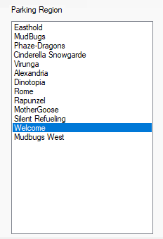

Region Setup
You must enable Smart Start in the region panel.
This can be enabled or disabled for any region. Edit any region and set the Smart Start Checkbox to True. This goes into effect immediately.
If the region is running and no avatar in it, it will shut down within the time period you set.
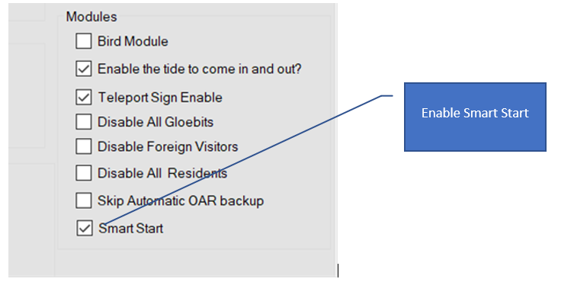

Enless Land and Sea
This optional feature will trigger an automatic fill of surrounding regions with the Landscaping and Trees/Plants modules if an avatar arrives. In those screens you can choose water regions, as just one example. If set to water, your avatar can walk, fly, or boat across the entire expanse of your grid. Its literally an “Endless Sea”.
You should select an avatar that will own the Estate named “SimSurround”, which is the owner of these Regions.
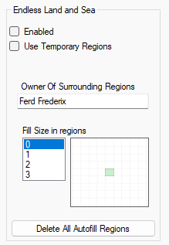
When enabled, and the Fill size is set to 1, then any avatar arrival in the center will generate a new set of regions surrounding that region. These regions may be Temporary or Permanent. If set to Temporary, when the avatar leaves, the regions will be deleted, and all traces of the region deleted. There is also a button to delete all these regions on demand.
This setting shows Temporary regions are Enabled, and when an avatar arrives in a region, a new DOS box will be generated with 48 regions surrounding the center region.
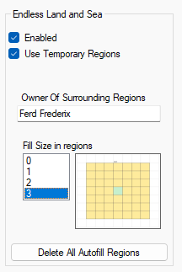

SSL Certficates
The SSL setup screen lets you create a free SSL certificate for Apache. This certificate will automatically renew.
The process is simple and automatic.
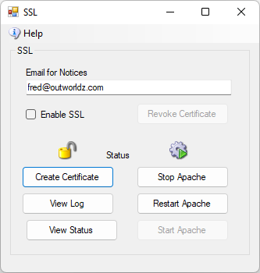
Step 1. Click “Create Certificate”. The System will take about one minute to create and authorize the certificate. This will create the SSL Certificates. Wait a minute and the icon will show green or it will show it unlocked.
Step 2. Click the Show Log button.
Step 2. Stop and Start Apache. Or click Restart if it is available.
If you want to see it in action, just run the batch file in the \SSL folder. You need to type CMD and run CMD as Administrator. The n type cd … to get to the SSL folder, and type this.
InstallSSL.bat {enter}
That's basically what the Create Certificate button does. DreamGrid makes that batch file and runs it. It captures the output to a log.
If the batch file reports success, DreamGrid will enable the Apache server to use Certificates. These go into effect when Apache restart
.

Troubleshooting:
There are some rules:
- You must be running the Apache webserver.
- Apache must be using port 80. After this step completes you can use port 443 for SSL.
- You must be using a domain name in Setup->Settings->HG DNS Name.
- The domain must be accessible from the Internet so the system name can be validated. A simple test is to see if canyouseeme.org works on port 80. Then try your domain name + :80

There is a log specifically for SSL issues. It is located in Outworldzfiles\Logs.
2022-01-29 00:53:30:OK: A simple Windows ACMEv2 client (WACS)
Software version 2.1.20.1185 (release, pluggable, standalone, 64-bit)
Connecting to https://acme-v02.api.letsencrypt.org/...
Scheduled task looks healthy
Please report issues at https://github.com/win-acme/win-acme
Running in mode: Unattended
Source generated using plugin Manual: smartboot.outworldz.net
Overwriting previously created renewal
Using cache for [Manual] smartboot.outworldz.net. To get a new certificate within 1 days, run with --force.
Store with PemFiles...
Exporting .pem files to C:\Users\Fred\Desktop\Dreamgrid\Dreamworld\OutworldzFiles\Apache\Certs
Installing with None...
Scheduled task looks healthy
Next renewal scheduled at 2022/3/25 5:40:43
Certificate [Manual] smartboot.outworldz.net created
2022-01-29 00:53:31:Info:Certificate installed

Streaming MP3 files in Opensim
MP3 files can be used to make region and parcel-wide background sounds.
The files are located in Outworldzfiles\Apache\htdocs\Audio. You can add your own audio files there.
This selection of background sounds is CC-0 so can be used anywhere with no license restrictions.
You can play one sound at a time per parcel using your DreamGrid Apache web server. Apache must be enabled and running for this to work. You can divide up your land into small parcels and play different audio sounds in each parcel
- Oceans
- Forests
- Snow
- Rivers Caves
- and Streams
- Waterfalls
How does it work? It plays on a sim-wide on a special image.
These are the steps to play MP3 files continually on your region or parcel.
1. In your viewer, go to the About Land Menu:
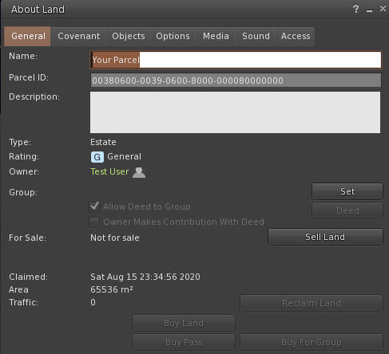
2. Change to the Media Tab:
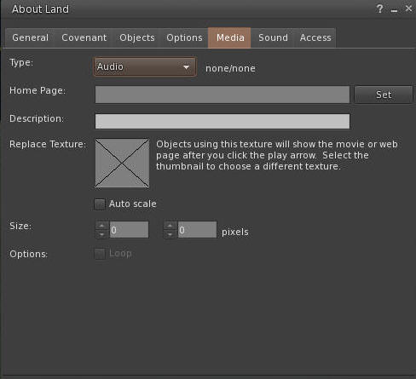
3. Click the Set button and enter the URL of the desired sound. You can click the link, and copy and paste the path.
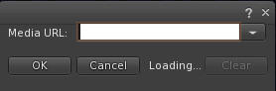

4. You need a unique texture not used before. This PNG file works well. Right click and save it, and then upload it to your viewer.

Drag and drop the Audio.png file into the X window so it appears like this. You need to use the web URL for your grid, typically http://something.outworldz.net:80/Audio, where ‘something’ is your chosen URL. You can get this link in the Help menu in the fist selection. Then change the port to whatever port you use for Apache, in Settings->Apache.
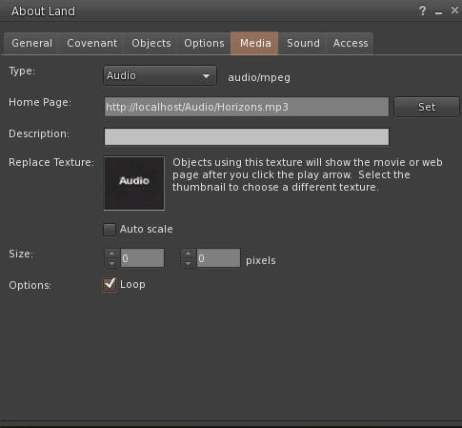
Make a prim or find a hidden face on a prim. Click "Select Face". Choose one face only! Drag and drop the image onto one fac.
e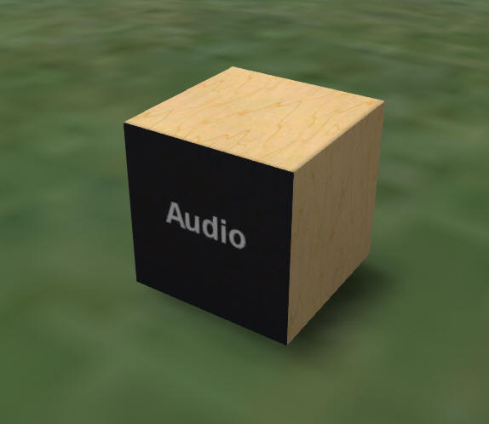
Now click the movie camera at the top right of your viewer:
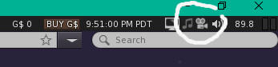
Enjoy your new background sound!

Streaming MOVIE files in Opensim
Apple’s MOV files can be used to make region and parcel-wide video players. The Video you see here is located in Outworldzfiles\Apache\htdocs\Video. You can add your own Video files there.
You can play one video at a time per parcel using your DreamGrid Apache web server. Apache must be enabled and running for this to work. You can divide up your land into small parcels and play different audio sounds in each parcel.
- Help Screens
- Movies
- About Your Region
How does it work? .MOV files can be streamed n a special image.
These are the steps to play Video files continually on your region or parcel.
1. In your viewer, go to the About Land Menu:
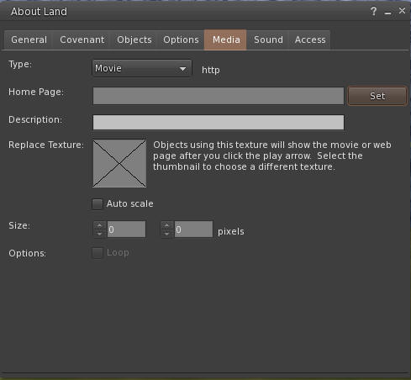
2. Change to the Media Tab:
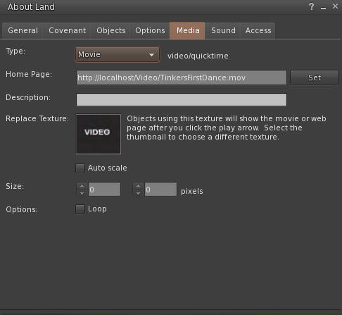
3. Change to the Movie Pulldown
3. Click the Set button and enter the URL of the desired video. You can click the link to the sample, and then copy and paste the path.
or just use http://localhost:80/Video/Tinkers First Dance.mp4
4. You need a unique texture not used before. This PNG file can be used. Right click and save it, and then upload it to your viewer.

Drag and drop the Audio.png file into the X window so it appears like this. You need to use the web URL for your grid, typically http://something.outworldz.net:80/Video/TinkersFirstDance.mov, where 'something' is your chosen URL. You can get this link in the Help menu in the first menu selection. Then change the port to whatever port you use for Apache, in Settings->Apache.
Make a prim or find a hidden face on a prim. Click "Select Face". Then choose one face only! Drag and drop the image onto one face only.
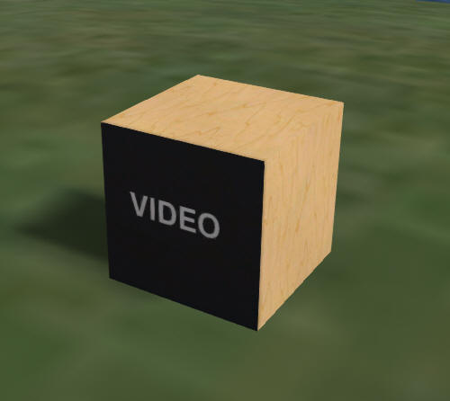
Now click the movie camera at the top right of your viewer:
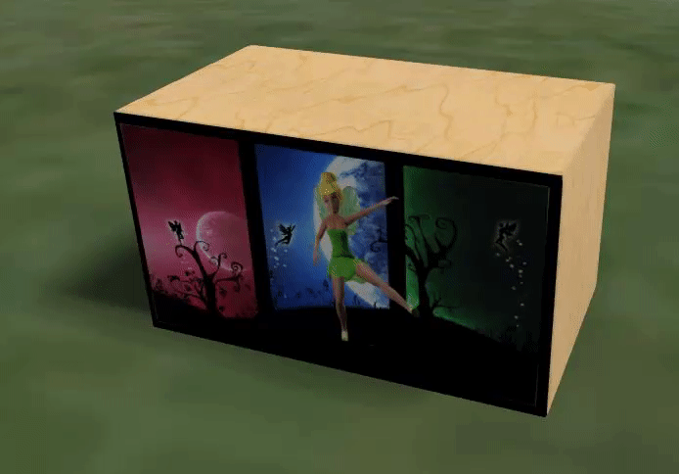

Terrain

The Terrain let The Landscape modules lets you add terrains and plants to any region.
The left side has 4 types of auto or premade terrains. The right side lets you browse and apply to any region any saved Terrain.

Menu:
- Load Terrain – You can choose any of the many pre-defined terrain files or browse to another location. The system supports PNG, RAW, R32, and TER (Terragen) formats
- Save Terrain – The system will save the selected region file in the above 4 formats along with a JPG image.
- Save All Terrains – The system will save the selected region file in the above 4 formats along with a JPG image in all running regions as well as all Idled Smart Start Regions.
- View Terrain Folder - open file explorer to the Opensim\bin\Terrain\ folder

Terrain Section
The left side has a set of functions for what effect to apply to the land.
Options: These modify the chosen effect
Just Options – ignore the terrain land, just apply the options.
Smooth: smooths the land. The smoothing operation is somewhat different than the others, as it does not deal with elevation values, but rather with strength values (in the range of 0.01 to 0.99). The algorithm is simplistic in averaging the values around a point, and is implemented as follows:
The "strength" parameter specifies how much of the result is from the original value ("strength" * map[x,y]).
The "taper" parameter specifies how much of the remainder is from the first ring surrounding the point (1.0 - "strength") * "taper". There are 8 elements in the first ring.
The remaining contribution is made from the second ring surrounding the point. There are 16 elements in the second ring.
e.g.
terrain modify smooth 0.5 -taper=0.6
- the original element will contribute 0.5 * map[x0,y0]
- each element 1m from the point will contribute ((1-0.5)*0.6)/8 * map[x1,y1]
- each element 2m from the point will contribute ((1-0.5)*0.4)/16 * map[x2,y2]

Noise - The smooth value represents a delta amount (at centre of range)
Taper - represents a delta amount (at edges of range)

Land Types
Flat – Land is always flat. The Option “Noise” will make the land bumpy. This makes nice underwater if the Option for Height is set below water level of 20 meters.
Random Terrain - uses one of the saved terrains. Options can apply
Water – The same as flat land with Height set to 0
Generated – a series of steps are applied:
- Options are set for Min Level between 22 and 40 meters
- Taper between 0 and 135 meters high
- Upon setting Apply the system will have:
- One in 6 chance fill of land at Height meters with the random taper
- One in 6 chance for low lying land at 12 meters with lots of noise
- One in 6 chance for center to be squared from 20 to 40 meters with the random taper
- One in 6 chance for water level with a variable raised bump with noise
- One in 6 chance for water level with a variable raised bump

Text to speech

DreamGrid has a text to speech converter that can make wave and mp3 files from text. These files can be played by your viewer in-world by uploading the wav file, or by playing either wav or mp3 using media on a prim.
This feature is still in development, but the basics shown here will remain unchanged.
An API allows LSL scripts to request Mp3 files by name for media-on-a-prim use so that products can talk in-world, without uploading as wav files.

Requirements
You must have a sound card to use this feature. VPS Servers typically do not have sound cards. Physical servers as well. There are several solutions:
- If you have physical access to the server, plug in a USB sound card.
- If you do not have access, you can install a virtual sound card.

GUI
This GUI makes the files.
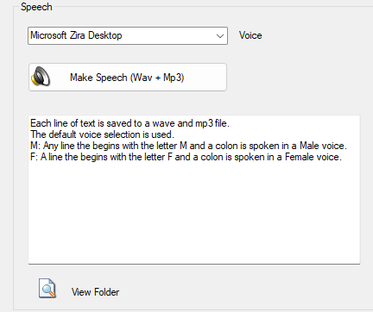

Voices
Windows 10 has four speech engines including two that are enabled by DreamGrid. Windows 7 comes with just one voice, typically Microsoft Anna.

You can find SAPI5 voices that are on your machine in the Control Panel. You are looking for the Text to Speech window, which is hidden away in the Speech Recognition settings in Control Panel. Some SAPI5 voices may be hidden (e.g., Acapela voices) but the ones you can see there can work in any program that uses SAPI5.
You may add more SAPI5 voices by purchasing. Sources of compatible speech systems:

Vendor | URL
Acapela | https://www.acapela-group.com/
Cereproc | https://www.cereproc.com/en/buy-voices
Ivona | https://nextup.com/ivona/
AT&T | https://nextup.com/attnv.html

Use
You can control the speech in several ways.
Any line beginning with M: will speak in a male voice. F: will speak in a female voice. Any line without a letter is spoken in the pre-selected voice.
Select the desired engine and click the button:

Then click View Folder

The folder should show a list of wave and MP3 files. If you have Apache enabled, these files are available as web files at http://YOURDNSNAME.outworldz.net/TTS

API
You can make the system speak over the Web, or by using Media On A Prim (MOAP)

Parameters:
TTS= Something to say
If a line begins with M: it will speak in a Male voice
If a line begins with F: it will speak in a female voice
Sex=M it will speak in a Male voice
Sex=F it will speak in a female voice
Voice=Zira|Mark|Some SAPI5 voice name

APIKey=123 must match the Voice password set in the settings->Speech Panel
Speak=Any value will cause it to speak using the default voice device, typically the servers’ speakers.
The response should be the world "Spoken"
If Speak is left off, a 301 Redirect to the mp3 will be sent
Minimum URL to say "Hello" in the default voice:
http://127.0.0.1/TTS/tts.plx?&APIKey=123&TTS=Hello

If your Apache port is not set to port 80, you must add it:
http://127.0.0.1:80/TTS/tts.plx?&APIKey=123&TTS=Hello

Speak Default Voice out of the server speakers. The HTTP responses is a 200 OK and "Spoken"
http://192.168.2.139/TTS/tts.plx?&APIkey=123&Speak=1&TTS=Hello

Use Ziras voice to say 1 2 3 4 5
http://127.0.0.1/TTS/tts.plx?TTS=test 1 2 3 4 5&Voice=Zira&APIKey=123

Force a Male voice to say A B C D
http://127.0.0.1/TTS/tts.plx?TTS=A B C D&APIKey=123&Sex=M

Force a Female voice to say A B C D
http://127.0.0.1/TTS/tts.plx?TTS=F:A B C D&APIKey=123

Force a Specific voice to say A B C D
http://127.0.0.1/TTS/tts.plx?TTS=A B C D&APIKey=123&Voice=Zira
http://127.0.0.1/TTS/tts.plx?TTS=A B C D&APIKey=123&Voice=Mark
http://127.0.0.1/TTS/tts.plx?TTS=A B C D&APIKey=123&Voice=Eva
If you get a cached response, you can add a random number to the end with ?r=some number or phrase:
http://127.0.0.1/TTS/tts.plx?TTS=F:A B C D&APIKey=123?r=1million

.

Tides Module
The tide module makes water go up and down. It has a buoy with a script to make boats and objects float with the changing water level. It must be used on a single sim surrounded by water.
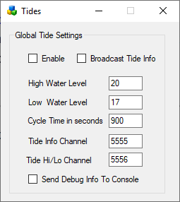
Enable: If set, Tides are enabled globally. Individual region Tide setting must be enabled to make the water go up and down in each region.
Broadcast Tide Info: This must be checked to send tide level info to the provided buoy. It uses channel 5555.
High Water Level: default 20 meters
Low Water Level: default 17 meters
Cycle time in seconds. default 900 seconds = 15 minutes
Tide Info Channel: As the tides rise and fall, a tide level command is broadcast on this channel. This must be set to 5555 for the provided script to work.
Tide High Low Channel: An announcement will be made on this channel when the tide is at a high or low level.
Send Debug Info to console: will send chat to the regions console for debugging.

Buoy:
A floating buoy is provided in the Load Local IAR menu.
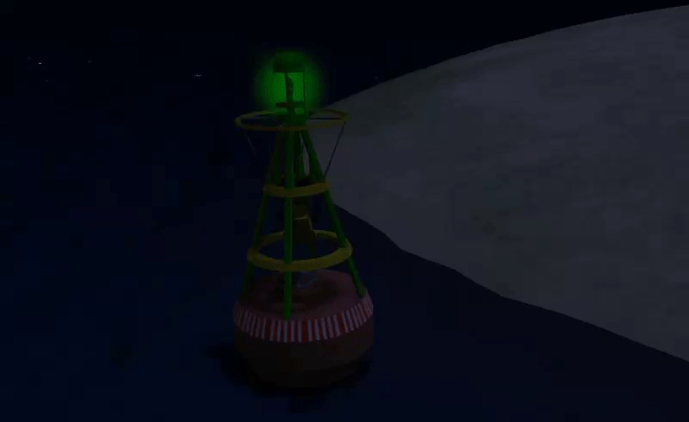

Tide script:
To make items float on water just place this script into their root prim.
integer listen_handle;
vector myPos;
float tideLevel = 20.0;
default {
on_rez(integer start_param)
{
llResetScript();
}
state_entry()
{
listen_handle = llListen(5556, "TIDE", NULL_KEY, "");
}
listen( integer channel, string name, key id, string message )
{
tideLevel=(float)message;
myPos = llGetPos();
llSetPos(<myPos.x, myPos.y, tideLevel + 0.05>);
}
}

To make items float on water just place this script into their root prim.
More complex stuff can be done using the full info channel, which has data about where in the tide cycle we are. Rez a cube prim and place this script inside:
integer listen_handle;
default
{
state_entry()
{
listen_handle = llListen(5555, "TIDE", NULL_KEY, "");
}
listen( integer channel, string name, key id, string message )
{
llWhisper(0,channel + " " + name + " " + id + "\n" + message);
}
}
The cube will whisper info about the current tide position every time the tide is updated.

Links:
Tides is by Jak Daniels from https://github.com/JakDaniels/OpenSimTide

Terms of Service
The TOS form lets you change the HTML for your TOS. A SAMPLE TOS is included here.
Feel free to delete it or change it as you see fit.
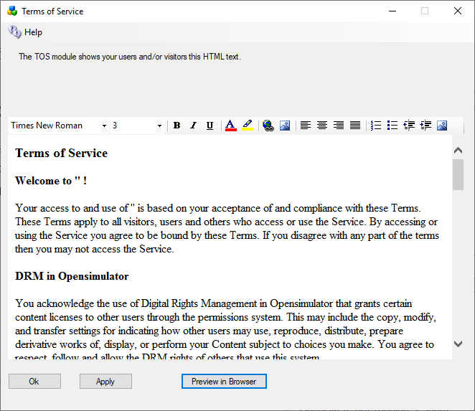
#includes There are several include directives that bring in the rest of the web site. Diva uses a series of <!--#include file=header.html --> statements to bring in files from the other folder set in Opensim\WifiPages. Includes in those files then bring in increasingly of the web pages from Opensim\Bin\Wifipages.
#get There are several statements that are replaced by server data:
Users in World: <!-- #get var=UsersInworld -->
Regions: <!-- #get var=RegionsTotal -->
Total Users: <!-- #get var=UsersTotal -->
Active Users last <!-- #get var=UsersActivePeriod --> days
Active Users: <!-- #get var=UsersActive -->

Troubleshooting Manually
Run Help-Network Diagnostics and see what it says. Or troubleshoot it manually, step-by-step. The diagnostics essentially do what is described below, but sometimes you just need to know more.
Diagnostics are run by going to Help->Diagnostics
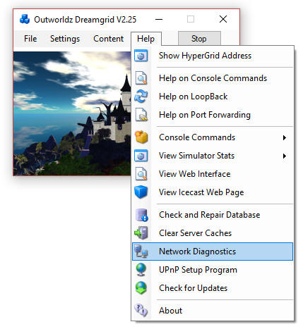

How to Get on The Hypergrid
Accessing the Hypergrid can be done with compatible uPnP router with loopback. If your router does not support loopback, you can still join the Hypergrid by installing a special pointer in /etc/hosts or a special Windows Device Driver. Additional information about routers is available online at the Opensimulator site at http://opensimulator.org/wiki/NAT_Loopback_Routers.

Step-By-Step
Try these in order:
1. http://127.0.0.1:8002 <- gives a web page. Verifies that robust is running on the machines Network Card loopback adapter.
If not, start Robust.
Go to the next step only when this test passes.
2. Find your LAN IP with the dos command 'ipconfig' or look at the console screen in DreamGrid.
Use a web browser to go to your LAN IP, such as http://192.168.0.10:8002
You should get a Web Page when robust is running. If not, double check your IP with the DOS command 'ipconfig'. It will be listed as an IPV4 address.
Go to the next step only when this test passes.
3. Use a cellphone or some other PC connected to your LAN for this next one.
Navigate using a web browser on that OTHER device to http://192.168.0.10:8002 or whatever you system reported. You should see the web page.
If this fails, it is likely to be an antivirus program blocking a port such as the Windows Defender firewall. Turn them ALL off. Look for Malwarebytes or other installations that can block the port. I have troubleshot one machine that had three anti-viruses. You can turn them back on once you get it working, one at a time, and see when Opensim quits. Then add the necessary exclusions to that anti-virus program.
Go to the next step only when this test passes.
4. If UPNP is enabled in the Setup-Settings->Network ports, go to step 5. If not, you MUST port forward port 8002 and 8004-8100 or more in the router. Go read the manual on Port Forwards.
5. All the above tests are LAN-based. So now try the router:
http://canyouseeme.org on port 8002
This test must pass. If it does not the problem can be another firewall is blocking you. Usually this is when people realize they have their router plugged into another router that needs to port forward, too. Or that they are running 3 different Antiviruses. Or that their ISP is terrible and is blocking you. Call them on the phone and ask if you are double NAT’ed,
Go read the manual on Port Forwards again.
Look up your router manual. Go to http://portforward.com and look it up.
If this still fails, it is still likely to be your anti-virus. The grid was running back in Step 4. AV can detect if it’s a local IP or a remote IP, so go shut them all down.
It can also be the Windows Defender windows firewall. Turn them all off. Look again for Avast and Malwarebytes or other installations that can block the LAN port. You have already proven it is not DreamGrid, so there is no point in re-installing the grid or restarting it.
Do not go to the next step until the above is working. There is no point until the above works.
If you still can’t get it working, it is likely your ISP is blocking the port. Call them.
6. If you added Loopback, go to the network settings and click the properties of the Microsoft Driver for the Loopback Adapter. You should have renamed it 'Loopback". If you did, DreamGrid will update this IP when it changes. In the IPV4 settings, it should show the same address Canyouseeme.org shows as the address. The gateway is 255.255.255.0 No other settings are needed. Close those settings, and right click the adapter and enable it.
7. Navigate to http://(The Ip address reported by CanyouSeeme.org):8002
You should see the web page. If not, recheck the Loopback settings.
Go to the next step only when this test passes.
8. Right click the Loopback Network Adapter and disable it, if you have installed it.
Navigate to http://(The Ip address reported by CanyouSeeme.org):8002. It may or may not work. If not, you need to re-enable the adapter.
If it gives a web page, congratulations, your router supports loopback. Leave it disabled.
9. Go to DreamGrid Settings-> Hypergrid DNS name. Add your desired name, such as in ‘somename.outworldz.net’. The allowed characters are a-z, 0-9, and a dash '-'. Press Save.
`0. Go to a DOS prompt. Type 'nslookup<enter>'. Type ‘somename.outworldz.net', where name is the name you chose. It should report the IP with the exact same number as Canyouseeme.org.
11. Add the ‘somename.outworldz.net:8002’ to the viewer’s grid selection, and log in. Both the robust and welcome region should show you logging in. If you only see Robust, then you forgot to port forward or unblock Ports 8004 upwards. You should unlock 10 to 100 ports for expansion, as any extras are harmless.

Ports are still blocked?
Reset your router by cycling the router power. This is often the ONLY WAY to clear out old UPNP entries.
UPnP settings are usually removed when the program is started to keep your system safe. DreamGrid uses Universal Plug and Play (uPnP) and several diagnostics to configure compatible routers automatically. uPnP may be disabled or fail. If your router does not support uPnP, you must manually open ports in your router and Port Forward them to your PC.

Try This SIMPLE BEGINNING
Go to Setup-> Settings, click the DNS button at top left, and enter '127.0.0.1'. Now start the grid.
You should also be able to see the Systems admin web page with a viewer by clicking the above address with the :8002.
Open up your viewer. Now add the grid http://127.0.0.1:8002 to the viewer. You should be able to log in on the Server from the Server.
You should see the Welcome region spit out a lot of text as you log in. If this fails, it is not your network, router, or loopback as you are on localhost, aka. 127.0.0.1. You will need to read the error message and troubleshoot from there.

Password Reset
You may have forgotten your Opensim password. You can reset your password with the command 'reset user password' in the Robust screen.

Troubleshooting the Network.
Any IP from outside must be able to connect to port 8002, and from 8004 upwards. A test at http://canyouseeme.org should work on port 8002 when Robust is running. It should also work on port 8004 which is the default home or welcome region at the very beginning.
If not, you must Port Forward. See the manual on Port Forwards.
If it does not work after port forward, it is very likely to be an antivirus firewall. DreamGrid automatically opens the Windows firewall.

Anti Virus
Programs such as MalwareBytes, Norton, Avast, and others are designed to block Ports. Try disabling them entirely to get Canyouseeme.org to work on port 8002. You have a firewall in your router so should be perfectly safe. Once you get the system running, enable your AV one at a time. If it quits, add exclusions to the ports you used:
8001 – Used by PC for icons, signs and status, may be closed in the router
8002 - Robust HTTP port “The Grid”. This is where avatars connect. Must be open
8003 – Should not normally be port forwarded but can be if you want to run a special Region server.
8004 – from 8004 upwards it uses one port per region.

AV Exclusions
You need to add exclusions to Real Time Scanners for Outworldzfiles\Opensim\bin\. Opensim creates millions of files and thousands of DLL’s.

Flaky Teleports
Multiple factors can cause flaky things, some of which may not be under your control, such as at the far-end system.
One way to prove your issue is not Opensim or your PC network card is to boot up after changing the Hypergrid DNS name to the IP of the server, or just leave it blank, so it will choose the LAN IP by default. You should be login to that IP address in your viewer, and teleports on your grid should take just moments.
Try uploading a dozen textures. Do they all load without aborting? Now ask some on the Hypergrid to do so. If there is a difference, you have issues with the router and loopback, as the traffic from you and the outside both go to the region, but the region cannot reliably reach some of the ports.
Do you have more than one Network adapter with paths to the Internet, such as both wireless and hardwired running? Opensim can listen to only one adapter, but traffic can come back on either.
Loopback is often flaky in routers. For example, the routers from FIOS and Frontier have tiny 1K buffers for UDP leaving to flaky teleports. Have you tried adding the Microsoft Loopback driver?
These are the URLS it checks to see if it is working that can be run on the server.
When the DNS name is blank, such as first boot, I need a LAN IP to broadcast to the viewer. If a LAN IP is unreachable from the Internet, I announce you cannot Hypergrid.
DG tries to always make a working system, no matter what. There are multiple ways to connect to a LAN, by the WAN IP with or without a DNS name, and as a LAN IP, and localhost. In a complex network environment, there can be multiple ways and more than one IP in use to connect to the outside. Both Wifi and Ethernet adapters, for example. Opensim can only listen to one IP, thus return traffic on the wrong IP can be lost. This is flaky, at best, and is a major cause of teleport problems.
Opensim needs to listen and broadcast only on the "proper" IP. But which is it? I do this by connecting to Googles 8.8.8.8 DNS server, then asking Windows what the Endpoint address is. Typically, this is a number in the 192.168 range, or the 10. * range, which are typical LAN IP's. But it can be anything. If I cannot reach it, I use localhost. DG will thus always come up in a working configuration on first boot.

I cannot teleport to two different grids on the same network.
(1) on the server: add the public IP address as a secondary IP address on the server's network interface with the 255.255.255.255 mask (web service or whatever you want on the server should listen on this IP address too); all modern operating systems will permit you to do this (or a loopback interface with the public IP address assigned to it can be used instead of adding a secondary IP to the primary interface).
(2) on the LAN hosts: add a host route for the public IP address, for example, for Windows hosts use the following command: route -p add <WANIP> mask 255.255.255.255 <LANIP>
And fill in the LAN and WAN IP.

The URL I use to Test port forwards:
https://outworldz.com/cgi/probetest.plx?Port=9000
Answer should be yes

Test Private Loopback:
http://192.168.2.135:8001 (change this to your LAN IP of the server)
Answer should be Test Completed

Test Public Loopback
http://YOURNAME.Outworldz.net:8002
Gives back a web page

UPnP Not Working?
Do you have Plug and Play (uPnP) issues? Your Help menu has a useful tool to look at uPnP in your router:
Free UPnP (Universal Plug and Play) Tool for Windows
You can add, delete, and modify the settings without a password, assuming you have uPnP enabled. This is included in Dreamworld and DreamGrid in the Help menu.
You can still manually forward ports in your Router. Instructions for your specific router can be located at http://www.portforward.com

Firewall
Windows will prompt you to allow Opensim to open ports when it first runs. If you say no, you will not be able to log in.
If you are using an Anti-virus with a firewall, such as Zone Alarm, AVG Internet Suite, or anything else, running Start.exe my trigger the 3rd party firewall popup warnings. Opensim.exe needs to be allowed internet access, and Start.exe should be allowed to make changes. This code is digitally signed by me, Fred Beckhusen of Outworldz.com, and is open source and available for inspection on https://www.github.com/Outworldz.

Updater:
If it acts wonky or is missing files, look in Help->Check for Updates. It will repair any missing files.

Help with Opensim Crashes:
Your MySQL database may be crashed. This is a way to start MYSQL manually.
Navigate to the Outworldzfiles\MySQL\bin folder. Press and hold the Shift Key and right click the BLANK area next to the files. Or navigate there, as I did below, by typing in commands. Then run "StartManually.bat"
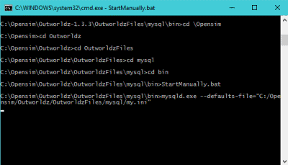
Any error message it prints may be helpful. If the above DOS window closes, a MySQL LOG file will be saved in OutworldzFiles\MySQL\data as a *.err file. That will give you a clue as to what to do.

My database still did not start.
Try running Outworldzfiles\MySQL\bin\Repair_ISAM.bat. Start MySQL and wait until the Task manager in Windows shows that Mysqld.exe is at 0% CPU use.
Still not working? Delete the two 10 MB files, ib_logfile0, and ib_logfile1 in MySQL\Data and repeat the Repair_ISAM.bat and run "StartManually.bat" again and wait for the CPU to drop to 0%

Starting Over with A Blank Database
You can wipe ALL data out and recreate it from OAR and IAR files. This WILL LOSE ALL DATA.
If you MUST wipe out the database and start over, there are two methods.
The easiest way is to unzip the provided blank database and replace (do not mix) the contents of MySQL\Data with it.
Method 2 is to delete the ib_logfile0, ib_logfile1 and ibdata1 file in OutworldzFiles\MySQL\data (leave the folders). Then delete just the contents of data\opensim\*. Leave the folder "MySQL\data\MySQL" alone.
Either method will make it start over at the very beginning and you need to re-enter your Avatar name and password and reload everything.

Ports
Here is more detail about ports and the way the interact with the outside world such as www.canyouseeme.org and to my diagnostics tests.
Port 8001:
8001 is a TCP/HTTP port that is used for setting icons to the state of what Opensim is doing, and some other simple functions such as automatic updating teleport signs and the Partners prim. It is unique to Dreamworld.
Port 8002:
Opensim has a web server that web browsers understand, using the same protocol (TCP/HTTP) that tools such as www.canyouseeme.org support. Put simply, Robust listens to port 8002 and answers to http:// requests on 8002. Port 8002 is much like port 80, the default port for web pages. You can actually set Dreamworld's 8002 port to 80, and it will work. You can then drop the need to type :8002 at the end of your hyperlink. http://hg.Osgrid.org does this. There would be no need to type the :80, as literally http:// means "add a :80 to the end of it". So only 8002 works with web-based probe tools. If you do switch it to 80, then you must change the Apache port 80 to some other port. Only one program can listen to a port.
If Opensim is not running and your ports are open, it is as if you tried to connect to www.google.com's web server, but their web server is down. Nothing will happen, though your packets can get through the Google firewall because it is still open to traffic and is steering it to a dead server. You will get no answer. Similarly, if Opensim is not running, there is no web server to answer the request.
Port 8003:
This port is listened to by Robust so regions can chat to the server database for login, presence, and other services so people can teleport from one region to another. In Dreamgrid, just like OsGrid or any other remotely attachable grid, the regions can run on any machine anywhere in the world.
If you opened port 8003 to anyone on the web, you expose the internal database protocol to the web. Anyone with the right knowledge could attach a region to your sim. If you run a DreamGrid and host region outside your LAN, it is recommended you use firewall rules to only allow access from known IP addresses running approved regions.
Port 8004 and upwards:
The region ports (8004-upward) run both TCP and UDP. UDP is used for the viewer. UDP cuts the load on the server dramatically as there is no need to automatically always ACK every packet. As one example, no one cares if an audio stream gets briefly interrupted as you cannot hear it anyway, and it is too late to use it if it comes later in a retry. It just gets discarded.

Running Manually
You can run Opensimulator without Dreamgrid. Dreamgrid sets up Opensim to run. Once it has run once, you can run Opensim without it.
When you click [Start], Dreamgrid looks for a MySQL listening on a specific Port. If it does not see one, it starts MySQL as a separate process. When you exit, it shuts MySQL down gracefully with *MySQL-admin.-u root shutdown*. Dreamgrid will detect Robust running on Port 8002 and just use it. If it does not see it, Dreamgrid starts up a Robust.
For running manually, MySQL can be used in two ways.
1) MySQL\bin\ StartManually.bat runs MySQL manually. Once the Command Prompt opens, this window can be closed manually, as MySQL will run by itself in another thread.
This is also useful for diagnostics and manual backups and running a Dreamgrid in folder A on a database in Folder B or C or D:\SomeWhereElse. But there is a significant issue: you need to shut down MySQL gracefully! This really needs to be done correctly to reboot or log out of Windows. The command is *MySQL\bin\mysqladmin.-u root shutdown*. There is a batch file in MySQL\bin named *StopMySql.bat* that will do this for you.

Run as A Service
You can install MySQL as a Windows service. There is a batch file *InstallAsAService.bat* in MySQL\bin to set this up. MySQL will then start with Windows.
This batch file must be run once, as an Administrator. You type "CMD" in the search box, and then right click the Command Prompt and select "Run as Administrator". Use that DOS box to run *InstallAsAService.bat*. Then type in 'Services.msc” and use it to start MySQL.
You should also set the service to restart so MySQL restarts on any crash. Windows knows about services and will send signals to MySQL to shut itself off gracefully. The only danger is that power fails and you corrupt the database. I have set this MySQL to always flush data to the disk without saving it in RAM, which helps. If you are serious about running a grid, then a UPS is necessary.
You can start Robust manually, too. Outworldzfiles\RunRobust.bat assumes MySQL is running.
Go.bat starts a command prompt with an instance of Opensim in it (an instance is a set of sims). The batch file switches to the bin folder and launches Opensim with the settings it needs for the INI files and the Log file.
You can start it all with a batch file like this:
@remarkable batch file to start Dreamgrid manually.
cd MySQL\bin
start startmanually.bat
cd ..\..\opensim
call runrobust.bat
call go Welcome
call go AnotherRegion

How to Compile DreamGrid
The vast majority of this software is just Opensimulator and MySQL with edits in the INI files to allow auto-configuration by XML and INI editing.
The source code package "How_to_Compile.txt" explains how it is compiled, and what changes are made. You need Visual Studio 2015 or higher, and preferably 2019.

sers
This screen lets you edit any user Title, Email, Name, and Login Levels
Change any data and close the windows and it will save the changes.
You may rename the avatar, add a title, and change the email and password.

Vivox Voice Settings
Please Note that Vivox is no longer giving out codes.
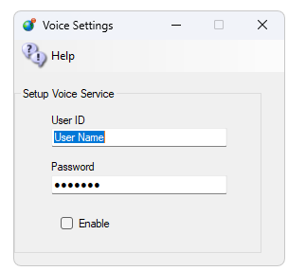
Add your User ID and Password to this form and enable it. Restart the system and voice should work.

Links:
https://support.vivox
http://www.hypergridbusiness.com/2011/12/free-vivox-for-all

Who Got What Module
This Opensimulator Region module lets you send data from scripts to a comma delimited list in your Opensim\bin folder. With just a bit of LSL you can determine who touched, e.g. “Who Got What” prim, or what door they opened, or what they collided with, or who went where in a sim.
A Demo Form included in DreamGrid will help explain. Navigate in a web browser to http://127.0.0.1:8004/diva/WhoGotWhat on your server.
The data the module accepts can be an Avatar Name, the region the item is on, the object (prim) name, the Location, such as <127,128,22> and a Text string. This can be the description or some other text.
The system also requires a password that only you know. Your password is located in Settings->Hypergrid DNS name.
Pressing send will say “OK your object has been recorded.” And add this data to a Comma Separated (.CSV) file named WhoGotWhat.csv in Opensim\bin. You can open this file with a spreadsheet.
11/16/2020 10:43:04 PM,Fred,Test,Object,<128,128,22>,Prim Description

Setting Up WordPress with DreamGrid
Download WordPress from https://wordpress.org/download/
Extract the zip file into wherever you installed your Grid in the Outworldzfiles\Apache\htdocs\WordPress folder. Do not put a second ‘Wordpress’ folder in there. If you do, just drag and drop the contents of the lower Wordpress folder to the htdocs\ WordPress folder. It should look like this:
- Go to DreamGrid settings -> Apache. Set the WordPress switch on.
- Enable the Apache Webserver on port 80 to run as a service.
- If you have not yet done so, install the necessary Visual C++ runtimes by clicking the button. **WARNING* This may suddenly reboot your machine, so save your work.
- If it does reboot, make your way back the Settings Apache page and , install the necessary Visual C++ runtimes by clicking the button.
- Stop the grid, exit the app, and start it again.
- Using a web browser, navigate to http://localhost. You should see a language choice screen:
After choosing your language, use these settings to set up WordPress and then Click Submit:

You should get this screen:
After this WordPress will ask for your name, password and email. Please a very strong password you have never used before! It is extremely importatnt that this be a long, strong password.
You can now navigate to http://localhost to view your new web site.

Error! Not a valid link.

